Decision No. R25-0072-I
BEFORE THE PUBLIC UTILITIES COMMISSION OF THE STATE OF COLORADO
PROCEEDING NO. 24A-0471CP-EXT
IN THE MATTER OF THE APPLICATION OF 303 PARTY BUS LLC FOR AUTHORITY TO EXTEND OPERATIONS UNDER CERTIFICATE OF PUBLIC CONVENIENCE AND NECESSITY NO. 55846.
INTERIM DECISION
acknowledging intervention and
shortening response time
Issued Date: July 31, 2026

STATEMENT
- On January 29, 2025, 303 Party Bus, LLC, filed its opposed Motion to Adopt Procedural Schedule and Remote Hearing Procedures. In order to expedite establishing hearing procedures, the undersigned will shorten response time sua sponte, as ordered below.
- On November 12, 2024, Mountain Star Transportation, LLC, doing business as Explorer Tours filed its Petition for Intervention and Entry of Appearance. Despite being titled as a petition, the pleading claims intervention of right and will be acknowledged accordingly.

ORDER

It Is Ordered That:
- The intervention of right by Mountain Star Transportation, LLC, doing business as Explorer Tours (“Explorer Tours”) is acknowledged.
- Response time to the Motion to Adopt Procedural Schedule and Remote Hearing Procedures filed by 303 Party Bus, LLC, is shortened to February 6, 2025.
- Explorer Tours must file any desired response to the Motion to Adopt Procedural Schedule and Remote Hearing Procedures on or before February 6, 2025.
- This Decision shall be effective immediately.
(S E A L)    ATTEST: A TRUE COPY  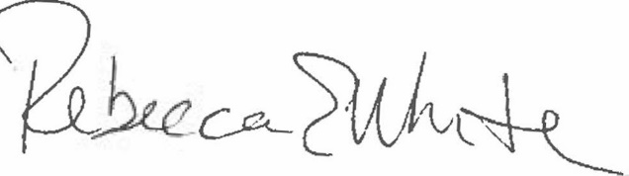  Rebecca E. White,  Director | THE PUBLIC UTILITIES COMMISSION  OF THE STATE OF COLORADO  G. HARRIS ADAMS  ________________________________  Administrative Law Judge

