Decision No. C25-0310
BEFORE THE PUBLIC UTILITIES COMMISSION OF THE STATE OF COLORADO
PROCEEDING NO. 23A-0104R
IN THE MATTER OF THE CITY OF LONGMONT FOR AUTHORITY TO INSTALL CROSSING IMPROVEMENTS FOR THE PURPOSES OF IMPLEMENTING A QUIET ZONE AT THE 9TH AVENUE AND BNSF RAILWAY CROSSING (US DOT NO. 245007B).
COMMISSION DECISION
GRANTING AMENDED APPLICATION
Issued Date: April 22, 2025
Adopted Date: April 16, 2025

BY THE COMMISSION

Statement, Findings and Conclusions
- This matter comes before the Commission for consideration of a Joint Motion for Amendment of Application (“Joint Amended Application”) filed by the City of Longmont (“Longmont”) and the BNSF Railway Company (“BNSF”) on April 1, 2025, requesting authority to amend the approved application for the crossing of 9th Avenue with the tracks of the BNSF at railroad mile post 44.77 of the Front Range Subdivision, National Inventory No. 2445007B, in Longmont, County of Boulder, State of Colorado to move the railroad signal bungalow location from the southeast quadrant of the crossing to the southwest quadrant of the crossing.
- As grounds for the Joint Amended Application, Longmont and BNSF state that they discovered that the railroad signal bungalow location in the BNSF maintenance road, which would also not have easy access to electric power. Longmont and BNSF request to move the approved signal bungalow location from the southeast quadrant of the crossing to the southwest quadrant of the crossing where the BNSF maintenance is not located, where easy power access is located creating a safer location at the crossing. All other aspects of the previously approved application are proposed to remain the same.
- Now being fully advised on the matter, we grant the Joint Amended Application.

ORDER

The Commission Orders That:
- The Joint Motion for Amendment of Application (“Joint Amended Application”) filed by the City of Longmont (“Longmont”) and BNSF Railway Company (“BNSF”) on
April 1, 2025, requesting authority to amend the approved application for the crossing of
9th Avenue with the tracks of the BNSF at railroad mile post 44.77 of the Front Range Subdivision, National Inventory No. 2445007B, in Longmont, County of Boulder, State of Colorado to move the railroad signal bungalow location from the southeast quadrant of the crossing to the southwest quadrant of the crossing is granted.
- All previous compliance filings are still required.
- The 20-day period provided for in § 40-6-114, C.R.S., within which to file an Application for Rehearing, Reargument, or Reconsideration, begins on the first day following the effective date of this Decision.
- This Decision is effective upon its Issued Date.

ADOPTED IN COMMISSIONERS’ WEEKLY MEETING
April 16, 2025.
(S E A L)    ATTEST: A TRUE COPY  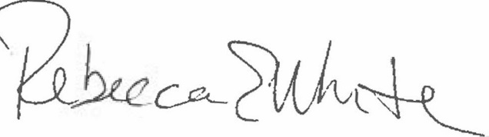  Rebecca E. White,  Director | THE PUBLIC UTILITIES COMMISSION  OF THE STATE OF COLORADO  ERIC BLANK  ________________________________  MEGAN M. GILMAN  ________________________________  TOM PLANT  ________________________________  Commissioners

