Decision No. C25-0052
BEFORE THE PUBLIC UTILITIES COMMISSION OF THE STATE OF COLORADO
PROCEEDING NO. 23A-0448R
IN THE MATTER OF THE APPLICATION OF THE CITY OF COLORADO SPRINGS AND THE COUNTY OF EL PASO FOR AUTHORITY TO ABOLISH AND REMOVE THE EXISTING HIGHWAY-RAIL CROSSING AND ASSOCIATED CROSSING WARNING DEVICES AT ROYER STREET AND TRACKS MANAGED BY THE BNSF RAILWAY ON RIGHT-OF-WAY OWNED BY UNION PACIFIC RAILROAD (USDOT NO. 253109P), AND CONSTRUCT A NEW AT-GRADE CROSSING NAMED TWIN BRIDGES ROAD AT APPROXIMATE M.P. 77.80 OF THE BNSF RAILWAY/UNION PACIFIC RAILROAD WITH ACTIVE CROSSING WARNING DEVICES IN THE CITY OF COLORADO SPRINGS,
EL PASO COUNTY, STATE OF COLORADO.
COMMISSION DECISION GRANTING
MOTION FOR EXTENSION OF TIME
Issued Date: January 23, 2025
Adopted Date: January 22, 2025

by the commission

Statement
- This matter comes before the Commission for consideration of a Motion for Extension of Time (“Motion”) filed by the Union Pacific Railroad Company (“UPRR”) on December 27, 2024, requesting an extension of time to December 31, 2026, to file updates to the National Inventory Forms with the Commission.
- As grounds for the Motion, UPRR states that applicants City of Colorado Springs and El Paso County requested an extension of time to December 31, 2026, to complete the crossing construction project approved in the instant proceeding that was approved by the Commission by Decision No. C24-0748 issued October 21, 2024.
- UPRR states in the Motion that it will be unable to update the National Inventory Forms for this application until the project is complete for which the Commission has approved an extension to December 31, 2026, to complete the project. UPRR requests an extension of time to the same date approved by the Commission, December 31, 2026, to file the updated
National Inventory Forms in this proceeding.
- No responses were filed to the Motion.
- Now being fully advised in the matter, we grant the Motion

ORDER

The Commission Orders That:
- The Motion for Extension of Time (“Motion”) filed by the Union Pacific Railroad Company (“UPRR”) on December 27, 2024, requesting an extension of time to
December 31, 2026, to file the updated National Inventory Forms with the Commission is granted.
- UPRR is given to December 31, 2026, to provide the updated National Inventory Forms in this proceeding.
- The Commission retains jurisdiction to enter further decisions as necessary.
- This Decision is effective upon its Issued Date.

ADOPTED IN COMMISSIONERS’ WEEKLY MEETING
January 22, 2025.
(S E A L)    ATTEST: A TRUE COPY  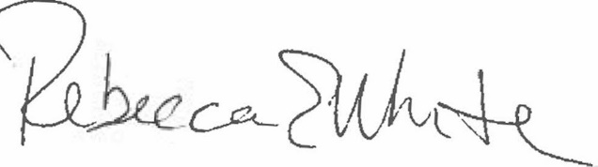  Rebecca E. White,  Director | THE PUBLIC UTILITIES COMMISSION  OF THE STATE OF COLORADO  ERIC BLANK  ________________________________  MEGAN M. GILMAN  ________________________________  TOM PLANT  ________________________________  Commissioners

