Decision No. R24-0931-I
BEFORE THE PUBLIC UTILITIES COMMISSION OF THE STATE OF COLORADO
PROCEEDING NO. 24G-0314TO
COLORADO PUBLIC UTILITIES COMMISSION,
COMPLAINANT,
V.
MNS TOWING LLC,
RESPONDENT.
INTERIM DECISION
GRANTING UNOPPOSED MOTION TO AMEND CPAN
Issued Date: December 23, 2024

STATEMENT
- On February 20, 2024, the Colorado Public Utilities Commission (“Commission”) filed Civil Penalty Assessment or Notice of Complaint to Appear No. 139039 (“CPAN”) against Sergio Cornejo doing business as MNS Towing LLC (“Sergio Cornejo”).
- On July 20, 2024, the Commission filed CPAN No. 138328 against MNS Towing LLC (“MNS Towing”).
- On October 12, 2024, the Commission filed against Sergio Conejo CPAN
Nos. 138903, 138978, 139090.
- CPAN Nos. 139039, 138328, 138903, 138978, and 139090 have been assigned Proceeding Nos. 24G-0084TO, 24G-0314TO, 24G-0439TO, 24G-0440TO, and 24G-0441TO, respectively. The undersigned Administrative Law Judge (“ALJ”) has been assigned to all of the foregoing proceedings. Trial Staff of the Commission (“Staff”) has entered its appearance in all of the proceedings.
- Decision Nos. R24-0860-I scheduled a remote joint prehearing conference in this proceeding and Proceeding Nos. 24G-0084TO, 24G-0314TO, 24G-0439TO, 24G-0440TO, and 24G-0441TO for December 12, 2024.
- The remote joint prehearing conference took place on December 12, 2024. Staff stated that it planned to file a motion for leave to amend change the Respondent in this CPAN from MNS Towing to Sergio Cornejo.
- On December 13, 2024, Staff filed an Unopposed Motion to Amend CPAN and Waive Response Time (“Unopposed Motion”).

Analysis
- As support, Staff states that the caption must be amended to “to align with the Respondent’s name in 24G-0439TO, 24G-04412TO, 24G-0440TO, and 24G-0084TO to support consolidation.” Staff also states that Respondent does not oppose the Unopposed Motion. Indeed, counsel for Respondent stated at the remote joint prehearing conference that Respondent does not oppose the amendment of the caption requested in the Unopposed Motion.
- Staff has stated good cause to grant the Unopposed Motion. Accordingly, the Unopposed Motion will be granted.

ORDER

It Is Ordered That:
- The Unopposed Motion to Amend CPAN and Waive Response Time filed by Trial Staff of the Commission on December 13, 2024 is granted.
- The Administrative Staff of the Commission is requested to change the caption of this proceeding to identify the Respondent as “Sergio Cornejo dba MNS Towing LLC”.
- This Decision is effective immediately.
(S E A L)    ATTEST: A TRUE COPY  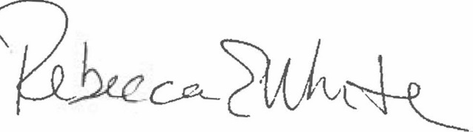  Rebecca E. White,  Director | THE PUBLIC UTILITIES COMMISSION  OF THE STATE OF COLORADO  CONOR F. FARLEY  ________________________________  Administrative Law Judge

Id.
Unopposed Motion at p. 2 (¶ 8).

