Decision No. R24-0849-I
BEFORE THE PUBLIC UTILITIES COMMISSION OF THE STATE OF COLORADO
PROCEEDING NO. 23N-0135GPS
IN THE MATTER OF THE NOTICE OF PROBABLE VIOLATION ISSUED TO COLORADO NATURAL GAS ON MARCH 20, 2023.
interim order satisfying SHOW CAUSE
Issued Date: November 20, 2024

STATEMENT
- On March 20, 2023, the Staff of the Public Utilities Commission (“Trial Staff”) initiated this matter by issuing its Notice of Probable Violation (“NPV”) to Colorado Natural Gas, Inc. (“CNG”).
- By Decision No. R24-0313-I, issued on May 7, 2024, Trial Staff was ordered to confer with CNG and file quarterly reports, including one (on or before) November 1, 2024, informing the Commission as to progress toward filing evidence of resolution and a motion to dismiss (or otherwise dispose of the proceeding), expectations regarding the filing of evidence of resolution and a motion to dismiss (or otherwise dispose of the proceeding), and whether any party believes it necessary to establish a new procedural schedule.
- By Decision No. R24-0807-I, issued on November 12, 2024, Trial Staff was ordered to show cause by written submission why the NPV initiating this proceeding should not be dismissed for failing to comply with Decision No. R24-0313-I.
- On November 14, 2024, Trial Staff’s Response to the Interim Order to Show Cause, its Second Quarterly Status Report, and its Unopposed Motion to Submit the Status Report After the Deadline was filed. Staff explained the circumstances leading to the failure to timely file a status report, provided the ongoing status in the matter, and requested leave to file the status report late.
- Trial Staff conferred with counsel for CNG concerning the filing and is authorized to state CNG supports continuing with this proceeding and does not oppose the motion to accept the status report late.
- The requested relief being unopposed, it is appropriate that response time be waived.
- Trial Staff having shown good cause, the Order to Show Cause will be satisfied and the status report will be accepted. Decision No. R24-0313-I remains in effect and Trial Staff shall continue reporting in accordance therewith. The next status report must be filed no later than February 1, 2025 (but may obviously be provided sooner).

ORDER

It Is Ordered That:
- Response time to Trial Staff’s Unopposed Motion to Submit the Status Report After the Deadline filed on November 14, 2024, is waived and the request is granted.
- The Status Report filed on November 14, 2024, is accepted.
- The Order to Show Cause issued in Decision No. R24-0807-I is satisfied.
- This Order is effective immediately.
(S E A L)    ATTEST: A TRUE COPY  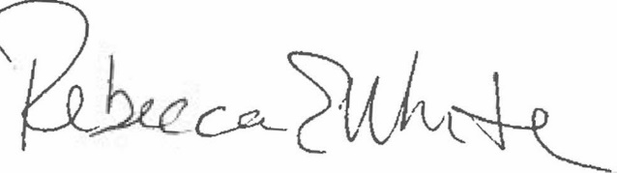  Rebecca E. White,  Director | THE PUBLIC UTILITIES COMMISSION  OF THE STATE OF COLORADO  G. HARRIS ADAMS  ________________________________  Administrative Law Judge

