Decision No. R24-0807-I
BEFORE THE PUBLIC UTILITIES COMMISSION OF THE STATE OF COLORADO
PROCEEDING NO. 23N-0135GPS
IN THE MATTER OF THE NOTICE OF PROBABLE VIOLATION ISSUED TO COLORADO NATURAL GAS ON MARCH 20, 2023.
interim order TO SHOW CAUSE
Issued Date: November 12, 2024

STATEMENT
- On March 20, 2023, the Staff of the Public Utilities Commission (“Staff”) initiated this matter by issuing its Notice of Probable Violation (“NPV”) to Colorado Natural Gas, Inc. (“CNG”).
- On March 21, 2023, Staff filed its Entry of Appearance.
- On April 19, 2023, CNG filed its Response Letter to the NPV with the Public Utilities Commission (“Commission”), stating that CNG and Staff had begun discussions and both parties were open to settling the NPV without a hearing. CNG also stated that both parties intended to continue meeting to resolve the NPV.
- On March 20, 2024, the Commission referred this proceeding to an Administrative Law Judge (“ALJ”) by minute entry.
- By Decision No. R24-0313-I, issued May 7, 2024, Staff was ordered to confer with CNG and file a quarterly report on (or before) November 1, 2024, informing the Commission as to progress toward filing evidence of resolution and a motion to dismiss (or otherwise dispose of the proceeding), expectations regarding the filing of evidence of resolution and a motion to dismiss (or otherwise dispose of the proceeding), and whether any party believes it necessary to establish a new procedural schedule.
- As of the date of this Interim Decision, no status report has been filed. Thus, Staff will be ordered to show cause why the NPV initiating this proceeding should not be dismissed.

ORDER

It Is Ordered That:
- On or before November 22, 2024, Staff of the Public Utilities Commission shall show cause by written submission why the Notice of Probable Violation initiating this proceeding should not be dismissed.
- This Order is effective immediately.
(S E A L)    ATTEST: A TRUE COPY  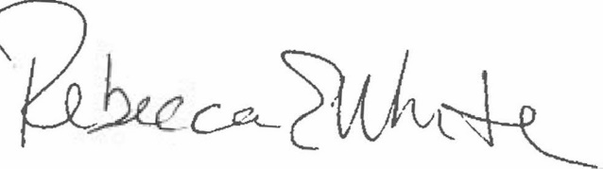  Rebecca E. White,  Director | THE PUBLIC UTILITIES COMMISSION  OF THE STATE OF COLORADO  G. HARRIS ADAMS  ________________________________  Administrative Law Judge

