Decision No. R24-0548-I
BEFORE THE PUBLIC UTILITIES COMMISSION OF THE STATE OF COLORADO
PROCEEDING NO. 24D-0220G
IN THE MATTER OF THE VERIFIED PETITION OF PUBLIC SERVICE COMPANY OF COLORADO FOR A DECLARATORY ORDER DETERMINING WHETHER A CERTIFICATE OF PUBLIC CONVENIENCE AND NECESSITY IS REQUIRED FOR COMPLETION OF THE CLARKSON SYSTEM SAFETY AND INTEGRITY PROJECT.
INTERIM decision
ADOPTING SCHEDILE AND VACATING REMOTE PREHEARING CONFERENCE
Issued Date: July 30, 2024

STATEMENT

Background
- On May 21, 2024, Public Service Company of Colorado (“Public Service”) filed the Petition for Declaratory Order (“Petition”) that initiated this proceeding.
- On June 10, 2024, the Commission issued Decision No. C24-0399-I that accepted the Petition, issued notice of the Petition, set a 30-day intervention period; and referred the proceeding to an Administrative Law Judge (“ALJ”). The proceeding was subsequently assigned to the undersigned ALJ. The 30-day intervention period ends on July 10, 2024.
- On June 24, 2024, Decision No. R24-0444-I issued scheduling a remote prehearing conference for July 31, 2024 and requiring the parties to confer regarding a schedule for this proceeding and for Public Service to file a conferral report by July 26, 2024.
- On July 10, 2024, Trial Staff of the Commission filed a Notice of Intervention as of Right, Entry of Appearance, and Request for Hearing.
- On July 26, 2024, Public Service filed the Conferral Report.

Conferral and Conferral Report
- In the Conferral Report, Public Service reported that the parties agree that an evidentiary hearing is unnecessary because “the questions raised by this Petition are purely questions of law.” The parties jointly propose the following schedule:
Event | Deadline
Staff’s Response to the Petition | September 27, 2024
Public Service’s Reply in Support of the Petition | October 25, 2024
Joint Motion Regarding Oral Argument | November 8, 2024
- The parties’ proposed schedule is acceptable and will be adopted.

Remote Prehearing Conference
- The Conferral Report adequately addresses the issues that would have been addressed at the remote prehearing conference. As a result, there is no need to hold the remote prehearing conference and it shall be vacated.

ORDER

It Is Ordered That:
- The schedule in paragraph 6 above is adopted.
- The remote prehearing conference scheduled for July 31, 2024 is vacated.
- This Decision is effective immediately.
(S E A L)    ATTEST: A TRUE COPY  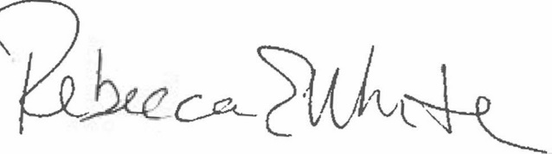  Rebecca E. White,  Director | THE PUBLIC UTILITIES COMMISSION  OF THE STATE OF COLORADO  CONOR F. FARLEY  ________________________________  Administrative Law Judge

Conferral Report at 2 (¶ 5).

