Decision No. R24-0523-I
BEFORE THE PUBLIC UTILITIES COMMISSION OF THE STATE OF COLORADO
PROCEEDING NO. 24A-0106W
IN THE MATTER OF THE APPLICATION OF PAPASON LLC D/B/A BAXTER WATER AND SERVICES REQUESTING APPROVAL FOR SIMPLIFIED REGULATORY TREATMENT AND PARTICIPATION IN THE RESOURCE COST PASS-THROUGH OPTION.
INTERIM DECISION
GraNting Motion to Extend Staff’s Deadline
to File Answer Testimony and Waive
Response Time

Issued Date: July 22, 2024

STATEMENT
- On March 1, 2024, Papason LLC, doing business as Baxter Water & Services (“Baxter” or “Applicant”) filed with the Commission its Application for Simplified Regulatory Treatment and Participation in the Resource Cost Pass-Through Option. This filing commenced Proceeding No. 24A-0106W.
- On April 19, 2024, the Trial Staff of the Public Utilities Commission (“Staff”) timely noticed its intervention of right and requested a hearing in this matter.
- On May 1, 2024, the Commission referred this matter to an Administrative Law Judge (ALJ) by minute entry.
- By Decision No. 24A-0391, issued June 6, 2024, the undersigned ALJ, among other things, adopted procedures for this Proceeding. According to Decision No. 24A-0391, the deadline for the submission of Staff’s Answer Testimony is July 19, 2024.
- On July 19, 2024, Staff filed its Unopposed Motion to Extend Staff’s Deadline to File Answer Testimony and to Waive Response Time (“Unopposed Motion”). In the Unopposed Motion, Staff states that the parties have engaged in lengthy and complex discussions in this matter and agreed on the outlines of a settlement in principle this week. Staff requests that the procedural schedule be modified by the granting a one-week extension of time, July 26, 2024, for Staff to file its Answer Testimony. Staff states that the requested extension of time would allow the parties sufficient time to possibly finalize their settlement agreement and submit a request to suspend the remained of the procedural schedule, or, in the case that the settlement discussions fall through, provide Staff with sufficient time to prepare and file its Answer Testimony. Lastly, Staff States that Applicant supports Staff’s extension request.
- The Unopposed Motion is unopposed, and Staff stated good cause for the granting of Staff’s extension request. Accordingly, response time to the Motion will be waived and the Motion will be granted, as ordered below.

ORDER

It Is Ordered That:
      - Response time to the Unopposed Motion to Extend Staff’s Deadline to File Answer Testimony and to Waive Response Time (“Unopposed Motion”), filed by Trial Staff of the Public Utilities Commission (“Staff”) is waived.
      - The Unopposed Motion is granted.
      - Staff shall file and serve its Answer Testimony by July 26, 2024.
      - The This Decision shall be effective immediately.

(S E A L)    ATTEST: A TRUE COPY  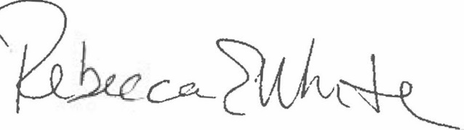  Rebecca E. White,  Director | THE PUBLIC UTILITIES COMMISSION  OF THE STATE OF COLORADO  AVIV SEGEV  ________________________________  Administrative Law Judge

See Notice at 1 and Notice of Intervention as of Right by Trial Staff of The Commission, Entry of Appearance, Notice Pursuant to Rule 1007(A) and Rule 1401, and Request For Hearing, filed by Staff on April 19, 2024.
Unopposed Motion, ¶6.
Id., ¶7
Id., ¶8.
Id., ¶7.

