Decision No. R24-0460-I
BEFORE THE PUBLIC UTILITIES COMMISSION OF THE STATE OF COLORADO
PROCEEDING NO. 23A-0585E
IN THE MATTER OF THE APPLICATION OF TRI-STATE GENERATION AND TRANSMISSION ASSOCIATION, INC. FOR APPROVAL OF ITS 2023 ELECTRIC RESOURCE PLAN.

INTERIM DECISION
Extending Settlement Agreements
Filing Deadline

Issued Date: June 26, 2024

STATEMENT
- On December 1, 2023, Tri-State Generation and Transmission Association, Inc. (“Tri-State”) filed an Application for Approval of its 2023 Electric Resource Plan. The filing of the Application commenced this Proceeding.
- By Decision No. R24-0138-I, issued March 5, 2024, the undersigned Administrative Law Judge ("ALJ”), among other things, adopted a procedural schedule to govern this Proceeding. According to the procedural schedule adopted by Decision No.
R24-0138-I, the deadline for the filing of any Settlement Agreements is June 26, 2024.
- On June 25, 2024, the undersigned ALJ received informal correspondence from Tri-State’s counsel on behalf of the parties in this Proceeding, indicating that a significant number of parties, including Tri-State, have reached a comprehensive settlement in principle in this Proceeding. Tri State’s counsel further indicated that Tri-State has conferred with all parties to this Proceeding and no party opposed the proposed settlement. Based on the foregoing,
Tri-State’s counsel requested to extend the deadline for the submission of any Settlement Agreements until June 27, 2024.
- Based on the foregoing, the ALJ finds good cause to extend the filing deadline for any settlement agreements through June 28, 2024, as ordered below.

ORDER

It is Ordered That:
- Consistent with the discussion above, the deadline for the filing of any settlement agreements is extended through June 28, 2024.
- This Decision is effective immediately.

(S E A L)    ATTEST: A TRUE COPY  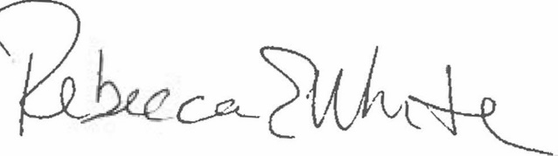  Rebecca E. White,  Director | THE PUBLIC UTILITIES COMMISSION  OF THE STATE OF COLORADO  AVIV SEGEV  ________________________________  Administrative Law Judge

