Decision No. R24-0070-I
BEFORE THE PUBLIC UTILITIES COMMISSION OF THE STATE OF COLORADO
PROCEEDING NO. 23D-0371E
IN THE MATTER OF THE CITY AND COUNTY OF DENVER’S PETITION FOR DECLARATORY ORDER REGARDING COMPENSATION FOR 2020-2021 SOLAR REWARDS COMMUNITY-BASED PROJECTS.
INTERIM decision OF
ADMINISTRATIVE LAW JUDGE
CONOR F. FARLEY
GRANTNG JOINT MOTION TO VACATE ORAL ARGUMENT AND VACATING ORAL ARGUMENT
Mailed Date: January 30, 2024

STATEMENT

Background
- On July 17, 2023, the City and County of Denver (Denver) filed the Petition for Declaratory Order (Petition) that initiated this proceeding.
- On August 7, 2023, the Commission issued Decision No. C23-0516-I that accepted the Petition and referred the proceeding to an Administrative Law Judge (ALJ) by minute entry. The proceeding was subsequently assigned to the undersigned ALJ.
- On August 16, 2023, Public Service filed a Notice of Intervention by Right or Alternative Motion for Permissive Intervention (Notice/Alternative Motion).
- On September 6, 2023, Trial Staff of the Commission filed a Notice of Intervention as of Right, Entry of Appearance, and Request for Hearing.
- On October 3, 2023, the ALJ issued Decision No. R23-0658-I that adopted the following schedule in this proceeding:
Event | Deadline
Initial Comments (All Parties) | December 8, 2023
Responsive Comments (All Parties) | January 5, 2024
Deadline to File Joint Motion to Vacate Oral Argument | January 25, 2024
Oral Argument | February 1, 2024

- The parties filed initial and responsive comments within the deadlines stated above.
- On January 23, 2024, Denver filed a Joint Motion to Vacate Oral Argument
(Joint Motion).

Remote Prehearing Conference
- The Joint Motion states good cause to vacate the oral argument. Accordingly, the oral argument scheduled for February 1, 2024 will be vacated.

ORDER

It Is Ordered That:
- The Joint Motion to Vacate Oral Argument is granted.
- The oral argument scheduled for February 1, 2024, is vacated.
- This Decision is effective immediately.
(S E A L)    ATTEST: A TRUE COPY  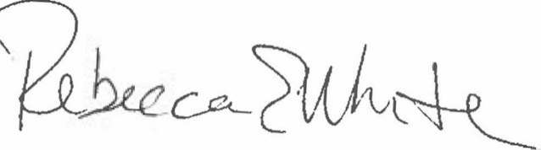  Rebecca E. White,  Director | THE PUBLIC UTILITIES COMMISSION  OF THE STATE OF COLORADO  CONOR F. FARLEY  ________________________________  Administrative Law Judge

