Decision No. R24-0021-I
BEFORE THE PUBLIC UTILITIES COMMISSION OF THE STATE OF COLORADO
PROCEEDING NO. 23D-0371E
IN THE MATTER OF THE CITY AND COUNTY OF DENVER’S PETITION FOR DECLARATORY ORDER REGARDING COMPENSATION FOR 2020-21 SOLAR REWARDS COMMUNITY-BASED PROJECTS.
INTERIM decision OF
ADMINISTRATIVE LAW JUDGE
CONOR F. FARLEY GRANTING UNOPPOSED MOTION FOR EXTENSION TO FILE RESPONSIVE COMMENTS AND WAIVER OF RESPONSE TIME
Mailed Date: January 10, 2024

STATEMENT

Background
- On July 17, 2023, the City and County of Denver (Denver) filed the Petition for Declaratory Order (Petition) that initiated this proceeding. The Petition requests direction on the application of a renewable energy credit (REC) multiplier for community-based projects to Solar*Reward Community incentives under the 2020-2021 Renewable Energy Compliance Plan for Public Service Company of Colorado (Public Service).
- On August 7, 2023, the Commission issued Decision No. C23-0516-I that accepted the Petition, issued notice of the Petition, and set a 30-day intervention period, and referred the proceeding to an Administrative Law Judge (ALJ) by minute entry. The proceeding was subsequently assigned to the undersigned ALJ. The 30-day intervention period ends on September 6, 2023.
- On August 16, 2023, Public Service filed a Notice of Intervention by Right or Alternative Motion for Permissive Intervention (Notice/Alternative Motion).
- On September 6, 2023, Trial Staff of the Commission (Staff) filed a Notice of Intervention as of Right, Entry of Appearance, and Request for Hearing.
- On October 3, 2023, the ALJ issued Decision No. R23-0658-I that, among other things, established a deadline of January 5, 2024 for Responsive Comments.
- On January 3, 2024, Staff filed an Unopposed Motion for Extension to File Responsive Comments and Waiver of Response Time (Unopposed Motion).

Conferral and Conferral Report
- Staff has stated good cause grant the Unopposed Motion. Accordingly, the Unopposed Motion will be granted and the deadline to file Responsive Comments will be extended to January 12, 2024.

ORDER

It Is Ordered That:
- The Unopposed Motion for Extension to File Responsive Comments and Waiver of Response Time filed by Trial Staff of the Commission on January 3, 2024 is granted. The deadline to file Responsive Comments is extended to January 12, 2024.
- This Decision is effective immediately.
(S E A L)    ATTEST: A TRUE COPY  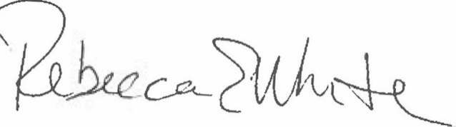  Rebecca E. White,  Director | THE PUBLIC UTILITIES COMMISSION  OF THE STATE OF COLORADO  CONOR F. FARLEY  ________________________________  Administrative Law Judge

