Decision No. R23-0814-I-E
BEFORE THE PUBLIC UTILITIES COMMISSION OF THE STATE OF COLORADO
PROCEEDING NO. 23A-0499CP
IN THE MATTER OF THE APPLICATION OF HER RIDE LLC FOR A CERTIFICATE OF PUBLIC CONVENIENCE AND NECESSITY TO OPERATE AS A COMMON CARRIER BY MOTOR VEHICLE FOR HIRE.
errata notice for
INTERIM DECISION OF
ADMINISTRATIVE LAW JUDGE
Aviv Segev
establishing procedural
schedule and setting hearing
Errata mailed : January 8, 2024
Original Decision No. R23-0814-I mailed December 7, 2023

- On page 4, Decision Paragraph No. 14 states,

On or before December 28, 2023, Her Ride will be required to file and serve on the Invernenors: (a) a list that identifies the witnesses Tour Estes Park intends to call at the hearing, the last known address and telphone number of each witness, and a summary of the anticipated testimony of each witness; and (b) copies of the exhibits Tour Estes Park will present at the hearing, as ordered below.

Decision Paragraph No. 14 shall be amended as follows,

On or before December 28, 2023, Her Ride will be required to file and serve on the Intervenors: (a) a list that identifies the witnesses Her Ride intends to call at the hearing, the last known address and telephone number of each witness, and a summary of the anticipated testimony of each witness; and (b) copies of the exhibits Her Ride will present at the hearing, as ordered below.

- On page 4, Decision Paragraph No. 15 states,

On or before January 18, 2024, Pike Peak will be required to file and serve on the Intervenors: (a) a list that identifies the witnesses Tour Estes Park intends to call at the hearing, the last known address and telephone number of each witness, and a summary of the anticipated testimony of each witness; and (b) copies of the exhibits Tour Estes Park will present at the hearing, as ordered below.

Decision Paragraph No. 15 shall be amended as follows,

On or before January 18, 2024, Pikes Peak will be required to file and serve on the Intervenors: (a) a list that identifies the witnesses Pikes Peak intends to call at the hearing, the last known address and telephone number of each witness, and a summary of the anticipated testimony of each witness; and (b) copies of the exhibits Pikes Peak will present at the hearing, as ordered below.

(S E A L)    ATTEST: A TRUE COPY  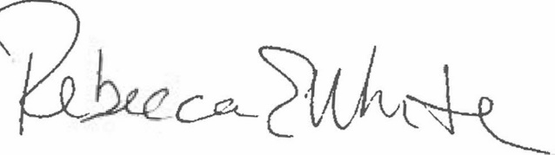  Rebecca E. White,  Director | THE PUBLIC UTILITIES COMMISSION  OF THE STATE OF COLORADO  AVIV SEGEV  ________________________________  Administrative Law Judge

