Decision No. C24-0795
BEFORE THE PUBLIC UTILITIES COMMISSION OF THE STATE OF COLORADO
PROCEEDING NO. 24M-0473W
IN THE MATTER Establishing the Interest Rate on customer depositsto be paid by jurISdictional GAS AND ELECTRIC UTilities for Calendar year 2025.
COMMISSION DECISION SETTING THE INTEREST RATE FOR 2025
Issued Date: November 1, 2024
Adopted Date: October 30, 2024

BY THE COMMISSION

Statement
- Pursuant to Commission Rule 5403 of the Rules Regulating Water, jurisdictional utilities may require a new or existing customer to pay a deposit if billing records are available and records indicate recent or substantial delinquencies. Payment of the deposit shall not relieve the customer of the obligation to pay current bills when due.
- When a jurisdictional electric or gas utility accepts the deposit, it is obligated to pay simple interest on the amount paid at a percentage rate calculated by the Commission Staff in the manner described in Rule 5403(o)(II) of Rules Regulating Water Utilities.
- Provisions of Rule 5403(o)(II) of Rules Regulating Water Utilities require the Commission’s Staff to calculate the customer deposit interest rate equal to the average for the period October 1 through September 30 (of the immediately preceding year) of the 12 monthly average rates of interest expressed in percent per annum, as quoted for one-year United States Treasury constant maturities, as published on the website or publication of the Board of Governors of the Federal Reserve System. This newly calculated simple interest per annum rate is compared to the existing customer deposit rate. If the difference is 25 basis points or more, then the new rate is to be used beginning January 1 of the following year. This provision is applicable as the existing rate for calendar year 2024 is 4.93 percent, and the newly calculated rate for 2025 is 4.93 percent. Accordingly, the newly calculated simple interest per annum rate for electric and gas utilities accepting customer deposits is lower than the 25 basis point differential threshold and a new rate for 2024 is not necessary. Thus, the interest rate on customer deposits for the year 2025 will remain at 4.93 percent.
- If necessary, a utility shall file a new advice letter and tariff on not less than two business days’ notice. The advice letter and tariff shall be filed as a new advice letter proceeding and shall comply with all applicable rules. In calculating the proposed effective date, the date the filing is received at the Commission is not included in the notice period and the entire notice period must expire prior to the effective date. The advice letter and tariff must comply in all substantive respects to this Decision in order to be filed as a compliance filing on shortened notice.

ORDER

The Commission Orders That:
- The simple interest rate on deposits to be paid by jurisdictional electric and gas utilities for the calendar year 2025 shall remain at 4.93 percent.
- To the extent necessary, utilities shall modify their tariffs to comply with this Decision. The compliance filing will be filed as a new advice letter filing and will not be filed in the Proceeding number of this Decision. An advice letter and tariff change may not be required.
- Pursuant to Rule 5403 of the Rules Regulating Water Utilities, utilities failing to file the required compliance filing could be subject to up to a $500.00 fine.
- Additional information concerning required action is set forth in the accompanying notice. If you have any questions, please contact Dipesh Dipu, Chief Rate Financial Analyst, at 303-894-2046 or Dipesh.Dipu@state.co.us.
- This Decision is effective upon its Issued Date.

ADOPTED IN COMMISSIONERS’ WEEKLY MEETING
October 30, 2024.
(S E A L)    ATTEST: A TRUE COPY  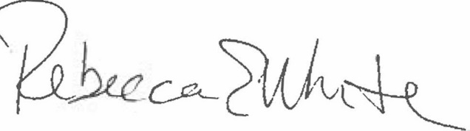  Rebecca E. White,  Director | THE PUBLIC UTILITIES COMMISSION  OF THE STATE OF COLORADO  ERIC BLANK  ________________________________  MEGAN M. GILMAN  ________________________________  TOM PLANT  ________________________________  Commissioners

