Decision No. C24-0435
BEFORE THE PUBLIC UTILITIES COMMISSION OF THE STATE OF COLORADO
PROCEEDING NO. 10A-842R
IN THE MATTER OF THE COLORADO DEPARTMENT OF TRANSPORTATION, AND THE CITY OF COMMERCE CITY FOR AUTHORITY TO WIDEN THE ROADWAY AND CROSSING, INSTALL PEDESTRIAN SIDEWALKS, REMOVE EXISTING FLASHERS AND GATES AND INSTALL NEW APPROACH GATES, RAISED MEDIANS AND FLASHERS, RELOCATE ONE EXISTING RAILROAD CONTROL POINT TO THE NORTH SIDE AND, RELOCATE TWO SWITCHES TO MOVE THE HAZELTINE SIDING TO THE NORTH AT THE CROSSING OF THE UNION PACIFIC RAILROAD TRACK ON STATE HIGHWAY 44 (104TH AVE.) IN CITY OF COMMERCE CITY, ADAMS COUNTY, COLORADO.
commission DECISION granting
motion for extension of time
Issued Date: June 26, 2024
Adopted Date: June 17, 2024

by the commission

Statement
- This matter comes before the Commission for consideration of a Motion for Extension of Time to Install a Queue Cutter Signal (Motion) filed by the City of Commerce City (“Commerce City”) on May 30, 2024, requesting an extension of time to December 31, 2024, to install the queue cutter signal ordered by the Commission in Decision No. C23-0817 mailed December 8, 2023.
- As grounds, Commerce City states that the complexity of the improvements and design required both Commerce City and the Colorado Department of Transportation (“CDOT”) to strictly adhere to their procedures and processes to prepare and approve the required plans. While Commerce City and CDOT have been working diligently to meet the June 30, 2024 deadline, the complexity of the necessary improvements, including the railroad preemption design, railroad signal design, CDOT permitting and railroad permitting, the completion of the project is taking longer than is typical. Commerce City requests an additional extension of time to December 31, 2024, to complete the construction and provide the letter of completion required by the Commission.
- No responses to the Motion were received.
- Now being fully advised in the matter, we grant the Motion.

ORDER

The Commission Orders That:
- The Motion for Extension of Time to Install a Queue Cutter Signal (“Motion”) filed by the City of Commerce City (“Commerce City”) on May 30, 2024, requesting an extension of time to December 31, 2024, to install the queue cutter signal ordered by the Commission in Decision No. C23-0816 mailed December 8, 2023, is granted.
- Commerce City shall file a letter of project completion in this proceeding by December 31, 2024.
- This Decision is effective on its Issued Date.

ADOPTED IN COMMISSIONERS’ WEEKLY MEETING
June 17, 2024.
(S E A L)    ATTEST: A TRUE COPY  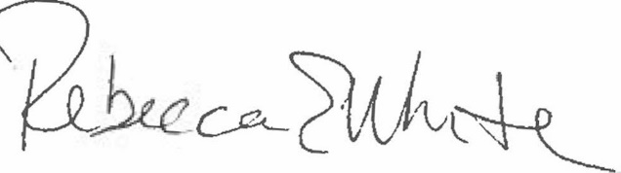  Rebecca E. White,  Director | THE PUBLIC UTILITIES COMMISSION  OF THE STATE OF COLORADO  ERIC BLANK  ________________________________  MEGAN M. GILMAN  ________________________________  TOM PLANT  ________________________________  Commissioners

