C24-0310-EDecision No. C24-0310-E
BEFORE THE PUBLIC UTILITIES COMMISSION OF THE STATE OF COLORADO
24A-0135TPROCEEDING NO. 24A-0135T
IN THE MATTER OF JOINT APPLICATION OF CBTS BORROWER, LLC, CINCINNATI BELL INC., AND CBTS TECHNOLOGY SOLUTIONS LLC, FOR APPROVAL OF THE PROPOSED TRANSFER OF INDIRECT CONTROL OF CBTS TECHNOLOGY SOLUTIONS LLC TO CBTS BORROWER, LLC.
ERRATA NOTICE FOR
COMMISSION DECISION DEEMING APPLICATION COMPLETE AND GRANTING APPLICATION
Errata Mailed: May 10, 2024
Original Decision No. C24-0310-I Mailed: May 7, 2024

- The first sentence in Decision paragraph no. 17 on page 4 of this Decision reads as follows:
17. We find that the proposed indirect transfer of control of CBTS-TS to Concept Communications is not contrary to the public interest and therefore grant the Joint Application for transfer to that extent.
The first sentence in Decision paragraph no. 17 is amended to read as follows:
17. We find that the proposed indirect transfer of control of CBTS-TS to CBTS Borrower is not contrary to the public interest and therefore grant the Joint Application for transfer to that extent.
(S E A L)    ATTEST: A TRUE COPY  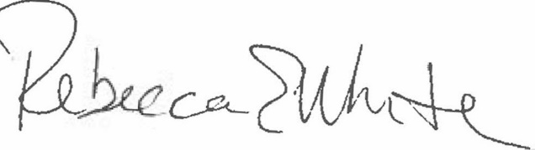  Rebecca E. White,  Director | THE PUBLIC UTILITIES COMMISSION  OF THE STATE OF COLORADO  REBECCA E. WHITE  ________________________________  Director

