Decision No. C24-0270
BEFORE THE PUBLIC UTILITIES COMMISSION OF THE STATE OF COLORADO
PROCEEDING NO. 24A-0090R
IN THE MATTER OF THE APPLICATION OF CITY OF COLORADO SPRINGS FOR AUTHORITY TO REPLACE AN EXISTING OVERPASS (US DOT NO. 253-I I4L) IN THE CITY OF COLORADO SPRINGS, EL PASO COUNTY, STATE OF COLORADO.
COMMISSION DECISION DEEMING APPLICATION COMPLETE AND GRANTING APPLICATION
Mailed Date: April 24, 2024
Adopted Date: April 17, 2024

by the commission

Statement
- This matter comes before the Commission for consideration of an application (Application) filed by the City of Colorado Springs (Colorado Springs) and El Paso County (Collectively Joint Applicants) on February 22, 2024, requesting authority to replace the existing bridge structures of the grade separated crossing of South Circle Drive over the tracks of the BNSF Railway Company (BNSF) and the Union Pacific Railroad Company (UPRR) at railroad milepost 78.84 of the BNSF Colorado Springs Subdivision, National Inventory No. 253114L in Colorado Springs, El Paso County, in the State of Colorado.
- Notice of the Application was provided by the Commission to all interested parties, including adjacent property owners pursuant to § 40-6-108(2), C.R.S., on
March 4, 2024.
- There were no interventions filed in this matter.
- The Commission has reviewed the record in this matter and deems that the Application is complete within the meaning of § 40-6-109.5, C.R.S.
- Now being fully advised in the matter, we grant the Application.

Findings of Fact
- The Commission gave notice to all interested parties, including the adjacent property owners. No intervention was received opposing the Application.
- The Joint Applicants propose to replace the bridge structures of South Circle Drive over the tracks of the BNSF and UPRR in Colorado Springs. The replacement bridge structures are proposed to be three-span structures over the existing tracks of the BNSF and UPRR. The length of the structures are 356’-6” from back face of abutment to back face of abutment. The structures have a minimum vertical clearance of 21’-6” and a minimum horizontal clearance of 21’-1/8” from the centerline of track to the face of the base of Pier 2. Each structure is 43’-0” out to out and accommodates two 11’-0” lanes, two 4’-0” shoulders, one 10’-0” sidewalk, and two 1’-6” bridge rail Type 9 with chain link fence. The proposed minimum clearances meet or exceed the clearances required by Commission Rules 4 Code of Colorado Regulations (CCR) 723-7-7324 and 7345 of the Commission’s Rules Regulating Railroads, Rail Fixed Guideways, Transportation by Rail, and Rail Crossings.
- The Joint Applicants state that the current train traffic volumes under the bridge structures are approximately 20 trains per day based on US DOT Inventory information for a nearby at-grade crossing near the South Circle Drive grade separated crossing traveling at a maximum timetable speed of 40 miles per hour (MPH). The current traffic volumes using South Circle Drive are 36,000 vehicles per day (VPD) traveling at a posted speed limit of 45 MPH with an estimated increase to 39,000 VPD in five years and 48,000 VPD in 20 years.
- The Joint Applicants estimate the cost of the project at $36,808,875.45 with Colorado Springs paying for the 100 percent of the cost of the project.
- The Joint Applicants propose to start work on the project November 13, 2023, and be completed by December 31, 2025. The Joint Applicants will be required to file a copy of the signed Construction and Maintenance Agreements for this project prior to starting any work over the railroads. For tracking purposes, we will expect these signed agreements to be filed by June 30, 2024, prior to the start of work over the railroads. The Commission will also expect the Joint Applicants to inform the Commission in writing that construction of the bridge replacements are complete and operational within ten days of completion. The Commission will expect this letter by December 31, 2025. However, the Commission does understand this letter may be provided earlier or later than this date depending on changes or delays to the construction schedule.

Conclusions
- The Commission has jurisdiction in this matter under §§ 40-4-106(2)(a) and (3)(a), C.R.S.
- No intervenor that filed a petition to intervene or other pleading contests or opposes the Application.
- Because the Application is unopposed, the Commission finds that it will determine this matter upon the record, without a formal hearing under § 40-6-109(5), C.R.S., and Rule 1403, 4 CCR 723-1 of the Commission’s Rules of Practice and Procedure.
- We find that good cause exists to grant the Application consistent with the above discussion.

ORDER

The Commission Orders That:
- The application (Application) filed by the City of Colorado Springs (Colorado Springs) and El Paso County (Collectively Joint Applicants) on February 22, 2024, requesting authority to replace the existing bridge structures of the grade separated crossing of South Circle Drive over the tracks of the BNSF Railway Company (BNSF) and the Union Pacific Railroad Company (UPRR) at railroad milepost 78.84 of the BNSF Colorado Springs Subdivision, National Inventory No. 253114L in Colorado Springs, El Paso County, in the State of Colorado is deemed complete within the meaning of § 40-6-109.5, C.R.S.
- The Application is granted.
- The Joint Applicants are authorized and ordered to proceed with the replacement of the South Circle Drive bridge structure in Colorado Springs, Colorado.
- The Joint Applicants shall be required to file a copy of the signed Construction and Maintenance Agreements for this project prior to starting any work over the railroads by June 30, 2024.
- The Joint Applicants shall inform the Commission in writing when the bridge replacement is complete and operational within ten days of completion. The Commission will expect this letter by December 31, 2025. However, the Commission understands this letter may be provided earlier or later than this date depending on changes or delays to the construction schedule.
- The 20-day period provided for in § 40-6-114, C.R.S., within which to file applications for rehearing, reargument, or reconsideration, begins on the first day following the effective date of this Decision.
- The Commission retains jurisdiction to enter further decisions as necessary.
- This Decision is effective on its Mailed Date.

ADOPTED IN COMMISSIONERS’ WEEKLY MEETING
April 17, 2024.
(S E A L)    ATTEST: A TRUE COPY  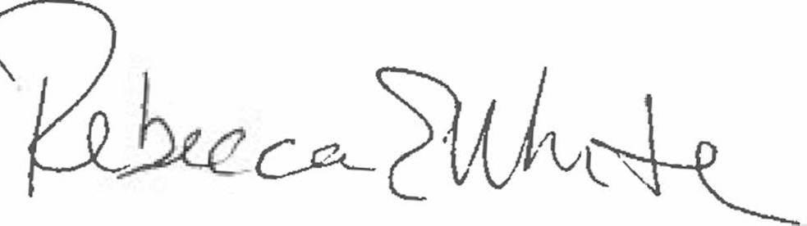  Rebecca E. White,  Director | THE PUBLIC UTILITIES COMMISSION  OF THE STATE OF COLORADO  ERIC BLANK  ________________________________  MEGAN M. GILMAN  ________________________________  Commissioners  COMMISSIONER TOM PLANT  ABSENT

