Decision No. C24-0088E-E
BEFORE THE PUBLIC UTILITIES COMMISSION OF THE STATE OF COLORADO
PROCEEDING NO. 23A-0627T
IN THE MATTER OF THE APPLICATION OF INTREPID COHORT 1 LLC FOR A CERTIFICATE OF PUBLIC CONVENIENCE AND NECESSITY TO PROVIDE PART IV TELECOMMUNICATIONS SERVICES (4 CCR 723-2-2103).
SECOND ERRATA NOTICE FOR
COMMISSION DECISION DEEMING APPLICATION COMPLETE AND granting APPLICATION
WITH CONDITIONS
Second Errata mailed February 28, 2024
First Errata mailed February 22, 2024
Original Decision No. C24-0088 mailed February 15, 2024

- The Errata for Decision No. C24-0088-E filed on February 22, 2024, referenced an entity not listed in this proceeding. The Ordering Paragraph No. 1 for Decision No. C24-0088-E was incorrectly Amended to reads as follows:
- INFINITI’s Application for designation as a Lifeline-only Eligible Telecommunications Carrier (ETC) filed on December 27, 2024, is deemed complete within the meaning of § 40-6-109.5, C.R.S., and is granted.
Ordering Paragraph No. 1 is now further Amended to read as follows:
- Intrepid Cohort 1 LLC’s Application for a Certificate of Public Convenience and Necessity to provide wholesale Part IV services statewide is granted with the conditions included herein, and is deemed complete within the meaning of § 40-6-109.5, C.R.S.
(S E A L)    ATTEST: A TRUE COPY  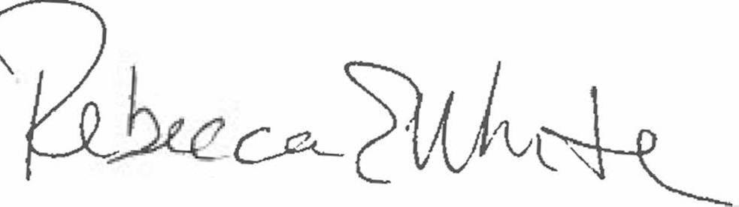  Rebecca E. White,  Director | THE PUBLIC UTILITIES COMMISSION  OF THE STATE OF COLORADO  REBECCA E. WHITE  ________________________________  Director

