Decision No. C24-0088-E
BEFORE THE PUBLIC UTILITIES COMMISSION OF THE STATE OF COLORADO
PROCEEDING NO. 23A-0627T
IN THE MATTER OF THE APPLICATION OF INTREPID COHORT 1 LLC FOR A CERTIFICATE OF PUBLIC CONVENIENCE AND NECESSITY TO PROVIDE PART IV TELECOMMUNICATIONS SERVICES (4 CCR 723-2-2103).
ERRATA NOTICE FOR
COMMISSION DECISION DEEMING APPLICATION COMPLETE AND granting APPLICATION
WITH CONDITIONS
Errata mailed February 22, 2024
Original Decision No. C24-0088 mailed February 15, 2024

- Ordering Paragraph No. 1 currently reads as follows:
- INFINITI’s Application for designation as a Lifeline-only Eligible Telecommunications Carrier (ETC) is granted.
Ordering Paragraph No. 1 is Amended to read as follows:
- INFINITI’s Application for designation as a Lifeline-only Eligible Telecommunications Carrier (ETC) filed on December 27, 2023, is deemed complete within the meaning of § 40-6-109.5, C.R.S., and is granted.
(S E A L)    ATTEST: A TRUE COPY  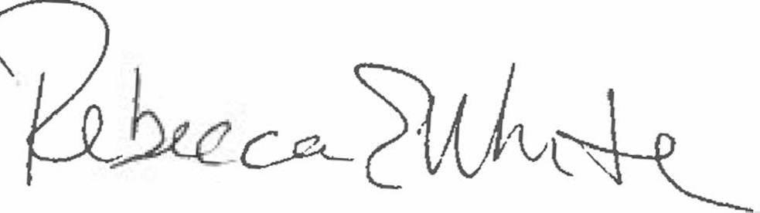  Rebecca E. White,  Director | THE PUBLIC UTILITIES COMMISSION  OF THE STATE OF COLORADO  REBECCA E. WHITE  ________________________________  Director

