Decision No. C24-0047-I-E
BEFORE THE PUBLIC UTILITIES COMMISSION OF THE STATE OF COLORADO
PROCEEDING NO. 23A-0597R
IN THE MATTER OF THE APPLICATION OF THE COLORADO DEPARTMENT OF TRANSPORTATION, ON BEHALF OF BOULDER COUNTY, FOR AUTHORITY TO RELOCATE AN EXISTING AT-GRADE HIGHWAY RAIL AND ADD FLASHING LIGHT SIGNALS, GATES, BELLS, CONSTANT WARNING TIME CIRCUITRY, AND NEW SIGNAL CABIN, AT THE COLORADO STATE HIGHWAY 52 (DOT# 244-831K) CROSSING OF TRACKS OWNED BY BNSF RAILWAY, IN BOULDER COUNTY, STATE OF COLORADO.
errata notice for
interim commission decisioN
DEEMING APPLICATION COMPLETE, approving plans, and requiring additional filings
Errata mailed January 26, 2024
Original Decision No. C24-0047-I mailed January 24, 2024

- Statement Paragraph No. 6 currently reads as follows:
Now being fully advised in the matter, we grant the Application.
Statement Paragraph No. 6 is Amended to read as follows:
Now being fully advised in the matter, we approve the preliminary plans and require additional filings to be made.

(S E A L)    ATTEST: A TRUE COPY  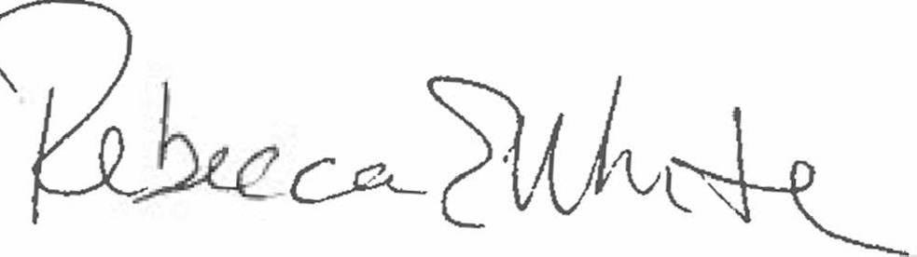  Rebecca E. White,  Director | THE PUBLIC UTILITIES COMMISSION  OF THE STATE OF COLORADO  REBECCA E. WHITE  ________________________________  Director

