Decision No. R23-0679-I-E
BEFORE THE PUBLIC UTILITIES COMMISSION OF THE STATE OF COLORADO
PROCEEDING NO. 23F-0418G
ARM, LLC, and HEARTLAND INDUSTRIES, LLC,

COMPLAINANTS,

V.

COLORADO NATURAL GAS, INC. and WOLF CREEK ENERGY, LlC,

RESPONDENTS.
ERRATA NOTICE FOR
interim decision OF
ADMINISTRATIVE LAW JUDGE
CONOR F. FARLEY
SCHEDULING REMOTE
PREHEARING CONFERENCE AND
requiring parties to confer and COMPLAINANTS TO file a report REGARDING THE CONFERRAL before the REMOTE prehearing conference
Errata mailed October 25, 2023
Original Decision No. R23-0679-I mailed October 11, 2023

- Ordering Paragraph No. 1 states:
The parties in this proceeding are Arm, LLC and Heartland Industries, LLC (collectively, Complainants) filed a Formal Complaint against Colorado Natural Gas, Inc. and
Wolf Creek Energy, LLC.
Ordering Paragraph No. 1 is amended to read as follows:
The parties in this proceeding are ARM, LLC, Heartland Industries, LLC (collectively, Complainants), Colorado Natural Gas, Inc., Wolf Creek Energy, LLC, Trial Staff of the Colorado Public Utilities Commission, and the Office of the Utility Consumer Advocate.
(S E A L)    ATTEST: A TRUE COPY  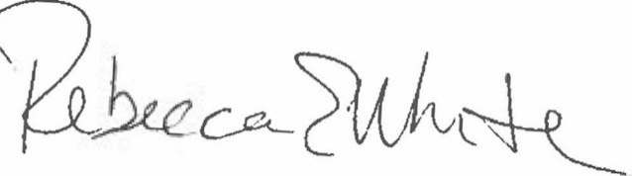  Rebecca E. White,  Director | THE PUBLIC UTILITIES COMMISSION  OF THE STATE OF COLORADO  CONOR F. FARLEY  ________________________________  Administrative Law Judge

