Decision No. R23-0658-I
BEFORE THE PUBLIC UTILITIES COMMISSION OF THE STATE OF COLORADO
PROCEEDING NO. 23D-0371E
IN THE MATTER OF THE CITY AND COUNTY OF DENVER’S PETITION FOR DECLARATORY ORDER REGARDING COMPENSATION FOR 2020-2021 SOLAR REWARDS COMMUNITY-BASED PROJECTS.
INTERIM decision OF
ADMINISTRATIVE LAW JUDGE
CONOR F. FARLEY
ADOPTING SCHEDuLE AND VACATING REMOTE PREHEARING CONFERENCE
Mailed Date: October 3, 2023

STATEMENT

Background
- On July 17, 2023, the City and County of Denver (Denver) filed the Petition for Declaratory Order (Petition) that initiated this proceeding. In the Petition, Denver requests direction on the application of a renewable energy credit multiplier for community-based projects to Solar*Reward Community incentives under the 2020-2021 Renewable Energy Compliance Plan for Public Service Company of Colorado (Public Service).
- On August 7, 2023, the Commission issued Decision No. C23-0516-I that accepted the Petition, issued notice of the Petition, set a 30-day intervention period, and referred the proceeding to an Administrative Law Judge (ALJ). The proceeding was subsequently assigned to the undersigned ALJ. The 30-day intervention period ended on September 6, 2023.
- On August 16, 2023, Public Service filed a Notice of Intervention by Right or Alternative Motion for Permissive Intervention (Notice/Alternative Motion).
- On September 6, 2023, Trial Staff of the Commission filed a Notice of Intervention as of Right, Entry of Appearance, and Request for Hearing.
- On September 15, 2023, the ALJ issued Decision No. R23-0615-I that scheduled a remote prehearing conference and required the parties to confer regarding a schedule for this proceeding and for Denver to file a conferral report by September 27, 2023.
- On September 27, 2023, Denver filed the Conferral Report.

Conferral Report
- In the Conferral Report, Denver reported that the parties agree that an evidentiary hearing is unnecessary because “the questions presented by the Petition are legal determinations for the ALJ, as opposed to factual determinations.” The parties jointly propose the following schedule:
Event | Deadline
Initial Comments (All Parties) | December 8, 2023
Responsive Comments (All Parties) | January 5, 2024
Deadline to File Joint Motion to Vacate Oral Argument | January 25, 2024
Oral Argument | February 1, 2024

- The parties’ proposed schedule is acceptable and will be adopted.

Remote Prehearing Conference
- The Conferral Report adequately addresses the issues that would have been addressed at the remote prehearing conference. As a result, there is no need to hold the remote prehearing conference and it shall be vacated.

ORDER

It Is Ordered That:
- The schedule in paragraph 7 above is adopted.
- The remote prehearing conference scheduled for October 4, 2023, is vacated.
- This Decision is effective immediately.
(S E A L)    ATTEST: A TRUE COPY  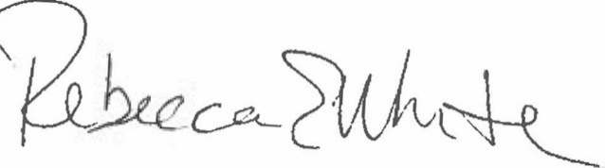  Rebecca E. White,  Director | THE PUBLIC UTILITIES COMMISSION  OF THE STATE OF COLORADO  CONOR F. FARLEY  ________________________________  Administrative Law Judge

Conferral Report at 2 (¶ 4).

