Decision No. R23-0244-I
BEFORE THE PUBLIC UTILITIES COMMISSION OF THE STATE OF COLORADO
PROCEEDING NO. 23F-0170EG
Paul Hilton,

Complainant,

v,

Black Hills Energy,

Respondent.
interim decision OF
ADMINISTRATIVE LAW JUDGE
CONOR F. FARLEY
prohibiting discontinuance of service
Mailed Date: April 11, 2023

STATEMENT
- On April 7, 2023, Complainant Paul Hilton filed a Complaint against Black Hills Energy (Black Hills). Mr. Hilton alleges that Black Hills has improperly demanded payment for utility services and has threatened to disconnect Mr. Hilton’s utility service unless he pays the improperly demanded amount.
- The Commission has the authority to prohibit discontinuance of service pending resolution of a proceeding involving a dispute over utility charges upon such terms as the Commission deems reasonable, including the requirement that the Complainants post a bond. See Rules Regulating Electric Utilities, 4 Code of Colorado Regulations (CCR)
723-3-3408(c)(X) and 4 CCR 723-4-4408(c)(X).
- In the Complaint, Mr. Hilton alleges that a complicated series of transactions involving multiple accounts, some of which Mr. Hilton contends are not his accounts, have led to the current situation in which Black Hills is threatening to disconnect Mr. Hilton’s service. While Mr. Hilton has not filed a motion requesting that Black Hills be prohibited from disconnecting his utility service during the pendency of this proceeding, the ALJ construes the Complaint as containing such a request.
- The Complaint establishes sufficient grounds for prohibiting Black Hills from discontinuing utility service. The foregoing relief will be conditioned upon Mr. Hilton keeping current with future charges incurred for utility services provided by Black Hills. If Mr. Hilton does not meet this condition, Black Hills can file an appropriate motion requesting the modification of the relief granted in this Decision.

ORDER

It Is Ordered That:
- Black Hills Energy (Black Hills) shall not discontinue utility service to Paul Hilton at service address 901 Maple Ave., Rocky Ford, CO 81067, pending resolution of this proceeding or further order of the Commission.
- The order prohibiting discontinuance of utility service set forth in ordering paragraph no. 1 above is conditioned upon Mr. Hilton keeping current with charges incurred for future utility services provided by Black Hills at 901 Maple Ave., Rocky Ford, CO 81067.
- If the condition of the relief granted in ordering paragraph 2 is not met, Black Hills may file an appropriate motion seeking to modify the relief granted herein.
- This Order shall be effective immediately.
(S E A L)    ATTEST: A TRUE COPY  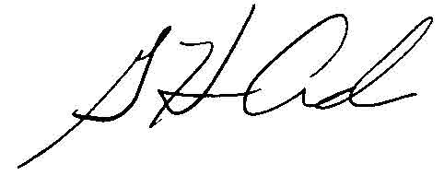  G. Harris Adams,  Interim Director | THE PUBLIC UTILITIES COMMISSION  OF THE STATE OF COLORADO  CONOR F. FARLEY  ________________________________  Administrative Law Judge

