Decision No. R23-0179-I
BEFORE THE PUBLIC UTILITIES COMMISSION OF THE STATE OF COLORADO
PROCEEDING NO. 22AL-0483E
IN THE MATTER OF ADVICE LETTER NO. 834 FILED BY BLACK HILLS COLORADO ELECTRIC, LLC DOING BUSINESS AS BLACK HILLS ENERGY TO INCREASE THE TRANSMISSION COST ADJUSTMENT RIDER, TO BECOME EFFECTIVE JANUARY 1, 2023.
ERRATA NOTICE FOR
Interim Decision of
Administrative Law Judge
Aviv Segev
SUSPENDING the EFFECTIVE
DATE OF TARIFF SHEETS, ESTABLISHING SCHEDULE, ASSIGNING EXHIBIT NUMBER BLOCKS, AND SCHEDULING REMOTE HEARING
Errata mailed March 17, 2023
Original Decision No. R23-0179-I mailed March 15, 2023

- The Original Ordering Paragraph 3 reflects the remote hearing date of May 5-6, 2023: Order Paragraph 3 shall be amended to read as follows:
A remote hearing is scheduled as follows:
DATE: May 18-19, 2023
TIME: 9:00 a.m. to 5:00 a.m., daily
WEBCAST: Commission Hearing Room B
METHOD: Join by video conference using Zoom at the link to be provided in an email from the Administrative Law Judge OR Commission Staff

(S E A L)    ATTEST: A TRUE COPY  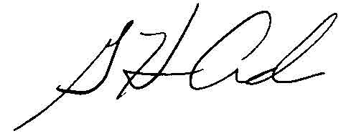  G. Harris Adams,  Interim Director | THE PUBLIC UTILITIES COMMISSION  OF THE STATE OF COLORADO  G. HARRIS ADAMS  ________________________________  Interim Director

Additional information about the Zoom platform and how to use the platform are available at: https://zoom.us/. All are strongly encouraged to participate in a test meeting prior to the scheduled hearing. See https://zoom.us/test.

