Decision No. R20-0328-I
BEFORE THE PUBLIC UTILITIES COMMISSION OF THE STATE OF COLORADO
PROCEEDING NO. 20A-0063E
IN THE MATTER OF the APPLICATION OF PUBLIC SERVICE COMPANY OF COLORADO FOR A CERTIFICATE OF PUBLIC CONVENIENCE AND NECESSITY FOR THE GREENWOOD TO DENVER TERMINAL 230 KV TRANSMISSION PROJECT ASSOCIATED WITH THE COLORADO ENERGY PLAN, ASSOCIATED FINDINGS OF NOISE AND MAGNETIC FIELD REASONABLENESS, AND UPRATE PROJECTS.
INTERIM DECISION OF
ADMINISTRATIVE LAW JUDGE
Steven H. Denman
On INTERVENTIONS, ScheDuling
a remote prehearing
conference, AND GIVING ADVISEMENTS
Mailed Date: May 1, 2020

TABLE OF CONTENTS
I. STATEMENT 2
A. Procedural History. 2
II. FINDINGS AND CONCLUSIONS 5
A. Further Extension of the Decision Deadline. 5
B. Interventions. 6
C. Prehearing Conference. 7
D. Other Advisements. 11
E. Instructions for Participating in the Remote Prehearing Conference 12
1. Instructions for Participating by Telephone 13
2. Instructions for Participating by Computer 13
3. Instructions for Observing the Prehearing Conference 19
III. ORDER 20
A. It Is Ordered That: 20

STATEMENT

Procedural History.
- On February 21, 2020, Public Service Company of Colorado (Public Service or the Company) filed with the Colorado Public Utilities Commission (Commission), a Verified Application (Application) for a Certificate of Public Convenience and Necessity (CPCN) requesting that the Commission grant the Application and: (1) issue a CPCN for construction of the Greenwood to Denver Terminal 230 kV Transmission Project (GDT Project) and three transmission line uprate projects; (2) grant a presumption of prudence for the costs of the Project and transmission line uprate projects; and (3) find that the associated noise and magnetic field levels that the Company estimates will result from operating the GDT Project are reasonable by rule and require no further mitigation.
- The GDT Project includes: (1) installing approximately 15 miles of new 230 kV transmission facilities located in existing rights-of-way originating at the existing Greenwood Substation located in the southeastern Denver Metro area, and terminating at the Denver Terminal Substation located on the west side of the City of Denver’s city center; and (2) modifications to the existing Greenwood, Arapahoe, and Denver Terminal Substations to accommodate the new 230 kV circuit, including an expansion of the Denver Terminal Substation. The Company also plans to perform minor uprates to three existing transmission lines by modifying termination equipment within existing substations.
- In the Application, Public Service asserts that the GDT Project and transmission line uprates are needed to implement the Colorado Energy Plan Portfolio (CEPP) approved by the Commission in Decision No. C18-0761 in Proceeding No. 16A-0396E (i.e., the Company’s 2016 Electric Resource Plan (ERP) proceeding). Public Service estimates that the construction of the Project using the preferred approach will cost approximately $50.1 million with an additional $1.8 million for the three transmission line uprate projects, both components plus or minus 20 percent.
- Public Service explains that in Decision No. C18-0761, the Commission approved the CEPP following a competitive resource solicitation process implemented by Public Service to meet its resource needs through 2023. In approving the CEPP, the Commission granted Public Service a presumption of prudence regarding future actions to pursue these new resources, but also directed the Company to file for CPCNs for related projects and investments. In Paragraph 133 of Decision No. C18-0761, the Commission directed Public Service to:
… file a CPCN application for ... the additional transmission investment identified in the 120-Day Report for the Pueblo area that is part of the $204 million total transmission investment associated with the CEP Portfolio. The application for the CPCNs shall be filed pursuant to Rule 4 CCR 723-3-3102.

- According to Public Service, while the GDT Project is not located in the Pueblo area, it comprises part of the transmission investment associated with the CEPP as identified in the 2016 ERP 120-Day Report and discussed in Decision No. C18-0761. In addition to the network upgrades that are the subject of this CPCN Application, the total transmission
- investment associated with the CEPP includes two other categories of transmission investment, as initially described in the 120-Day Report, including: (1) voltage control facilities for which Public Service filed a CPCN Application on December 20, 2019 (Proceeding No. 19A-0728E), and (2) interconnection facilities (i.e., Badger Hills switching station located in the Pueblo area and other switching stations/substations necessary to interconnect CEPP generation facilities), which Public Service says will be the subject of a future CPCN Application, likely to be filed after the Commission has issued a final decision in the Company’s ongoing ERP Amendment filing (Proceeding No. 19A-0530E).
- Along with the Application, Public Service filed the supporting testimony and attachments of three witnesses. First, Thomas W. Green, Consulting Engineer, Xcel Energy Services Inc. (XES), testifies regarding the need for the GDT Project and provides a detailed description of the GDT Project, transmission line uprates, and the system benefits they will provide. Second, Stanley (Parker) Wrozek, Senior Manager, Transmission Engineering with XES, Wrozek addresses details of the transmission line design associated with the GDT Project, presents the results of the noise and magnetic field analyses for the GDT Project, and discusses the GDT Project’s estimated costs and construction timeline. Third, Carly R. Rowe, Manager, Siting and Land Rights with XES, describes the siting, permitting, and land rights associated with the GDT Project, discusses the public outreach activities that have occurred or are planned to occur, and explains the land use cost estimates associated with the GDT Project.
- On February 24, 2020, the Commission issued a Notice of Application Filed (Notice) establishing deadlines for the filing of intervention pleadings. Interested persons were to file motions to intervene within 30 days, or no later than March 25, 2020. Commission Staff had seven additional days to file a notice of intervention of right. The Notice observed that Public Service had filed testimony with the Application and was seeking a Commission decision within 120 days.
- During the Commission’s weekly meeting held on April 1, 2020, the Application was deemed complete for purposes of § 40-6-109.5, C.R.S. (2019), and was referred to an Administrative Law Judge (ALJ) for disposition. Subsequently the undersigned ALJ was assigned to preside over this Proceeding.

FINDINGS AND CONCLUSIONS

Further Extension of the Decision Deadline.
- As noted above, Public Service filed supporting direct testimony and attachments with its Application. Pursuant to § 40-6-109.5(1), C.R.S. (2019), when supporting testimony is filed with an application, the Commission’s initial decision is due within 120 days after the application is deemed complete, or in this proceeding no later than July 30, 2020. Moreover, a recent amendment to § 40-6-109.5(1), C.R.S. (2019), provides further that: “If the commission
- finds that additional time is required, it may, by separate order, extend the time for decision by an additional period not to exceed one hundred thirty days.” (Emphasis added.)
- A procedural schedule has not yet been proposed or adopted in this Proceeding. Considering the Application, the time available under the 120-day timeline, the time necessary for the ALJ to address other pending matters, and the need for the Commission to have adequate time to deliberate the issues presented in this matter, it is not feasible for the Commission
to issue a final decision on the Application by July 30, 2020. Therefore, pursuant to
§ 40-6-109.5(1), C.R.S. (2019), the ALJ will exercise his sound discretion to extend the decision deadline by this separate order for an additional 130 days, that is for a maximum period of 250 days or until December 7, 2020.

Interventions.
- No motions for permissive intervention, pursuant to Rule 1401(c) of the Rules of Practice and Procedure, 4 Code of Colorado Regulations (CCR) 723-1, were filed by the March 25, 2020 deadline.
- Rule 1401(b) of the Rules of Practice and Procedure, 4 CCR 723-1, governs interventions as of right and states in pertinent part: “A notice of intervention as of right, unless filed by Commission staff, shall state the basis for the claimed legally protected right that may be affected by the proceeding.”
- On March 17, 2020, Trial Staff of the Colorado Public Utilities Commission (Staff) filed a Notice of Intervention as of Right by Staff, Entry of Appearance, Notice Pursuant to Rule 1007(a) and Rule 1401, and Request for Hearing (Staff’s Intervention). Staff’s
- Intervention is of right and identifies three specific issues it will raise and address in this Proceeding.
- Staff’s intervention as of right is acknowledged.
- On March 25, 2020, the Colorado Office of Consumer Counsel (OCC) filed a Notice of Intervention of Right, Request for Hearing, and Entry of Appearance. OCC says it intervenes to determine if Public Service’s Application for a CPCN for the GDT Project is just and reasonable and in the public interest. OCC’s Intervention is of right and identifies three issues it may address regarding the Application.
- OCC’s Intervention as of right is acknowledged.
- Both Staff and OCC request an evidentiary hearing on the Application.
- The Parties to this Proceeding are Public Service, Staff, and OCC.

Prehearing Conference.
- In anticipation of scheduling an evidentiary hearing, the ALJ will schedule a prehearing conference, in accordance with Rule 1409(a) of the Rules of Practice and Procedure, 4 CCR 723-1. A prehearing conference, via video platform, will be scheduled for May 15, 2020 at 10:00 a.m.
- Holding the prehearing conference remotely is consistent with current public health orders and advisories to prevent the spread of coronavirus (COVID-19) in Colorado. The
- Parties may not appear at the Commission in person to attend the prehearing conference. Instead, Parties and their counsel shall appear at the prehearing conference from remote locations, either by video conference, or by telephone, using the link and instructions provided in this Decision. The ALJ encourages the Parties and their counsel to attend by video conference.
- At the prehearing conference, the Parties must be prepared to discuss: (a) the date by which each intervenor will file answer testimony and attachments; (b) the date by which Public Service will file rebuttal testimony and attachments; (c) the date by which each intervenor may file cross-answer testimony and attachments; (d) the date by which each party will file corrected testimony and attachments; (e) the date by which each party will file prehearing motions, other than motions relating to discovery, but including any dispositive motions, motions in limine, or motions to strike; (f) whether a final prehearing conference is necessary and, if it is, the date for that prehearing conference; (g) the date by which the parties will file any stipulations or a settlement agreement; (h) the date(s) for the evidentiary hearing, including a statement of how many days the parties will need to try this case; and (i) the date by which each party will file its post-hearing statement of position (statements of position will be simultaneous and no responses will be permitted).
- The following page limits on statements of position will be imposed: The statement of position to be filed by Public Service may not exceed 60 pages in length, exclusive of a table of contents and appendices; the statement of position to be filed by each intervenor may not exceed 30 pages in length, exclusive of a table of contents and appendices. If the intervenors file joint statements of position, the foregoing 30-page limit will apply to all joint statements of position.
- Absent a waiver of the decision deadline pursuant to § 40-6-109.5(3), C.R.S. (2019), or a further extension of the deadline pursuant to § 40-6-109.5(4), C.R.S. (2019), the Commission decision in this Proceeding must issue no later than December 7, 2020. To allow time for statements of position, the recommended decision, exceptions, responses to exceptions, and a Commission decision on exceptions, the evidentiary hearing in this matter must be concluded no later than July 24, 2020.
- At the prehearing conference, the Parties must be prepared to discuss any matter pertaining to discovery if the procedures and timeframes contained in Rule 1405, 4 CCR 723-1 are not sufficient.
- At the prehearing conference, the Parties must be prepared to discuss any matter pertaining to the treatment of information claimed to be confidential if the procedures and timeframes contained in Rules 1100 and 1101, 4 CCR 723-1, are not adequate. This discussion will include the treatment of additional information for which extraordinary protection may be sought, assuming that there may be such additional information.
- At the prehearing conference, the Parties must be prepared to discuss whether the presentation of evidence at the hearing should be done through electronic exhibits to the fullest extent possible, with the exception of exhibits to be used for impeachment or rebuttal.
- At the prehearing conference, a party may raise any additional issues relevant to this Proceeding.
- The Parties must consult prior to the prehearing conference with respect to the matters to be discussed at the prehearing conference and are encouraged to present, if possible, a consensus procedural schedule and hearing date(s) that are acceptable to all Parties. The ALJ will order Public Service to coordinate these discussions.
- If the Parties are able to reach agreements on a consensus procedural schedule, hearing date(s), and the other procedural matters addressed in this Decision, the ALJ encourages Public Service to make a filing no later than May 11, 2020, stating those agreements. If the prehearing conference is not needed, it may be vacated in another interim decision. Alternatively, the Company may present a consensus procedural schedule, hearing date(s), and the other procedural matters at the prehearing conference.
- The parties are advised, and are on notice, that the ALJ will deem a Party’s failure to appear or to participate in the prehearing conference to be a waiver of that Party’s objection to the rulings made, the procedural schedule established, and the hearing dates scheduled during the prehearing conference.

Other Advisements.
- The Parties are advised that an order may issue requiring that the presentation of evidence at the hearing shall be done through electronic exhibits to the fullest extent possible, with the exception of exhibits to be used for impeachment or rebuttal.
- The Parties are advised, and are on notice, that they must be familiar with, and strictly abide by, the Rules of Practice and Procedure, 4 CCR 723 Part 1. These Rules are available on-line at www.dora.colorado.gov\puc and in hard copy format from the Commission.
- At this point in the Proceeding, all Parties are represented by counsel. The ALJ calls counsels’ attention to the requirement of Rule 1202(d), 4 CCR 723-1, that, “[e]very pleading of a party represented by an attorney shall be signed by the attorney, and shall state the attorney’s address, telephone number, e-mail address, and attorney registration number.” (Emphasis supplied.) The Parties are advised, and are on notice, that filings must comply with this requirement and with the other requirements found in the Commission’s rules pertaining to filings made with the Commission.
- The Parties are advised, and are on notice, that timely filing with the Commission means that the Commission receives the filing by the due date. Thus, if a document is placed in the mail on the date on which the document is to be filed, then the document is not filed timely with the Commission. Pleadings and other documents are filed with the Commission either by using the E-filings System, or by filing the original of a paper document
- along with three copies. Emailing pleadings and other documents to the ALJ, the Commissioners, the Director of the Commission, or other employees of the Commission does not constitute a proper filing under Rule 1204 of the Rules of Practice and Procedure, 4 CCR 723-1.
- Each Party is specifically advised that all filings with the Commission must also be served upon counsel for all other Parties, in accordance with Rule 1205 of the Rules of Practice and Procedure, 4 CCR 723-1.
- Each Party is specifically advised that, pursuant to Rule 1400(b) of the Rules of Practice and Procedure, 4 CCR 723-1, responding Parties (i.e., the Parties that did not file a motion) have the procedural right to file a written response to motions within 14 days after service of the motion, unless that time is shortened by the ALJ or the Commission.
- Other advisements may be provided in subsequent Interim Decisions.

Instructions for Participating in the Remote Prehearing Conference
- The Commission uses the web-hosted video conferencing service, GoToMeeting, to hold video conferences, and in this case, a remote prehearing conference. The parties and their counsel can participate either by telephone or computer. The following are general instructions for how to participate by telephone or by computer.
- Additional information and tutorials for using GoToMeeting are available at:
https://www.gotomeeting.com/meeting/resources/gotomeeting-quick-and-helpful-guide-for-attendees.
These links are only provided for the convenience of the parties and counsel who intend to participate remotely, and are not intended to guarantee that the information on the link is accurate or that it provides all the information the parties may need in order to use GoToMeeting. Those individuals who plan to participate remotely by computer are strongly advised to familiarize themselves with GoToMeeting before the prehearing conference.

Instructions for Participating by Telephone
- Details about how to participate by telephone will be sent to the parties and counsel by email from the ALJ in order to protect the security of the prehearing conference. That email will include the telephone number to call when the prehearing conference takes place, and an access code to input when prompted. You will then be placed into the prehearing conference. Please note that your session and participation will be controlled by the organizer of the meeting.

Instructions for Participating by Computer
- Parties or counsel who wish to participate in the prehearing conference by computer must use a computer that is connected to the internet and has a microphone and a speaker. Details about how to participate by computer will be included in the email from the
- ALJ. At the time of the prehearing conference, input the URL in the email, and the webpage below will appear.
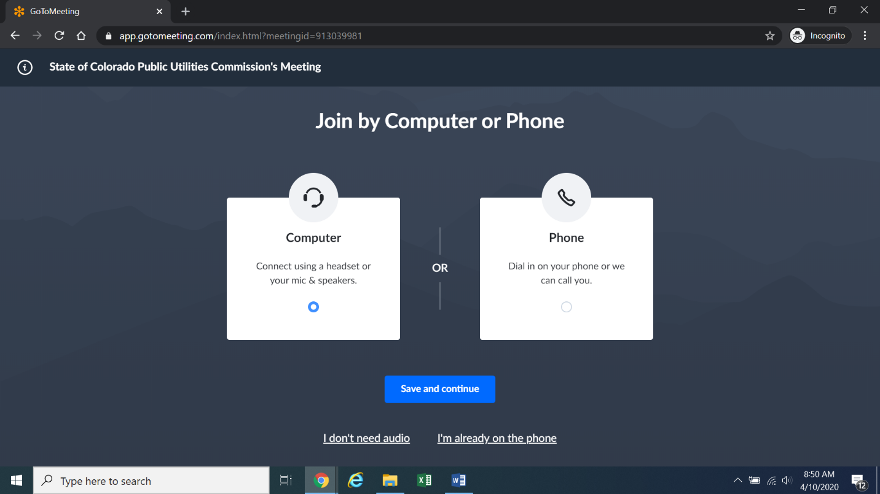
Confirm your audio settings and click “Save and continue.” Note: You may be prompted to allow the session to access your microphone and/or camera. Finally, you will be prompted to enter your name for identification during the session:
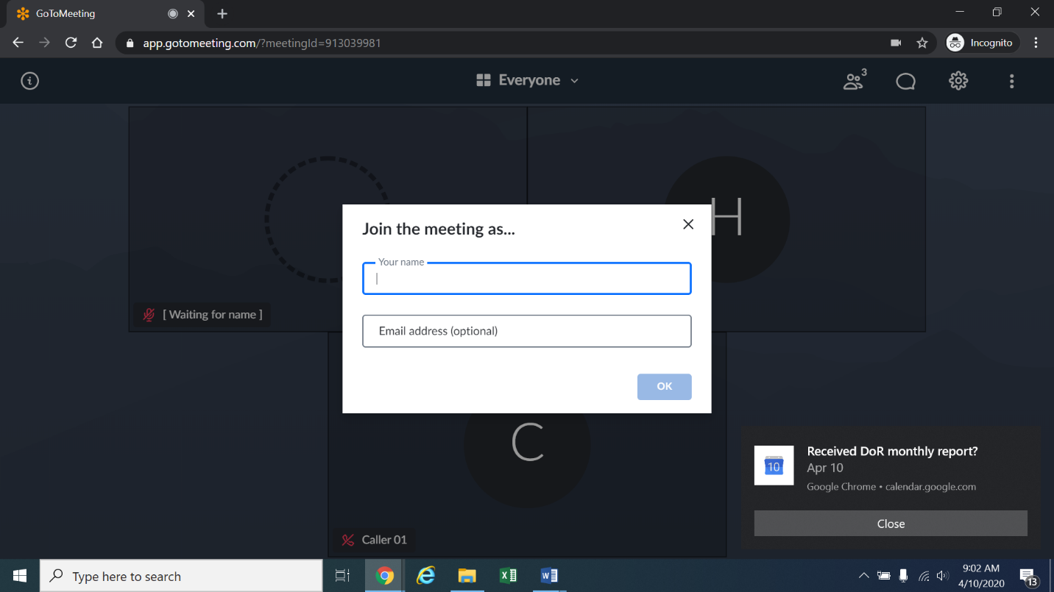
Alternatively, if there is any problem with the link provided in the ALJ’s email, please go to https://app.gotomeeting.com/home.html and enter the nine-digit Meeting ID/Access Code stated in the email to join the meeting.
- If you do not want others participating in the prehearing conference to see you, please click on the camera icon contained in the green circle at the bottom of the video screen. The icon will turn white and a slash will be placed over the camera icon indicating that your camera has been turned off. Likewise, if you do not want others participating in the prehearing conference to hear you, confirm that there is a slash over the microphone icon contained in the red circle indicating that your microphone has been turned off.
- In the screenshot of the webpage below, the microphone is turned off while the camera is turned on:
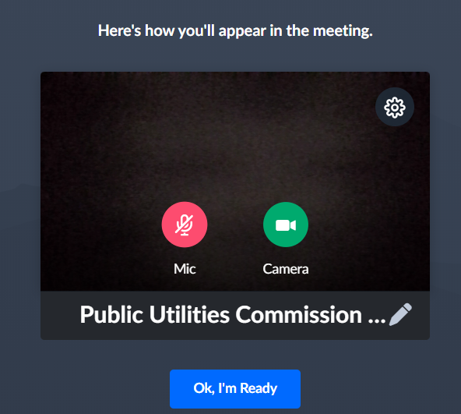
Conversely, the screenshot of the webpage below shows the microphone and video icons turned on and ready to transmit video and audio when you join the hearing.
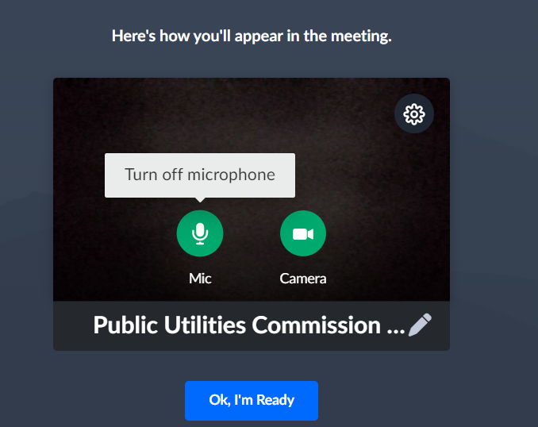
- You can control the volume of the audio through the volume controls on your computer. The screenshot below shows the screen after joining the hearing with the camera turned on and the microphone turned off.
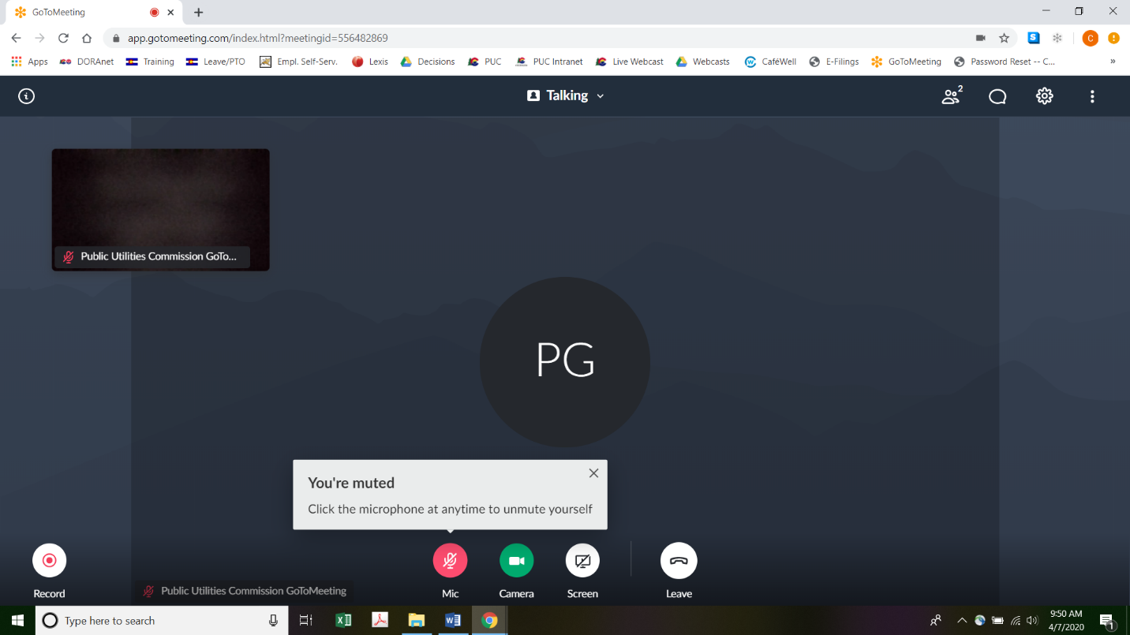
- All participants in the prehearing conference should mute (turn off) their microphones during the conference until called upon by the ALJ to comment or to reply. When prompted by the ALJ, please click on the microphone icon to turn on your microphone and then commence speaking. The red circle around the microphone icon will turn green indicating that your microphone is turned on. While you are speaking, please listen for any directions you are given by the ALJ.
- To terminate your participation in the prehearing conference, please click on the telephone handset icon with the word “Leave” underneath it and then click the “Yes” button in the pop-up box, or the “Not now” button if you would like to stay in the meeting, as shown in the screenshots below.
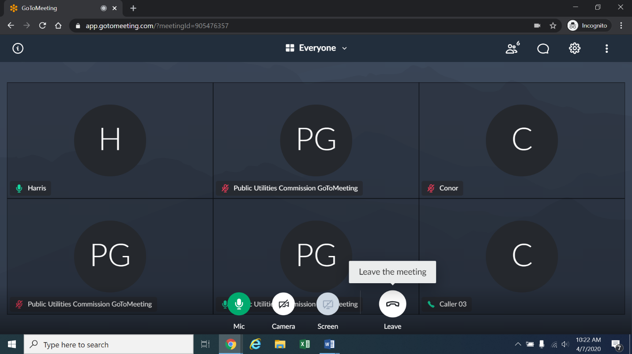
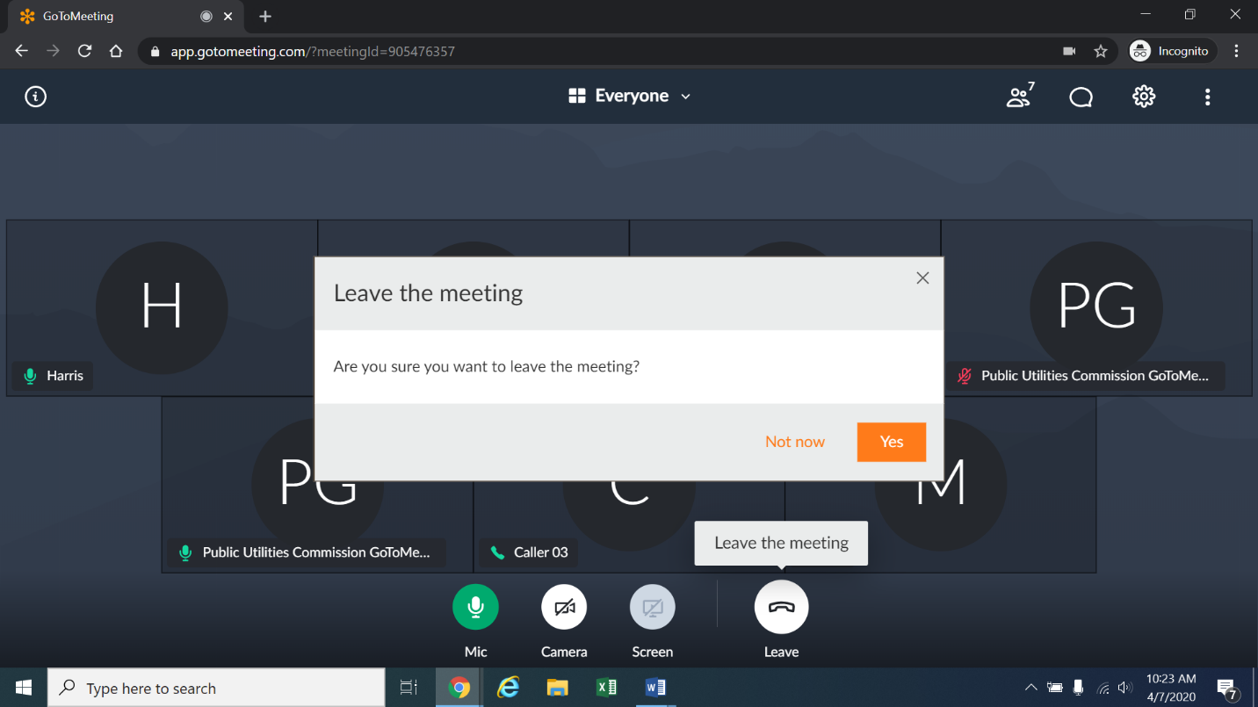
- The remote prehearing conference will be transcribed.

Instructions for Observing the Prehearing Conference
- If you do not wish to speak but would like to listen to the prehearing conference, please do not participate by telephone or computer as described above. Rather, please go to https://puc.colorado.gov/webcasts. The following webpage will appear.
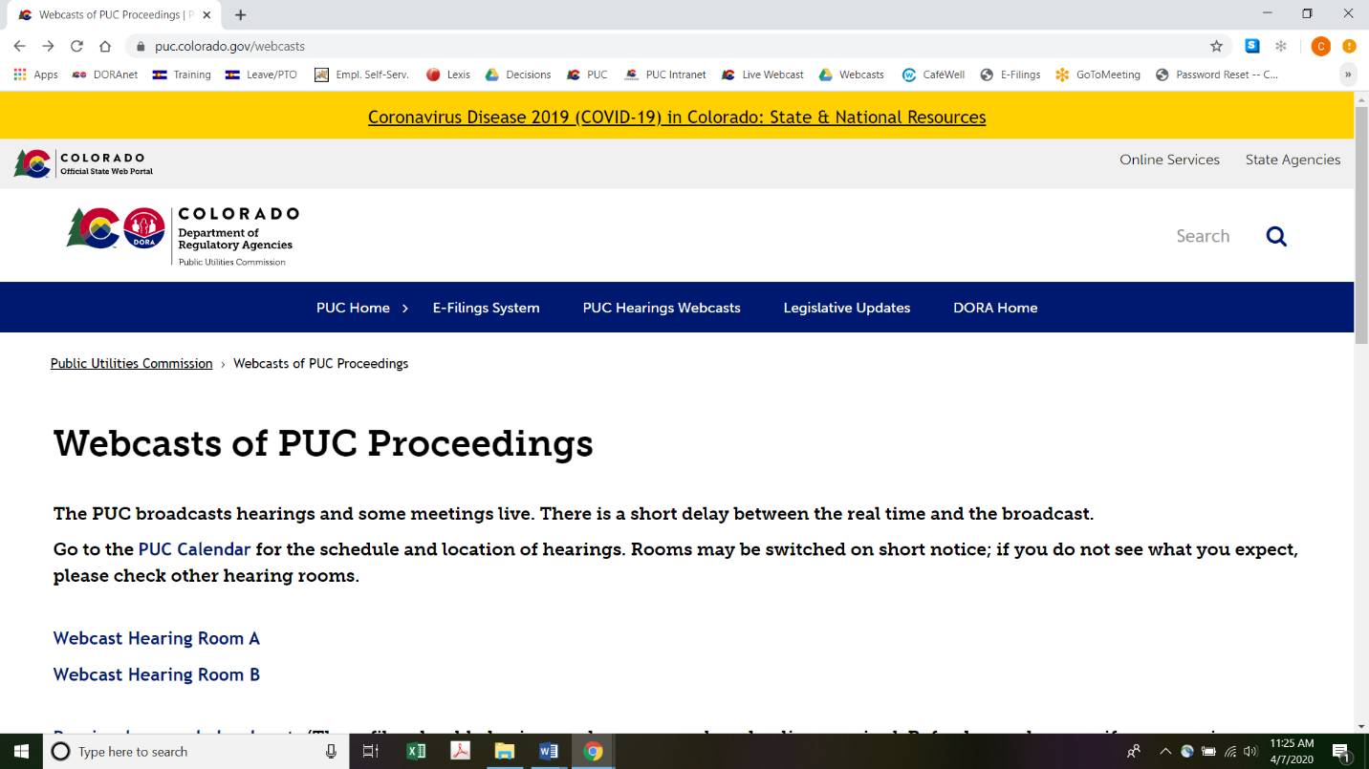
Please select the hearing room (“Webcast Hearing Room A” or “Webcast Hearing Room B”) listed for the prehearing conference on the Commission’s public calendar, available at https://puc.colorado.gov/puccalendar. Once the hearing room is selected, please click one of the “audio only” links (e.g., “Hearing Room A Audio Only (IOS)” or “Hearing Room A Audio Only (Android/Other)”), or click the play button on the black screen, to stream audio of the hearing live (with a short delay between real time and the broadcast, as noted in the screenshot above).

ORDER

It Is Ordered That:
- Pursuant to § 40-6-109.5(1), C.R.S. (2019), the time for issuance of the Commission’s decision in this Proceeding shall be extended by an additional period of
130 days, or to and including December 7, 2020.
- A prehearing conference in this proceeding is scheduled as follows:
DATE: May 15, 2020
TIME: 10:00 a.m.
WEBCASTS: Commission Hearing Room B
METHOD: Remote Access - https://global.gotomeeting.com/join/895324085
Telephone access: +1 (571) 317-3112;
Access Code: 895-324-085

- Consistent with the discussion and findings supra, the matters identified in this Interim Decision will be discussed at the prehearing conference. Those Parties and counsel appearing at the prehearing conference must be prepared to address those matters identified in this Decision and must have authority to agree to a procedural schedule, to the resolution of all procedural matters, and to evidentiary hearing dates.
- Failure of a Party or its counsel to appear or to participate in the prehearing conference shall constitute a waiver of any objection to the rulings made, to the procedural schedule established, and to the hearing dates scheduled during the prehearing conference.
- Consistent with the discussion above, counsel for Public Service Company of Colorado (Public Service) shall consult prior to the prehearing conference with counsel for the intervenors, regarding the procedural schedule, hearing date(s), and the other procedural matters addressed in this Decision.
- If the Parties are able to reach agreements on a consensus procedural schedule, hearing date(s), and the other procedural matters addressed in this Decision, counsel for Public Service may make a filing no later than May 11, 2020, stating those agreements. If the prehearing conference is not needed, it may be vacated in another interim decision.
- The Notice of Intervention as of Right, filed by Trial Staff of the Colorado Public Utilities Commission on March 17, 2020, is acknowledged.
- The Notice of Intervention of Right, filed by the Colorado Office of Consumer Counsel on March 25, 2020, is acknowledged.
- This Decision is effective immediately.

(S E A L)    ATTEST: A TRUE COPY  Doug Dean,  Director | THE PUBLIC UTILITIES COMMISSION  OF THE STATE OF COLORADO  STEVEN H. DENMAN  ________________________________  Administrative Law Judge

Application, at pages 1-2. Public Service explains that the uprates to existing transmission lines do not require new construction or extension of transmission facilities, as the power carrying capabilities (continuous ratings) of these lines are limited by facilities other than the transmission conductors (e.g., switches, jumpers, and relay equipment in existing substations) that when replaced, allow the continuous rating of the transmission line to be the conductor rating. Id., Footnote 1 at page 2.
Application, at page 2. See Decision No. C18-0761 (mailed September 10, 2018) in Proceeding No. 16A-0396E (Phase II ERP Decision).
Public Service states that, “The proposed switching station identified as Badger Hills throughout Proceeding No. 16A-0396E has been renamed “Mirasol” at Pueblo’s request.” Application, Footnote 2 at page 3.
Application, at pages 3 and 4.
Section 40-6-109(1), C.R.S., was amended, effective on May 30, 2019, to give the Commission the discretion to extend the 120-day decision deadline on applications by an additional 130 days, for a total of 250 days. See Senate Bill 19-235, Section 16, at page 31; signed into law by Governor Jared S. Polis and effective on May 30, 2019.
OCC’s Intervention, ¶ 4 at pages 2 and 3.
Cross-answer testimony shall respond only to the answer testimony of another intervenor.
Filing of corrections is limited to correcting errors (e.g., mathematical errors, typographical errors) in the testimonies or attachments as filed. Without a finding of good cause and leave of the ALJ, corrections may not be used for any other purpose (e.g., to make material or substantive changes to prefiled testimony or attachments).
This date shall be at least 21 calendar days before the first day of the hearing.
This date shall be at least ten calendar days before the first day of hearing.
Post-hearing statements of position should be filed no later than 14 calendar days from the conclusion of the evidentiary hearing.
During the course of this Proceeding, the ALJ may have occasion to inform counsel, on short notice, of his rulings. The ALJ will make such notifications by e-mail and will rely solely on signature blocks of pleadings for the appropriate e-mail addresses. If any counsel’s email address changes during the pendency of this Proceeding, please promptly update it with the Commission.
To minimize audio feedback, you are encouraged to listen using headphones connected to the audio/headset jack on your computer.

