Decision No. R20-0245-I
BEFORE THE PUBLIC UTILITIES COMMISSION OF THE STATE OF COLORADO
PROCEEDING NO. 19A-0742CP
IN THE MATTER OF THE APPLICATION OF ARROWHEAD TAXI LLC FOR A CERTIFICATE OF PUBLIC CONVENIENCE AND NECESSITY TO OPERATE AS A COMMON CARRIER BY MOTOR VEHICLE FOR HIRE.
INTERIM DECISION OF
ADMINISTRATIVE LAW JUDGE
Steven H. Denman
scheduling remote status conference
Mailed Date: April 10, 2020

TABLE OF CONTENTS
I. STATEMENT 1
A. Procedural History 1
B. Setting Remote Status Conference. 3
C. Instructions for Participating in the Remote Status Conference 5
1. Instructions for Participating by Telephone 5
2. Instructions for Participating by Computer 5
3. Instructions for Observing the Status Conference 11
II. ORDER 12
A. It Is Ordered That: 12

STATEMENT

Procedural History
- On December 30, 2019, Arrowhead Taxi LLC (Arrowhead or Applicant) filed an Application for a Certificate of Public Convenience and Necessity to Operate as a Common Carrier by Motor Vehicle for Hire (Application). Arrowhead did not file testimony and exhibits with its Application and, therefore, seeks a Commission decision within 210 days, or no later than September 10, 2020.
- The procedural history of this proceeding is set out in previous Decisions and is repeated here as necessary to put this Decision into context.
- During the Commission’s weekly meeting held February 13, 2020, the Commission deemed the Application complete and referred it to an Administrative Law Judge (ALJ) for disposition. The undersigned ALJ was subsequently assigned to preside over this proceeding.
- On January 31, 2020, Jerry’s Valley Taxi, LLC, doing business as Valley Taxi of Glenwood Springs, LLC, doing business as Valley Taxi (Valley Taxi), which holds Certificate PUC No. L55723, filed its Entry of Appearance and Petition for Intervention. Decision
No. R20-0125-I (mailed on February 25, 2020) acknowledged Valley Taxi’s intervention by right.
- Arrowhead and Valley Taxi are the Parties to this proceeding. Decision
No. R20-0125-I allowed Arrowhead to be represented by Ronald V. Carl, the Owner. Valley Taxi is represented by counsel.
- By Decision No. R20-0156-I (mailed on March 10, 2020), the Administrative Law Judge (ALJ) set an evidentiary hearing for May 5, 2020 at 9:00 a.m. in the City Council Chambers in Rifle, Colorado.
- Decision No. R20-0156-I ordered that, on or before March 31, 2020, Arrowhead shall file and serve on counsel for Valley Taxi: (a) a list that identifies the witnesses Arrowhead intends to call at the hearing, including the last known address and telephone number of each witness; (b) a summary of the anticipated testimony of each witness; and (c) copies of the exhibits Arrowhead intends to present at the hearing.
- Finally, Decision No. R20-0156-I also ordered that, on or before April 21, 2020, Valley Taxi will be ordered to file and serve on Arrowhead: (a) a list that identifies the witnesses Valley Taxi intends to call at the hearing, including the last known address and telephone number of each witness; (b) a written summary of the anticipated testimony of each witness; and (c) copies of the exhibits Valley Taxi intends to present at the hearing.

Setting Remote Status Conference.
- Since the hearing was scheduled, several significant developments have occurred. First, Colorado Governor Jared Polis declared a disaster emergency due to the presence of the coronavirus disease (COVID-19) in Colorado. Governor Polis recently extended the disaster emergency declaration until May 8, 2020. On March 25, 2020, Governor Polis issued a
“stay-at-home order” for the entire State through April 11, 2020. On April 8, 2020, Governor Polis extended the “stay-at-home order” for the entire State through April 26, 2020. In addition, state agencies and local governments have implemented numerous restrictions to slow the spread of COVID-19. For example, Commission personnel are restricted only to essential travel.
- While these statewide restrictions may expire before the May 5, 2020 hearing, there is significant uncertainty as to whether they will be extended beyond their expiration and whether the public will continue to be at risk for contracting COVID-19 at the time of the scheduled in-person hearing. Given all of these factors, the ALJ finds that it is necessary to hold a remote status conference.
- At the status conference, the parties should be prepared to discuss these issues and their potential impact on the May 5, 2020 hearing; whether the May 5, 2020 hearing must be continued; whether Applicant is willing to waive the statutory deadline for a final Commission decision to issue; whether circumstances exist to warrant further extension of the current September 10, 2020 statutory deadline by 130-days under § 40-6-109.5(6), C.R.S. (2019); and any other relevant matters.
- The ALJ finds that holding the status conference remotely is consistent with current public health orders and advisories to prevent the spread of COVID-19. This means that the parties may not appear at the Commission in person to attend the status conference. Instead, parties and their counsel will attend the status conference from remote locations, either by telephone, or by video conference using the link and instructions provided in this Decision. The ALJ encourages the parties to attend by video conference, as this will provide helpful additional information on appropriate next steps.

Instructions for Participating in the Remote Status Conference
- The Commission uses the web-hosted video conferencing service, GoToMeeting, to hold video conferences, and in this case, a remote status conference. The parties and their counsel can participate either by telephone or computer. The following are general instructions for how to participate by telephone or by computer.
- Additional information and tutorials for using GoToMeeting are available at:
https://www.gotomeeting.com/meeting/resources/gotomeeting-quick-and-helpful-guide-for-attendees.

These links are only provided for the convenience of the parties and counsel who intend to participate remotely, and are not intended to guarantee that the information on the link is accurate or that it provides all the information the parties may need in order to use GoToMeeting. Those individuals who plan to participate remotely by computer are strongly advised to familiarize themselves with GoToMeeting before the status conference.

Instructions for Participating by Telephone
- Details about how to participate by telephone will be sent to the parties and counsel by email from the ALJ in order to protect the security of the status conference. That email will include the telephone number to call when the status conference takes place, and an access code to input when prompted. You will then be placed into the status conference. Please note that your session and participation will be controlled by the organizer of the meeting.

Instructions for Participating by Computer
- Parties or counsel who wish to participate in the status conference by computer must use a computer that is connected to the internet and has a microphone and a speaker.
- Details about how to participate by computer will be included in the email from the ALJ. At the time of the status conference, input the URL in the email, and the webpage below will appear.
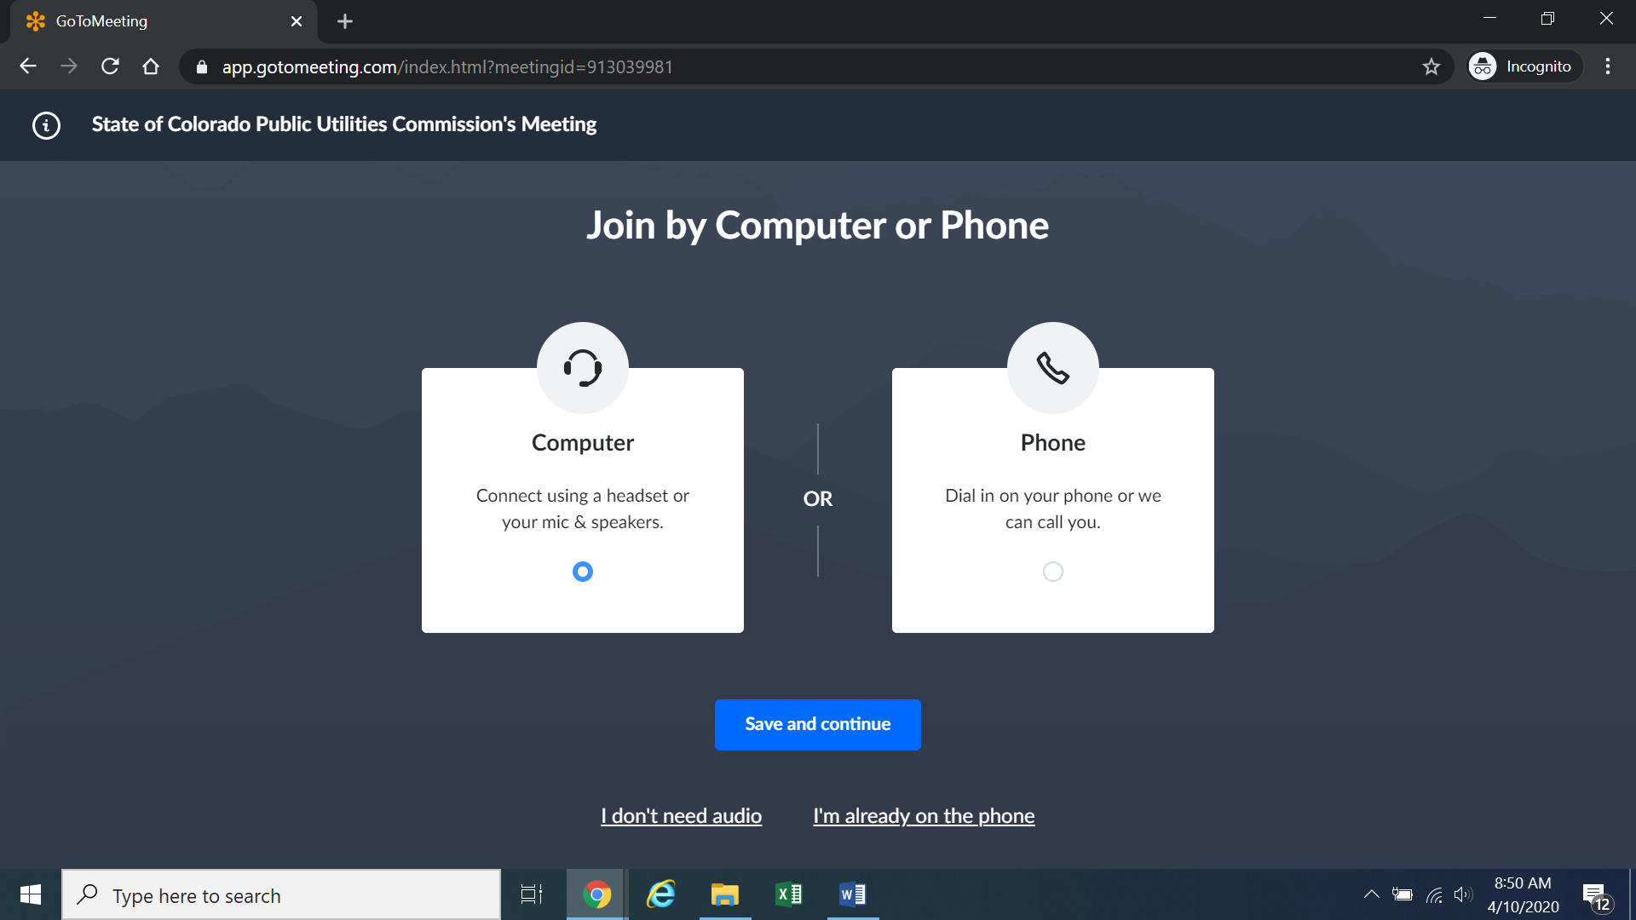
Confirm your audio settings and click “Save and continue.” Note: You may be prompted to allow the session to access your microphone and/or camera. Finally, you will be prompted to enter your name for identification during the session:
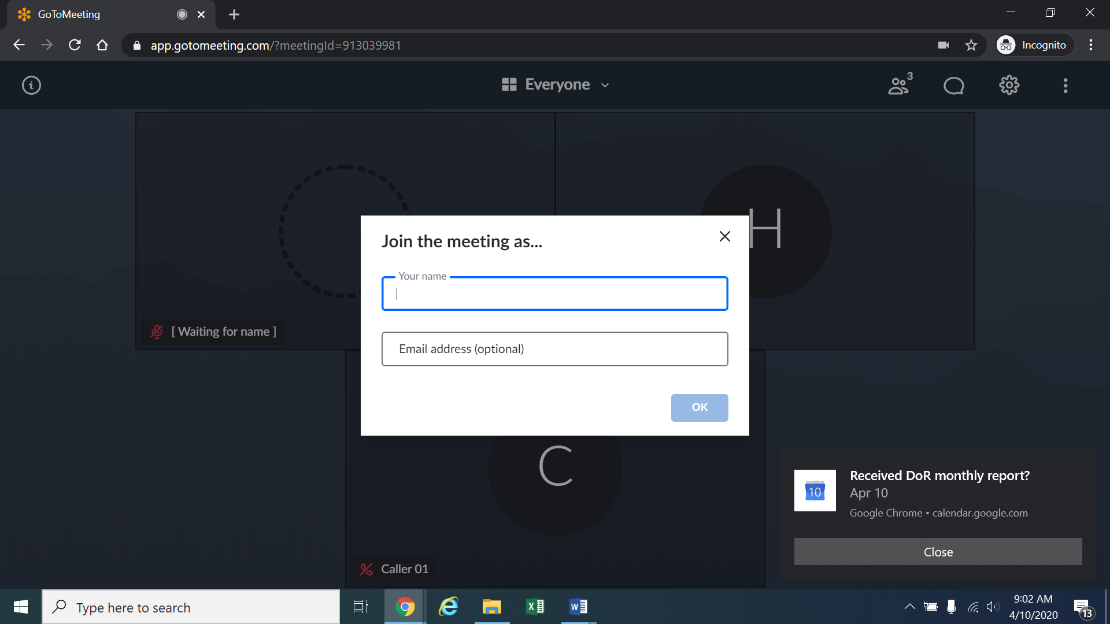
Alternatively, if there is any problem with the link provided in the ALJ’s email, please go to https://app.gotomeeting.com/home.html and enter the nine-digit Meeting ID/Access Code stated in the email to join the meeting.
- If you do not want others participating in the status conference to see you, please click on the camera icon contained in the green circle at the bottom of the video screen. The icon will turn white and a slash will be placed over the camera icon indicating that your camera has been turned off. Likewise, if you do not want others participating in the status conference to hear you, confirm that there is a slash over the microphone icon contained in the red circle indicating
- that your microphone has been turned off. In the screenshot of the webpage below, the microphone is turned off while the camera is turned on:
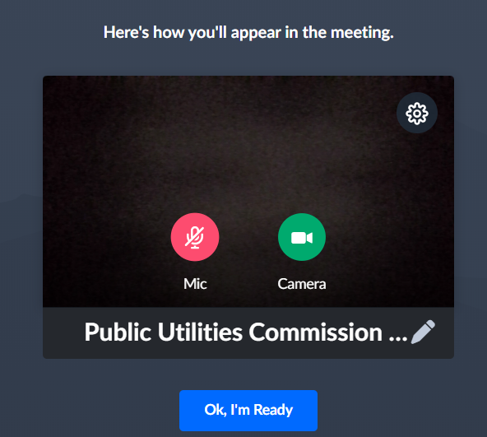
Conversely, the screenshot of the webpage below shows the microphone and video icons turned on and ready to transmit video and audio when you join the hearing.
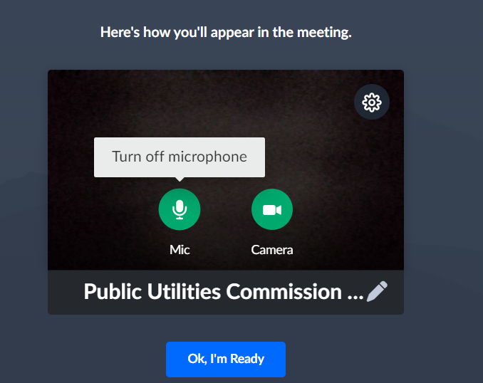
- You can control the volume of the audio through the volume controls on your computer. The screenshot below shows the screen after joining the hearing with the camera turned on and the microphone turned off.
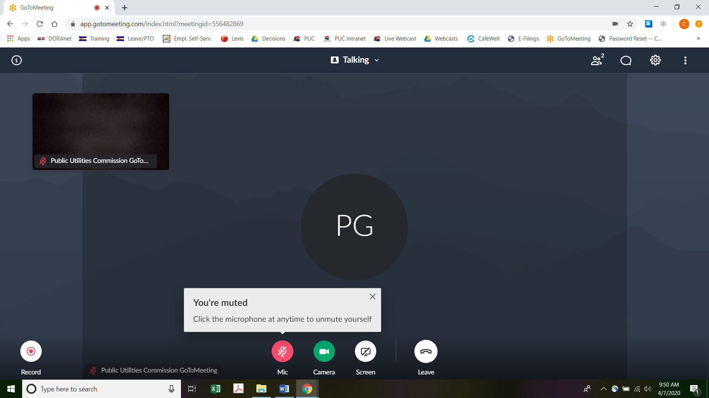
- All participants in the status conference should mute (turn off) their microphones during the conference until called upon by the ALJ to comment or to reply. When prompted by the ALJ, please click on the microphone icon to turn on your microphone and then commence speaking. The red circle around the microphone icon will turn green indicating that your microphone is turned on. While you are speaking, please listen for any directions you are given by the ALJ.
- To terminate your participation in the status conference, please click on the telephone handset icon with the word “Leave” underneath it and then click the “Yes” button in the pop-up box, or the “Not now” button if you would like to stay in the meeting, as shown in the screenshots below.
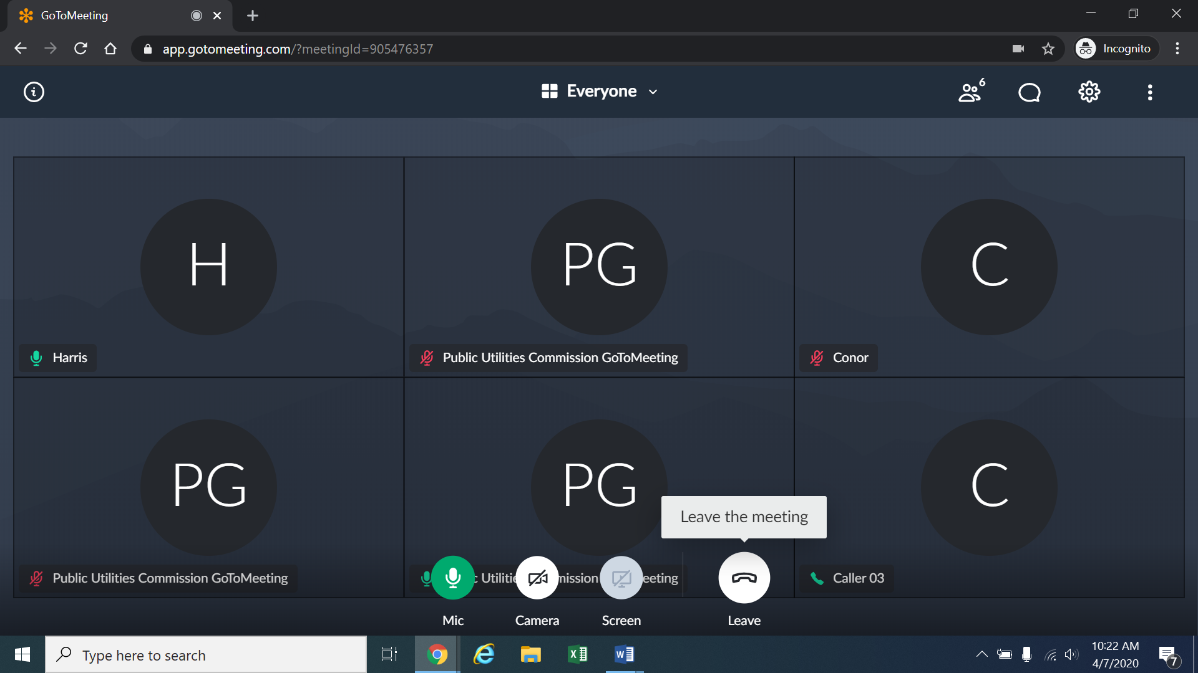
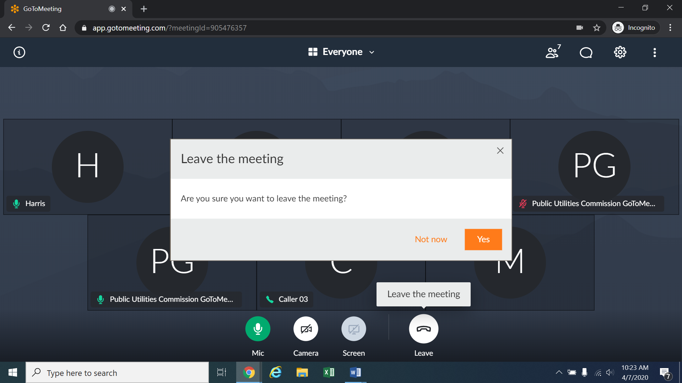
- The remote status conference will be transcribed.

Instructions for Observing the Status Conference
- If you do not wish to speak but would like to listen to the status conference, please do not participate by telephone or computer as described above. Rather, please go to https://puc.colorado.gov/webcasts. The following webpage will appear.
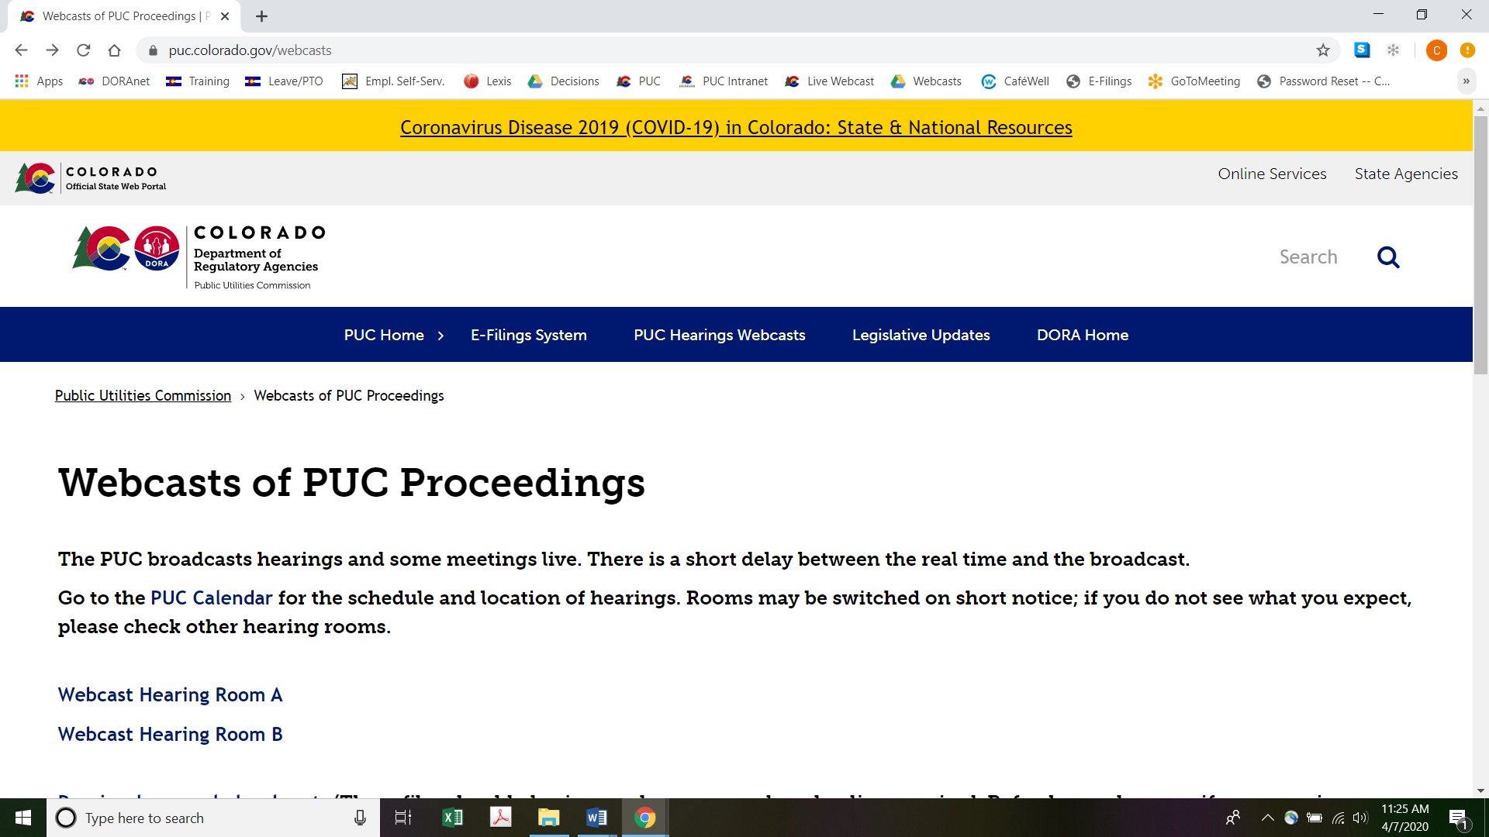
Please select the hearing room (“Webcast Hearing Room A” or “Webcast Hearing Room B”) listed for the status conference on the Commission’s public calendar, available at https://puc.colorado.gov/puccalendar. Once the hearing room is selected, please click one of the “audio only” links (e.g., “Hearing Room A Audio Only (IOS)” or “Hearing Room A Audio Only (Android/Other)”), or click the play button on the black screen, to stream audio of the hearing live (with a short delay between real time and the broadcast, as noted in the screenshot above).

ORDER

It Is Ordered That:
- A remote Status Conference is scheduled as follows:
DATE: April 17, 2020
TIME: 10:00 a.m.
FOR WEBCASTS: Hearing Room B
METHOD: Join by video conference at the link to be provided by the email from the Administrative Law Judge, OR

Join by telephone: Dial the telephone number provided in the email, and when prompted, enter the PIN (or Meeting ID) in the email.

- This Decision is effective immediately.

(S E A L)    ATTEST: A TRUE COPY  Doug Dean,  Director | THE PUBLIC UTILITIES COMMISSION  OF THE STATE OF COLORADO  STEVEN H. DENMAN  ________________________________  Administrative Law Judge

See § 40-6-109.5(2), C.R.S.
Decision No. R20-0125-I, ⁋ 15 at page 5. See Rule 1201(b)(II) of the Commission’s Rules of Practice and Procedure, 4 Code of Colorado Regulations 723-1 (2015). Mr. Carl was given the option of retaining counsel, but he did not.
Executive Order D-2020 003, issued March 11, 2020.
Executive Order D-2020 032, issued April 8, 2020.
Executive Order D-2020 017, issued March 25, 2020. See also Colorado Department of Public Health & Environment Order Updating Public Health Order 20-24, implementing Stay at Home Requirements, issued March 26, 2020
Executive Order D-2020 024, issued April 6, 2020.
The ALJ and the court reporter must travel to Rifle for the in-person hearing.
To minimize audio feedback, you are encouraged to listen using headphones connected to the audio/headset jack on your computer.

