Decision No. R20-0423-I
BEFORE THE PUBLIC UTILITIES COMMISSION OF THE STATE OF COLORADO
PROCEEDING NO. 19R-0654E
IN THE MATTER OF THE PROPOSED AMENDMENTS TO RULES REGULATING R-0654EELECTRIC UTILITIES, 4 CODE OF COLORADO REGULATIONS 723-3, RELATING TO INTERCONNECTION PROCEDURES AND STANDARDS.

ATTACHMENT A
REQUIREMENTS AND INFORMATION
ON USING GOTOMEETING TO ATTEND HEARING
______________________________________________________________________________
- This Attachment directs the participants on certain aspects of their participation in the scheduled remote public rulemaking hearing in this matter using GoToMeeting (https://www.gotomeeting.com/), and provides information that will aid participants in doing so. This Attachment is not intended to provide full and complete instructions on how to use GoToMeeting to participate in a hearing. Participants are responsible for ensuring they have familiarized themselves with GoToMeeting and are able to use it for the rulemaking hearing. (see https://support.goto.com/meeting/system-check).
- Participants in a GoToMeeting hearing by video-conference must use a computer, smart phone, or tablet with internet access, an operational microphone, camera, and a speaker. A few minutes prior to the start of the hearing, participants and counsel must enter the link provided to them for the GoToMeeting hearing in their internet browser. Each participant is responsible for ensuring that their respective witnesses, if any, are provided the same link.
- Participants will then be taken to the screen where they may join the hearing. Participants should select the computer option, as shown in the below image.
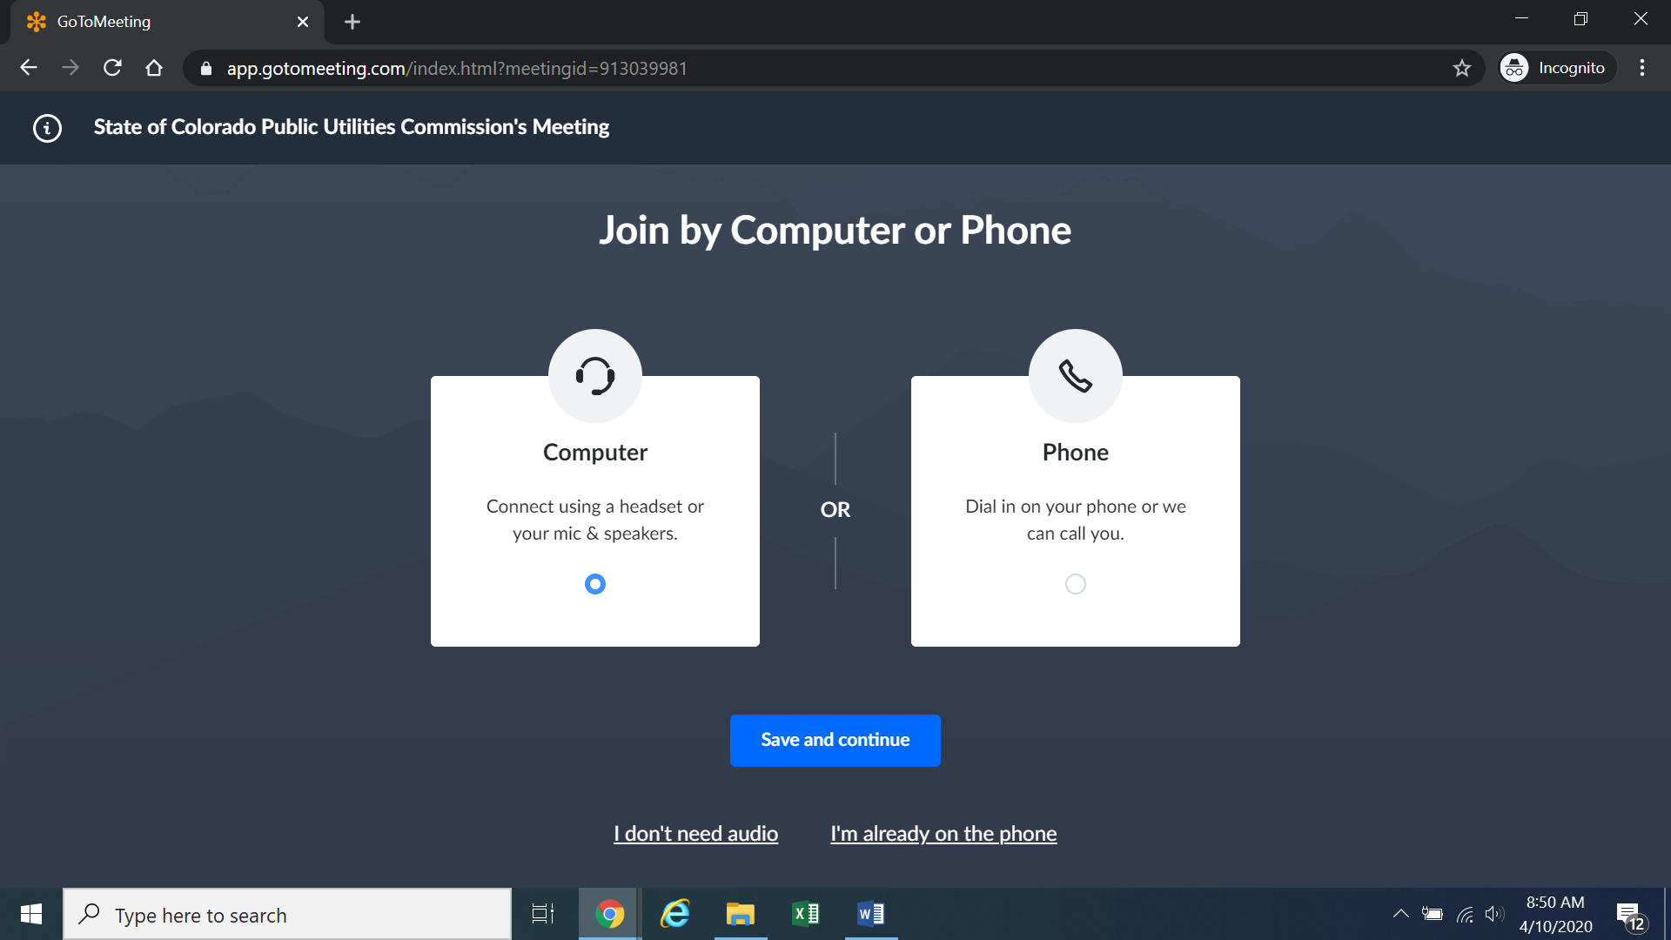
- Participants will then be required to confirm their audio settings; once complete, participants should select the “Save and continue” icon. If participants are prompted to allow the session to access their computers’ microphone and camera, they should allow access. As explained later, participants will be able to modify their settings should they need to turn off their cameras.

- Participants will be prompted to enter their name for identification during the session, as shown in the image below.
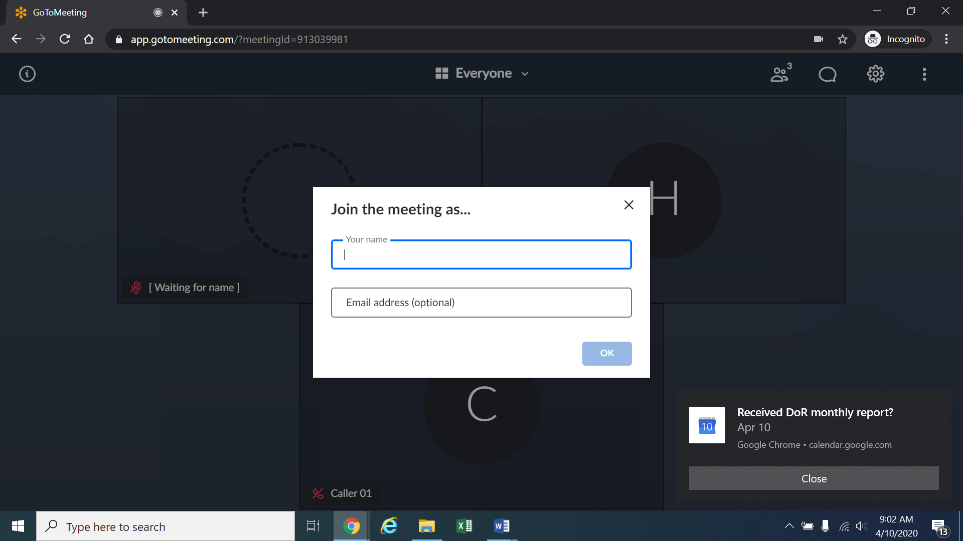
- All participants must enter their full first and last name. Among other reasons, this is required because the Administrative Law Judge (ALJ) will lock down the meeting once all participants have joined to minimize the potential for unnecessary background noise or feedback. It is also necessary to facilitate the Court Reporter’s ability to identify who is speaking during the hearing. The ALJ will unlock the hearing when any witnesses are called to testify, so that they may join GoToMeeting only when needed to testify.
- Participants may control the audio volume using their computer’s audio controls. Those who do not want their image displayed may select the camera icon in the green circle at the bottom of the video screen at any point. A slash will appear over the camera icon, indicating that the camera has been turned off. To mute or turn off the microphone, select the microphone icon and visually confirm that there is a slash over the microphone icon. Illustratively, the image below shows the microphone turned off and the camera turned on.
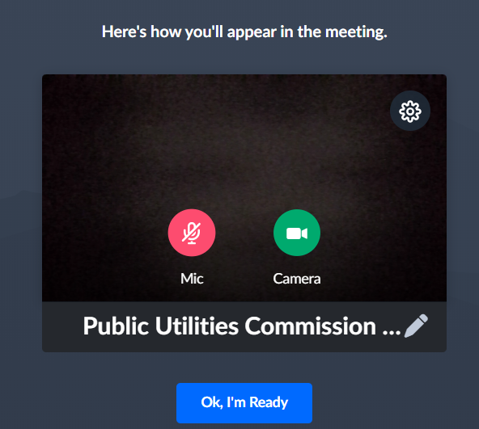
- Conversely, the image below shows the microphone and camera icons turned on and ready to transmit video and audio upon joining the hearing.
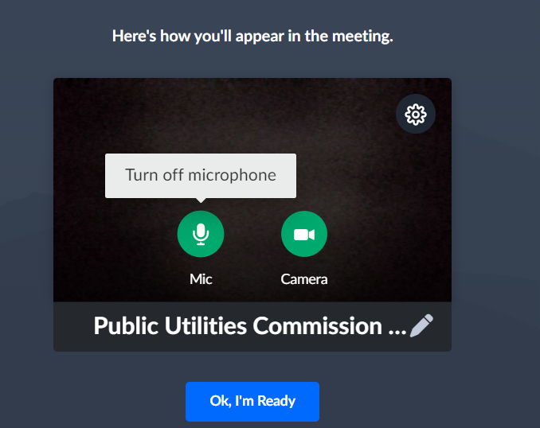
- A full and complete record and all testimony will be stenographically or electronically recorded. To facilitate this, participants must minimize feedback and background noise. First, all participants are required to mute their microphones during the hearing until called upon by the ALJ. Second, all participants must ensure that they are in a location with minimal or no background noise while participating in the hearing. Participants must avoid connecting to the hearing with multiple computers or devices located in the same room, as this will cause echos and audio feedback. Although not mandatory, participants are encouraged to participate using headphones connected to their computers, which may help reduce audio feedback
- To terminate participation in the hearing, select the telephone handset icon with the word “Leave” underneath it and then select “Yes” in the pop-up box, as shown below. A party who inadvertently selects the handset icon may select “Not now” instead of “Yes” to stay in the hearing, as shown below.
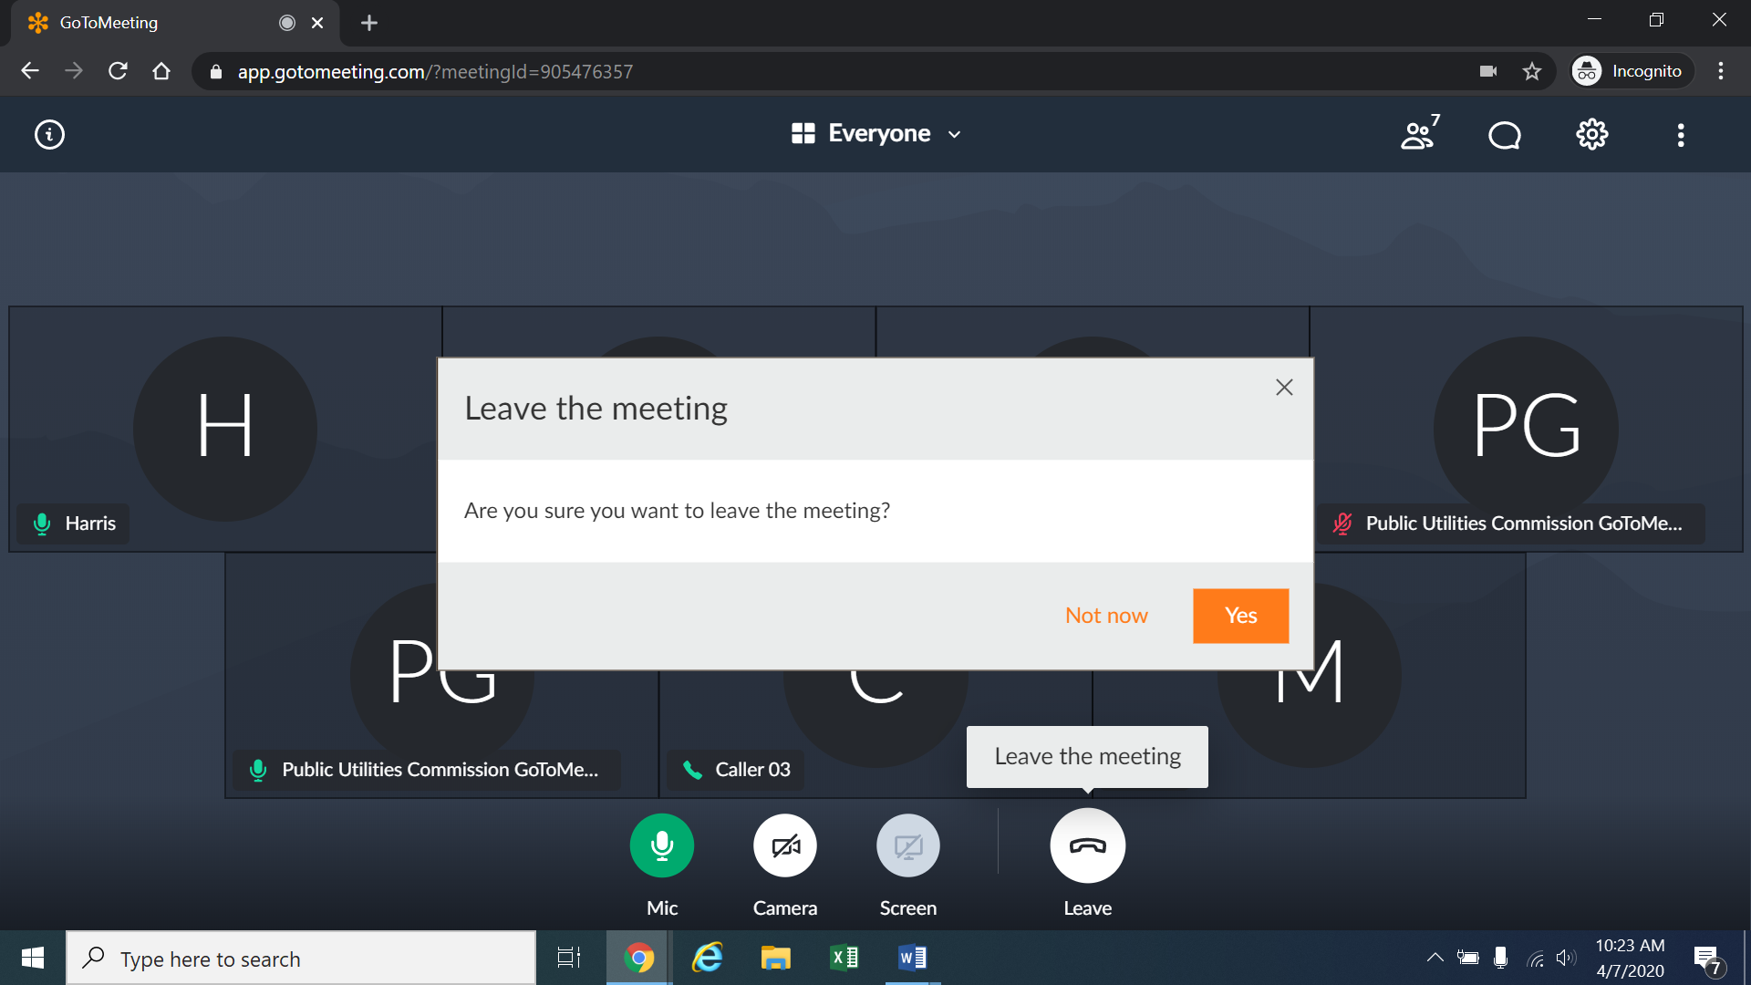
- Additional information and tutorials on using GoToMeeting are available at:
https://www.gotomeeting.com/meeting/resources/gotomeeting-quick-and-helpful-guide-for-attendees.

This link is provided for the participants’ convenience. Neither the ALJ nor the Commission warrants that the information on the link is accurate or that it provides all the information participants may need to use GoToMeeting.
12. This Attachment does not include instructions on how to present exhibits using GoToMeeting. Participants who may wish to introduce an exhibit during the rulemaking hearing must attach a copy of such exhibit to their written comments. The Interim Decision accompanying this Attachment addresses the filing of written comments prior to the remote rulemaking hearing.
13. The ALJ or a legal specialist may informally email counsel and participants during the week prior to the rulemaking hearing regarding procedural matters, including those related to the remote hearing. For this reason, counsel and participants who intend to participate in the remote rulemaking hearing should ensure that their correct email address appears on any written comments filed in this proceeding.

These instructions are not directed at using a tablet or smartphone to participate in a GoToMeeting video-conference.
If there is any problem with the link provided in the Decision scheduling the hearing, participants should enter: https://app.gotomeeting.com/home.html in their browser, and input the nine-digit access or ID code for the hearing.

