Decision No. R20-0414-I
BEFORE THE PUBLIC UTILITIES COMMISSION OF THE STATE OF COLORADO
PROCEEDING NO. 20V-0159EG
IN THE MATTER OF THE JOINT PETITION OF ATMOS ENERGY CORPORATION, COLORADO NATURAL GAS, PUBLIC SERVICE COMPANY OF COLORADO, BLACK HILLS COLORADO GAS, INC., BLACK HILLS COLORADO ELECTRIC, INC., AND ROCKY MOUNTAIN NATURAL GAS LLC FOR AUTHORIZATION TO TRACK EXPENSES RESULTING FROM THE EFFECTS OF COVID-19 AND RECORD AND DEFER SUCH EXPENSES INTO A REGULATORY ASSET.
ATTACHMENT A
REQUIREMENTS AND INFORMATION
ON USING GOTOMEETING TO ATTEND HEARING
______________________________________________________________________________
- This Attachment directs the parties on certain aspects of their participation in the remote hearing in this matter using GoToMeeting, and provides information which will aid parties in doing so. This is not intended to provide full and complete instructions on how to use GoToMeeting to participate in a hearing. Parties are responsible for ensuring they have familiarized themselves with GoToMeeting and are able to use it for the hearing.
- Participants in a GoToMeeting hearing by video-conference must use a computer connected to the internet with an operational microphone, camera, and a speaker. At the date and time of the hearing, parties and counsel must enter the link provided to them for the GoToMeeting hearing in their internet browser. Witnesses must use the same link, but will join the hearing only when called to testify.
- Participants will then be taken to the screen where they may join the hearing. Participants should select the computer option, as shown in the below image.
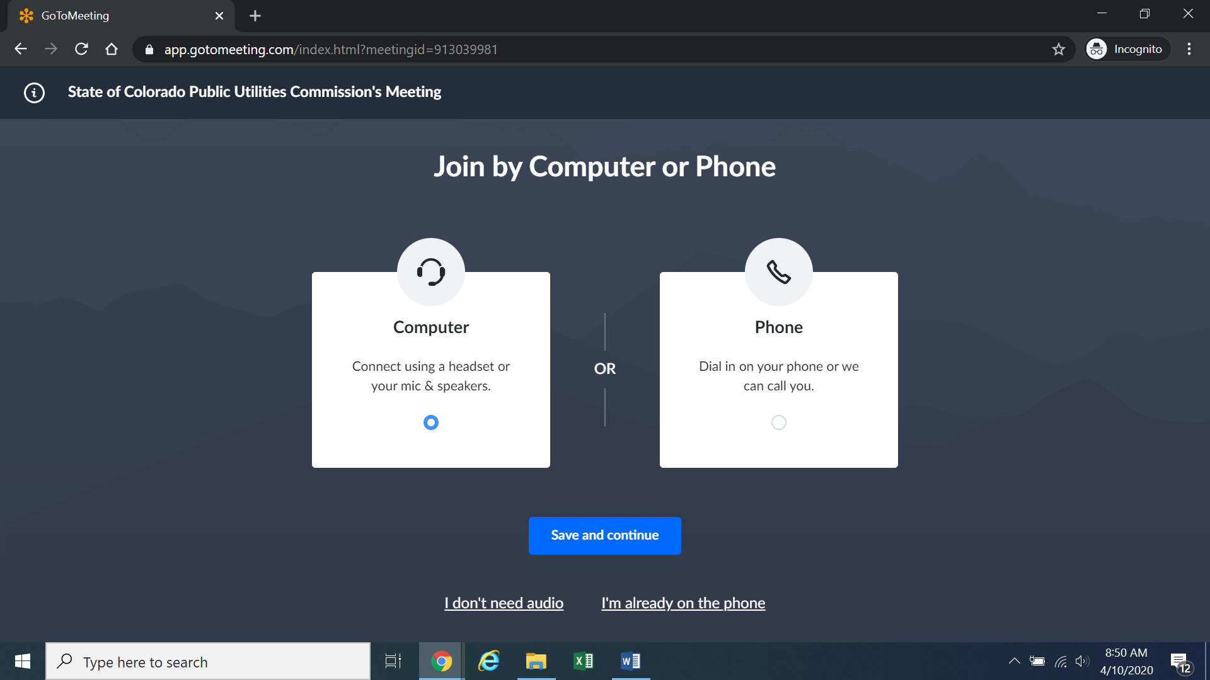
- Participants will then be required to confirm their audio settings; once done, participants should select the “Save and continue” icon. If participants are prompted to allow the session to access their computers’ microphone and camera, they should allow access. As explained later, participants will be able to modify their settings should they need to turn off their cameras.

- Participants will be prompted to enter their name for identification during the session, as shown in the image below.
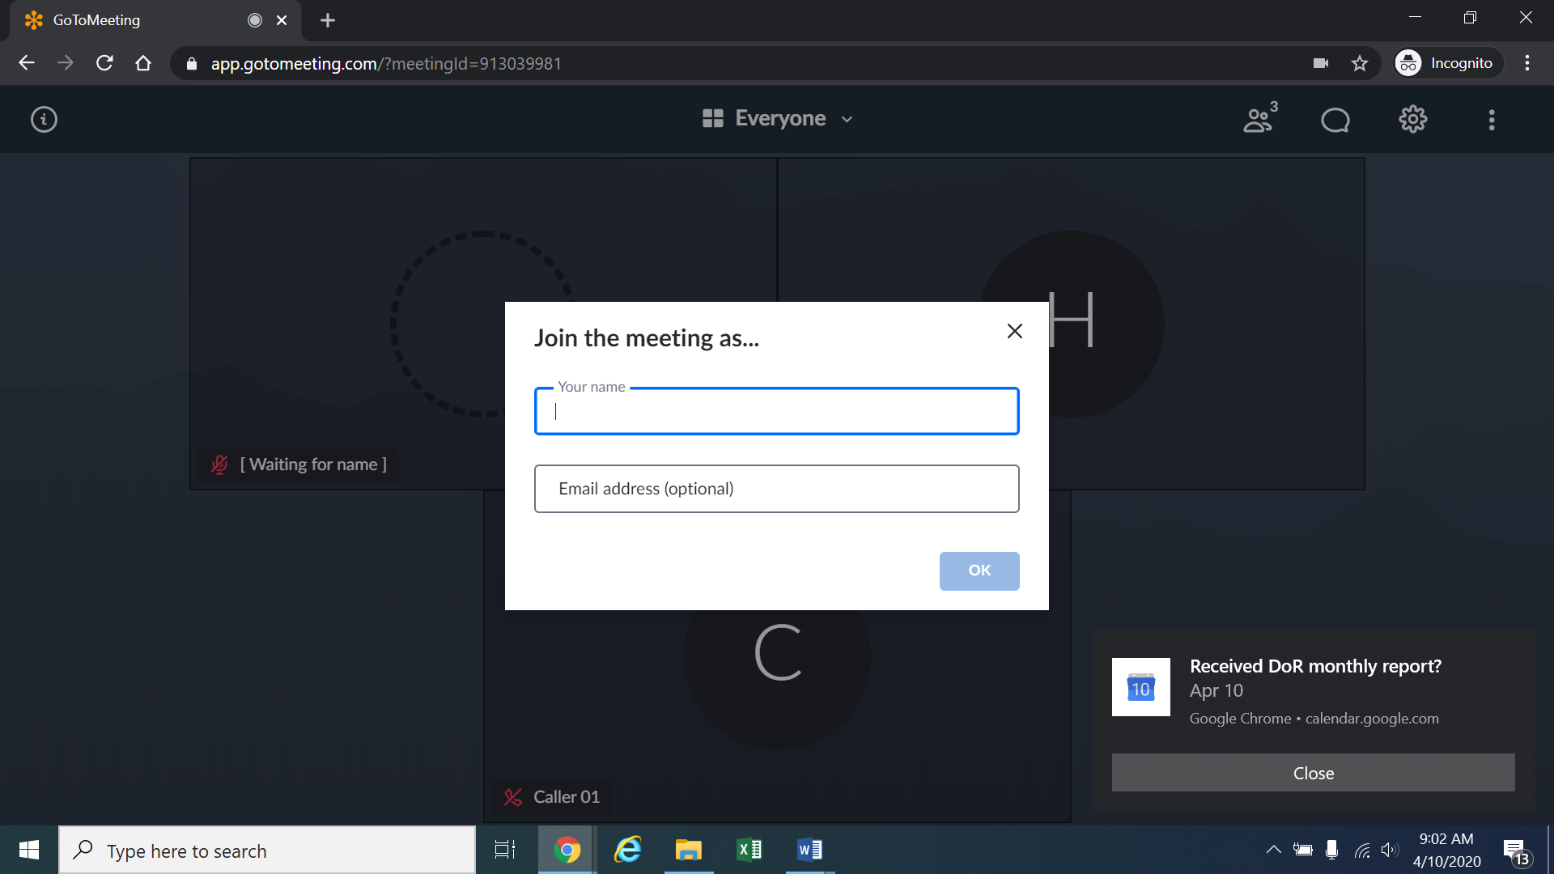
- All participants must enter their full first and last name. Among other reasons, this is required because the Administrative Law Judge (ALJ) may lock down the meeting once all parties have joined to minimize the potential for unnecessary background noise, feedback, or disruption by non-participants. It is also necessary to facilitate the court reporter’s ability to identify who is speaking during the hearing.
- Participants may control the audio volume using their computer’s audio controls. Participants who do not want their image displayed may select the camera icon in the green circle at the bottom of the video screen at any point. A slash will appear over the camera icon to indicate that the camera has been turned off. Likewise, to mute or turn off the microphone, select the microphone icon and visually confirm that there is a slash over the microphone icon. Illustratively, the below image shows the microphone turned off and the camera turned on.
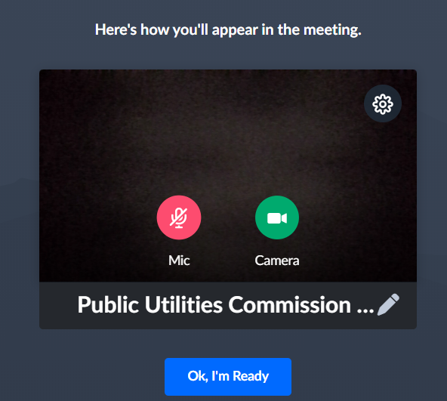
- Conversely, the below image shows the microphone and camera icons turned on and ready to transmit video and audio upon joining the hearing.
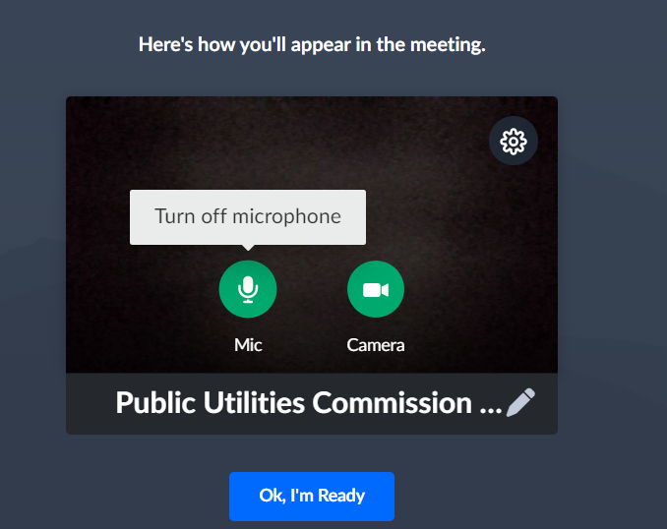
- A court reporter will be making a record of the hearing by video-conference. To facilitate this, participants must take steps to minimize feedback and background noise. First, all participants are required to mute their microphones during the hearing until called upon by the ALJ. Second, all participants must ensure that they are in a location with minimal or no background noise while participating in the hearing. Although not mandatory, participants are encouraged to listen using headphones connected to their computers, which may help reduce audio feedback.
- To terminate participation in the hearing, select the telephone handset icon with the word “Leave” underneath it and then select “Yes” in the pop-up box, as shown below. A party who inadvertently selects the handset icon may select “Not now” instead of “Yes” to stay in the meeting, as shown below.

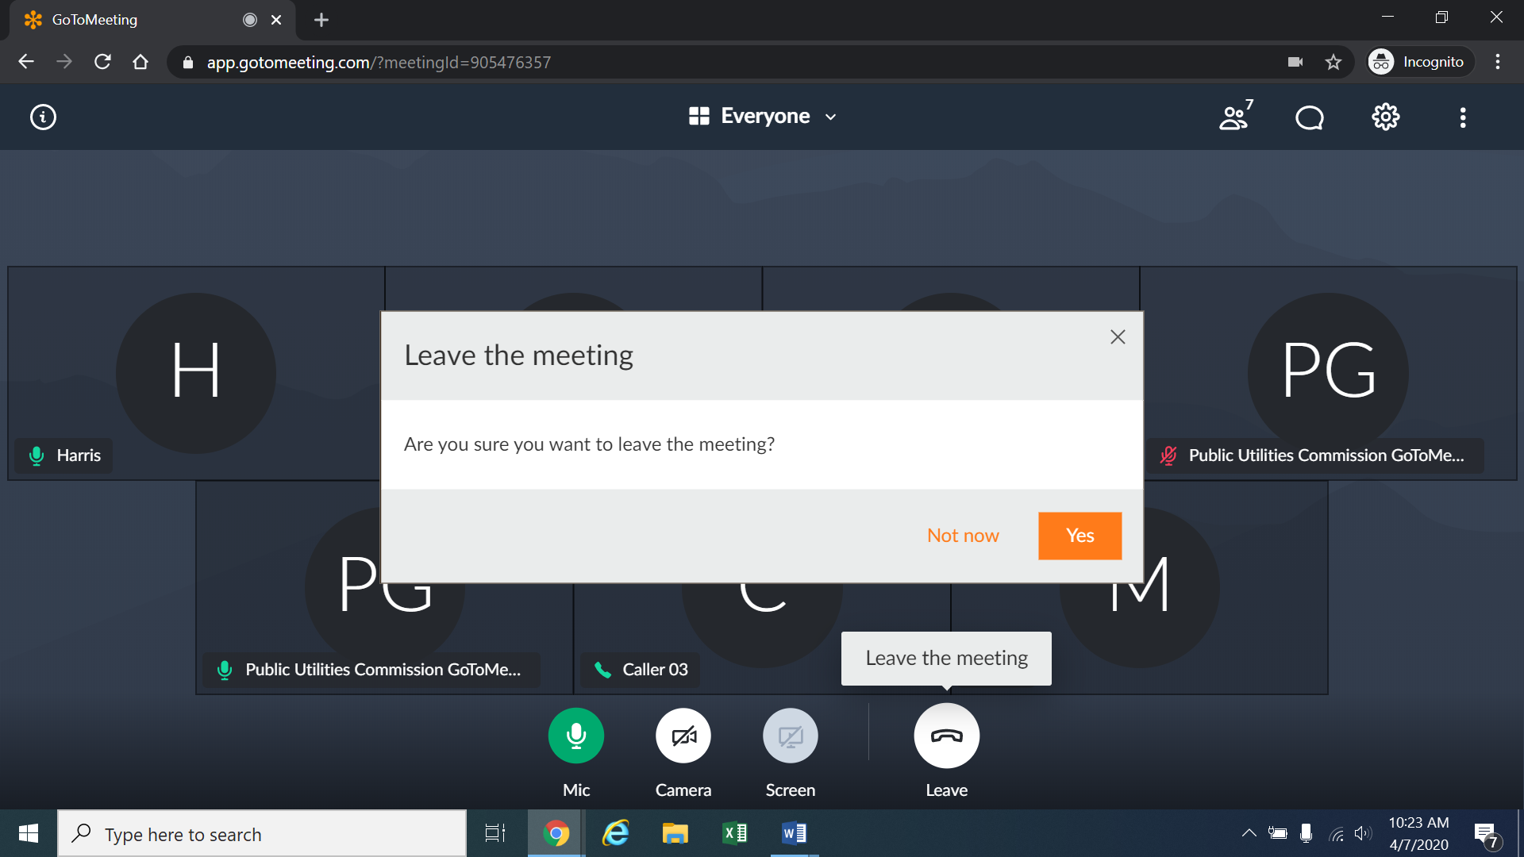
- Additional information and tutorials on using GoToMeeting are available at:
https://www.gotomeeting.com/meeting/resources/gotomeeting-quick-and-helpful-guide-for-attendees.

This link is provided for the parties’ convenience; the ALJ does not warrant that the information on the link is accurate or that it provides all the information participants may need to use GoToMeeting.
12. This Attachment does not include instructions on how to present exhibits using GoToMeeting. During the hearing, any party who wishes to use exhibits to impeach, refresh recollection, or for rebuttal that are not pre-filed will be required to present those documents themselves using GoToMeeting. As such, the parties are encouraged to review tutorials about presenting documents using GoToMeeting, and are responsible for ensuring they are able to do so.
13. The ALJ may reach out to the parties informally via email approximately one week before the hearing to perform a test run using GoToMeeting with the parties, including presenting exhibits. As such, the parties should be fully prepared to use GoToMeeting by that time.

These instructions are not directed at using a tablet or smartphone to participate in a GoToMeeting video-conference.
If there is any problem with the link provided in the Decision scheduling the hearing, participants should enter: https://app.gotomeeting.com/home.html in their browser, and input the nine-digit access or ID code in the Decision scheduling the hearing.

