Decision No. C23-0561-E
BEFORE THE PUBLIC UTILITIES COMMISSION OF THE STATE OF COLORADO
PROCEEDING NO. 23A-0373FG
IN THE MATTER OF THE APPLICATION OF black hills colorado gas, inc. FOR AN order granting to it a CERTIFICATE OF PUBLIC CONVENIENCE AND NECESSITY to EXERCISE NATURAL GAS FRANCHISE RIGHTS in the town of FREDERICK, COLORADO.
ERRATA NOTICE FOR
COMMISSION decision DEEMING
APPLICATION COMPLETE and GRANTING THE APPLICATION
Errata Mailed: September 13, 2023
Original Decision No. C23-0561 mailed: September 1, 2023

- Paragraph 10 of this Decision reads as follows:
10. According to the franchise agreement, as consideration for the franchise rights granted and in recognition of Black Hills’ right to use the Town streets, the Town requires Black Hills to collect and remit to the Town a franchise fee equal to two percent of all revenues received from the sale of natural gas service within the Town, excluding revenues received from the Town for the sale of natural gas service to the Town. Additionally, the franchise fee will now also be assessed to transport customers. These transport customers were duly noticed by mail on May 11, 2021.
The sentence that states that the franchise fee is equal to two percent of all revenues is incorrect. The franchise fee is equal to three percent of all revenues. In addition, the last two sentences of the paragraph should be deleted. Paragraph 10 is amended to read as follows:
10. According to the franchise agreement, as consideration for the franchise rights granted and in recognition of Black Hills’ right to use the Town streets, the Town requires Black Hills to collect and remit to the Town a franchise fee equal to three percent of all revenues received from the sale of natural gas service within the Town, excluding revenues received from the Town for the sale of natural gas service to the Town.

(S E A L)    ATTEST: A TRUE COPY  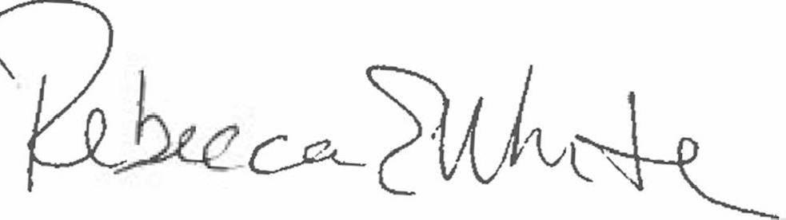  Rebecca E. White,  Director | THE PUBLIC UTILITIES COMMISSION  OF THE STATE OF COLORADO  REBECCA E. WHITE  ________________________________  Director

