Decision No. C23-0291
BEFORE THE PUBLIC UTILITIES COMMISSION OF THE STATE OF COLORADO
PROCEEDING NO. 23A-0115R
IN THE MATTER OF THE APPLICATION OF CANON CITY & ROYAL GORGE RAILROAD TO REMOVE ONE CURRENTLY EXISTING PUBLIC ROAD CROSSING AND ESTABLISH ONE NEW PUBLIC ROAD CROSSING AT S. 11TH STREET IN FREMONT COUNTY, CANON CITY, COLORADO.
commission decision
granting application
Mailed Date: May 9, 2023
Adopted Date: May 3, 2023

BY THE COMMISSION

Statement
- This matter comes before the Commission for consideration of an application (Application) filed by the Canon City & Royal Gorge Railroad (CCRGR) on March 8, 2023, requesting authority to register two currently existing public road crossings, remove the North Bay Crossing track, install new track at the South Bay Crossing, and install passive warning devices at the crossing of tracks of the CCRGR with 11th Street, National Inventory Numbers 253185H, in the City of in Cañon City, County of Fremont, State of Colorado.
- The Commission gave notice of this Application (Notice) to all interested parties, including adjacent property owners pursuant to § 40-6-108(2), C.R.S. The Notice was mailed on March 13, 2023.
- There were no interventions filed in this matter.
- The Commission has reviewed the record in this matter and the Application was deemed complete within the meaning of § 40-6-109.5, C.R.S. by operation of rule on April 27, 2023.
- The Commission has jurisdiction in this matter under §§ 40-4-106(2)(a) and (3)(a), C.R.S.
- Now being fully advised in the matter, we grant the Application.

Findings of Fact
- The Commission gave notice to all interested parties, including the adjacent property owners. No intervention was received opposing the Application.
- CCRGR seeks authority to register two currently existing public road crossings of tracks of the CCRGR with 11th Street. CCRGR also proposed to remove the track to the North Bay Crossing, replace the surface for the Center Bay Crossing, and install new track at the South Bay Crossing
- As grounds, CCRGR is applying to make the crossings official crossings and posting passive warning devices that currently do not exist and reconfigure the crossing to allow cars to be repaired in the Middle Bay and South Bay locations. Cars do not fit in the North Bay, so this track is being removed.
- CCRGR states there are currently approximately one train movement per week at a maximum speed of 2 miles per hour. The traffic volume at the crossing is approximately 432 vehicles per day with no estimates for increases in the future with vehicles traveling at a posted speed of 30 miles per hour. CCRGR proposes to install crossbuck signs with number of tracks signs indicating two tracks and yield signs at the crossing with advance warning signs posted in advance of the crossing. An additional track will be added to the South Bay Crossing and the North Bay Crossing will be removed. CCRGR estimates the cost of the work at $55,500 for the new track and the removal of the North Bay Crossing track is estimated at $15,000 with all costs being paid for by CCRGR.
- CCRGR proposes starting the project within six months of Commission approval and estimate the work being completed within 30 days of starting construction. We will require CCRGR to inform us in writing that construction is complete within ten days of project completion. We shall expect this letter by January 31, 2024. However, we understand this letter may be provided earlier or later than this date depending on changes or delays to the construction schedule.

Conclusions
- The Commission has jurisdiction in this matter under §§ 40-4-106(2)(a) and (3)(a), C.R.S.
- No intervenor that filed a petition to intervene or other pleading contests or opposes the Application.
- Because the Application is unopposed, the Commission finds that it will determine this matter upon the record, without a formal hearing under § 40-6-109(5), C.R.S., and Rule 1403, 4 CCR 723-1 of the Rules of Practice and Procedure.
- We find that good cause exists and that the requirements of public safety are met by granting the Application consistent with the above discussion.

ORDER

The Commission Orders That:
- The application (Application) filed by the Canon City & Royal Gorge Railroad (CCRGR) on March 8, 2023, requesting authority to register two currently existing public road crossings, remove the North Bay Crossing track, install new track at the South Bay Crossing, and install passive warning devices at the crossing of tracks of the CCRGR with 11th Street, National Inventory Numbers 253185H, in the City of in Cañon City, County of Fremont, State of Colorado was deemed complete within the meaning of § 40-6-109.5, C.R.S. by operation of rule on April 27, 2023.
- The Application is granted.
- CCRGR is authorized and ordered to upgrade the crossing at 11th Street in Cañon City, Colorado per the plans included with the Application.
- CCRGR shall inform the Commission in writing when the crossing changes are complete within ten days of completion. The Commission will expect the letter by January 31, 2024. However, the Commission understands this letter may be provided earlier or later than this date depending on changes or delays to the construction schedule.
- The 20-day period provided for in § 40-6-114, C.R.S., within which to file applications for rehearing, reargument, or reconsideration, begins on the first day following the effective date of this Decision.
- The Commission retains jurisdiction to enter further decisions as necessary.

- This Decision is effective on its Mailed Date.

ADOPTED IN COMMISSIONERS’ WEEKLY MEETING
May 3, 2023.
(S E A L)    ATTEST: A TRUE COPY  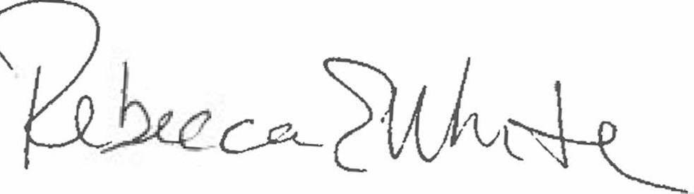  Rebecca E. White,  Director | THE PUBLIC UTILITIES COMMISSION  OF THE STATE OF COLORADO  ERIC BLANK  ________________________________  MEGAN M. GILMAN  ________________________________  TOM PLANT  ________________________________  Commissioners

