Decision No. C23-0108
BEFORE THE PUBLIC UTILITIES COMMISSION OF THE STATE OF COLORADO
PROCEEDING NO. 21R-0314G
IN THE MATTER OF THE PROPOSED RULES ADDRESSING GAS COST ADJUSTMENT APPLICATIONS FILED PURSUANT TO THE RULES REGULATING GAS UTILITIES,
4 CODE OF COLORADO REGULATIONS (CCR) 723-4.
COMMISSION decision DENYING AS MOOT APPLICATION FOR REHEARING, REARGUMENT, OR RECONSIDERATION, AND GIVING NOTICE OF CORRECTION OF CLERICAL ERROR
Mailed Date: February 16, 2023
Adopted Date: February 15, 2023

BY THE COMMISSION

Statement, Findings, and Conclusions
- By this Decision, the Commission addresses the Application for Rehearing, Reargument, or Reconsideration (RRR) filed on February 6, 2023, by Durango Mountain Utilities, LLC (DMU) requesting reconsideration of Decision No. C23-0029 (Decision), issued in this Proceeding on January 17, 2023.
- The Commission’s Decision adopted modified rules governing the gas cost adjustment (GCA) at 4 Code of Colorado Regulations 723-4-4600, et seq. (GCA Rules).
- DMU notes in its Application for RRR that the Commission’s adopted GCA Rules contain a clerical error at Rule 4602(c). DMU points out this rule contains a cross reference to paragraph 4306(b), which should instead refer to paragraph 4603(b).
- The Commission agrees this cross-reference is a clerical error in the rule and will correct this error in the final version of the rules submitted to the Office of the Secretary of State for publication in The Colorado Register.
- This clerical error does not rise to the level of a substantive change and therefore we find it appropriate to deny DMU’s application for RRR as moot with the note that the Commission has made this correction in the final rules submitted for publication.
- For reference, the adopted rules with this clerical correction are attached to this Decision in legislative format (i.e., strikeout/underline) as Attachment A, and in final format as Attachment B.

ORDER

The Commission Orders That:
- The Application for Rehearing, Reargument, or Reconsideration filed on February 6, 2023, by Durango Mountain Utilities, LLC, is denied as moot, consistent with the discussion above.
- The clerical error in Rule 4602(c) shall be corrected as shown in the attachments to this Decision, consistent with the discussion above.

- This Decision is effective upon its Mailed Date.

ADOPTED IN COMMISSIONERS’ WEEKLY MEETING
February 15, 2023.

(S E A L)    ATTEST: A TRUE COPY  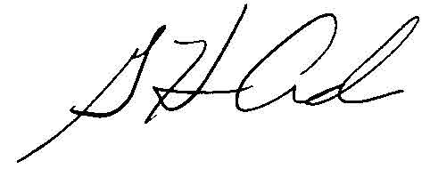  G. Harris Adams,  Interim Director | THE PUBLIC UTILITIES COMMISSION  OF THE STATE OF COLORADO  ERIC BLANK  ________________________________  MEGAN M. GILMAN  ________________________________  TOM PLANT  ________________________________  Commissioners

