Decision No. R23-0180
BEFORE THE PUBLIC UTILITIES COMMISSION OF THE STATE OF COLORADO
PROCEEDING NO. 22AL-0530E
IN THE MATTER OF ADVICE LETTER NO. 1906 - ELECTRIC FILED BY PUBLIC SERVICE COMPANY OF COLORADO TO REVISE ITS COLORADO P.U.C. NO. 8 - ELECTRIC TARIFF TO INCREASE BASE RATE REVENUES, IMPLEMENT NEW BASE RATES FOR ALL ELECTRIC RATE SCHEDULES, AND MAKE OTHER TARIFF CHANGES, TO BECOME EFFECTIVE DECEMBER 31, 2022.
PROCEEDING NO. 22AL-0478E
IN THE MATTER OF ADVICE LETTER NO. 1902 - ELECTRIC FILED BY PUBLIC SERVICE COMPANY OF COLORADO TO REVISE ITS COLORADO P.U.C. NO. 8 - ELECTRIC TARIFF TO INCREASE THE TRANSMISSION COST ADJUSTMENT RIDER, TO BECOME EFFECTIVE JANUARY 1, 2023.
Decision of Hearing commissioner
eric blank
shortening response time
to uca’s motion to compel
Mailed Date: March 14, 2023

Statement, Findings, and Conclusions
- On March 13, 2023, the Office of the Utility Consumer Advocate filed its Motion to Compel and Request for Shortened Response Time. Being duly advised in the motion, I will shorten response time to the motion and direct Public Service Company of Colorado to file a response to the motion by noon on Thursday, March 16, 2023.

ORDER

It Is Ordered That:
- The response time to the Office of the Utility Consumer Advocate’s Motion to Compel is shorted, and Public Service Company of Colorado is directed to file its response to the motion by noon on Thursday, March 16, 2023.
- This Decision is effective upon its Mailed Date.
(S E A L)    ATTEST: A TRUE COPY  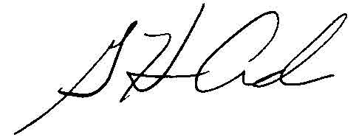  G. Harris Adams,  Interim Director | THE PUBLIC UTILITIES COMMISSION  OF THE STATE OF COLORADO  ERIC BLANK  ________________________________  Hearing Commissioner

