Decision No. R23-0648-I-E
BEFORE THE PUBLIC UTILITIES COMMISSION OF THE STATE OF COLORADO
PROCEEDING NO. 23A-0361G
IN THE MATTER OF THE VERIFIED APPLICATION OF BLACK HILLS COLORADO GAS, INC. FOR APPROVAL OF A NATURAL GAS DEMAND SIDE MANAGEMENT PLAN AND STRATEGIC ISSUES FOR CALENDAR YEARS 2024 AND 2025.
ERRATA NOTICE FOR
INTERIM DECISION OF ADMINISTRATIVE LAW JUDGE ALENKA HAN
GRANTING PERMISSIVE INTERVENTION,
EXTENDING TIME FOR A COMMISSION DECISION, SETTING PROCEDURAL SCHEDULE,
AND SCHEDULING EVIDENTIARY HEARING
Errata mailed December 5, 2023
Original Decision No. R23-0648-I mailed September 28, 2023

- Attachment A titled Requirements And Information On Using Zoom To Attend The Hearing, and Attachment B titled Establishing Procedures; Presentation of Exhibits Electronically During Evidentiary Hearing.
Attachments A and B are attached to this Errata.

(S E A L)    ATTEST: A TRUE COPY  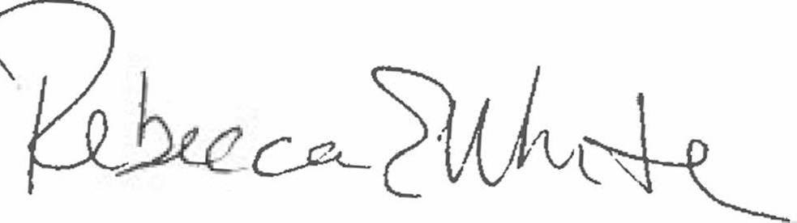  Rebecca E. White,  Director | THE PUBLIC UTILITIES COMMISSION  OF THE STATE OF COLORADO  REBECCA E. WHITE  ________________________________  Director

