Decision No. R23-0478-I
BEFORE THE PUBLIC UTILITIES COMMISSION OF THE STATE OF COLORADO
PROCEEDING NO. 23A-0330E
IN THE MATTER OF APPLICATION OF PUBLIC SERVICE COMPANY OF COLORADO FOR APPROVAL OF A NON-STANDARD EDR CONTRACT, AND FOR DETERMINATION NO CPCN IS NEEDED FOR CUSTOMER-FUNDED TRANSMISSION FACILITIES.
Interim Decision
OF ADMINISTRATIVE LAW JUDGE
G. HARRIS ADAMS
DISCLOSING RELATIONSHIP
Mailed Date: July 26, 2023

STATEMENT
- On June 23, 2023, Public Service Company of Colorado (Public Service or Company) filed an Application for Approval of a Non-Standard Economic Development Rate (EDR) Contract, and for Determination No Certificate of Public Convenience and Necessity (CPCN) is Needed for Customer-Funded Transmission Facilities (Application).
- By Decision No. C23-0472-I, the Commission referred the matter to an Administrative Law Judge (ALJ) for a Recommended Decision.
- The undersigned ALJ discloses that from December 1, 2022, through
April 30, 2023, he also acted as Interim Director of the Public Utilities Commission. In that role, the undersigned interacted with others, including individuals involved in this proceeding and parties to this proceeding, in a different capacity than as a judge. However, the undersigned does not recall any issues being addressed related to this proceeding.
- While the undersigned does not believe acting as Interim Director represents an actual or apparent conflict of interest or bias that would impede his ability to impartially decide matters presented, the prior relationship is disclosed out of an abundance of caution.
- Should any present or future party to this proceeding believe there to be any basis to move for recusal or disqualification of the ALJ, based upon this disclosure or otherwise, a motion should be filed as soon as practicable to raise those concerns.

ORDER

It Is Ordered That:
- Any party wishing to move for recusal or disqualification of the undersigned, considering the within disclosure or otherwise, shall make such request as soon as practicable.
- This Decision is effective immediately.

(S E A L)    ATTEST: A TRUE COPY  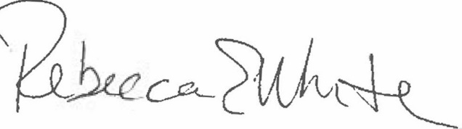  Rebecca E. White,  Director | THE PUBLIC UTILITIES COMMISSION  OF THE STATE OF COLORADO  G. HARRIS ADAMS  ________________________________  Administrative Law Judge

