Decision No. R23-0336-E
BEFORE THE PUBLIC UTILITIES COMMISSION OF THE STATE OF COLORADO
PROCEEDING NO. 22AL-0426G
IN THE MATTER OF ADVICE LETTER NO. 126 FILED BY ROCKY MOUNTAIN NATURAL GAS LLC DOING BUSINESS AS BLACK HILLS ENERGY TO REVISE ITS COLORADO PUC NO. 4 TARIFF FOR AN INCREASE IN RATES AND TO IMPLEMENT OTHER PROPOSED CHANGES, TO BECOME EFFECTIVE NOVEMBER 7, 2022.
ERRATA NOTICE FOR

Recommended decision of
ADMINISTRATIVE LAW JUDGE
ALENKA HAN,
granting motion for approval of settlement, MODIFYING AND approving settlement agreement
Errata mailed May 24, 2023
Original Decision No. R23-0336 mailed on May 19, 2023

- Paragraph 117 on page 37 of Decision No. R23-0336 incorrectly states that period for exceptions and responses will expire “seven days after the issuance of this Decision.” That is incorrect.
The second sentence of Paragraph 117 of Decision No. R23-06336 should be amended to read as follows:
The ALJ notes that the evidentiary hearing addressing approval of the settlement was held April 11-13, 2023; the parties filed Statements of Position on April 27, 2023; a timely decision was issued in due course; and no rates calculated in accordance with the Settlement Agreement can go into effect until the period for exceptions and responses has expired and the Commission has had an opportunity to rule on any exceptions.
- A new paragraph 7 shall be inserted in VI. ORDER of the Decision which states: “Response time to exceptions shall be shortened to seven (7) days.”
- Ordering paragraph 7 shall be renumbered as paragraph 8 and ordering paragraph 8 shall be renumbered as paragraph 9, respectively.
- New Ordering paragraph 8(a) shall be amended to read as follows:
  - If no exceptions are filed within twenty (20) days after service or within any extended period of time authorized, or unless the decision is stayed by the Commission upon its own motion, the recommended decision shall become the decision of the Commission and subject to the provisions of § 40-6-114, C.R.S.

(S E A L)    ATTEST: A TRUE COPY  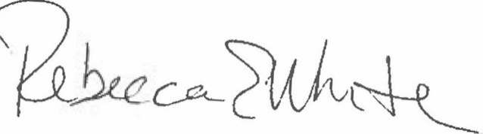  Rebecca E. White,  Director | THE PUBLIC UTILITIES COMMISSION  OF THE STATE OF COLORADO  ALENKA HAN  ________________________________  Administrative Law Judge

