Decision No. R23-0163-I
BEFORE THE PUBLIC UTILITIES COMMISSION OF THE STATE OF COLORADO
PROCEEDING NO. 22G-0333TO
COLORADO PUBLIC UTILITIES COMMISSION,

COMPLAINANT,

V.

Eric Houston doing business as CODE 3 Towing,

RESPONDENT.
INTERIM DECISION OF
ADMINISTRATIVE LAW JUDGE
Aviv segev
Vacating and Rescheduling hearing
Mailed Date: July 30, 2026

STATEMENT
- This proceeding concerns Civil Penalty Assessment Notice (CPAN)
No. 131017 filed by Commission Staff on July 22, 2022 against Eric Houston doing business as Code 3 Towing. (Respondent).
- On February 23, 2023, the ALJ issued Interim Decision No. R23-0131-I that scheduled an evidentiary hearing for March 7, 2023.
- On March 3, 2023 and March 5, 2023, the Commission received correspondence from email account completelandscaping1@yahoo.com (correspondence) indicating that Respondent wished to postpone the evidentiary hearing scheduled for March 7, 2023 due to Respondent’s medical condition and appointments. The correspondence indicates that Respondent was scheduled to have medical appointments, on March 8, 9, and 17, 2023.
- There is no indication that the correspondence was sent to Staff of the Public Utilities Commission (Staff). Therefore, it was filed in this Proceeding.
- Respondent does not currently hold a towing permit issued by this Commission. No prejudice will come to the parties from a short postponement of the evidentiary hearing herein. Therefore, the ALJ will sua sponte vacate the evidentiary hearing scheduled for March 7, 2023, and schedule a new hearing date as ordered below.

ORDER

It Is Ordered That:
- The evidentiary hearing currently scheduled for March 7, 2023, at 9:00 a.m. is vacated.
- An evidentiary hearing in this matter shall be conducted at the following date, time, and place:
DATE: March 23, 2023
TIME: 9:00 a.m.
PLACE: Commission Hearing Room
1560 Broadway, Suite 250
Denver, Colorado 80202
Optionally, any party may participate remotely by joining a video conference using Zoom at the link provided as to the established parties in an e-mail prior to the scheduled hearing, as addressed in Decision No. R23-0062-I.
- The parties and witnesses may not distribute the Zoom link and access code to anyone not participating in the remote hearing, if opted.
- The remaining requirements ordered in Interim Decision Nos. R23-0062-I and R23-0069-I shall remain in effect.
- This Decision shall be effective immediately.

(S E A L)    ATTEST: A TRUE COPY  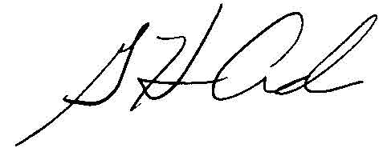  G. Harris Adams,  Interim Director | THE PUBLIC UTILITIES COMMISSION  OF THE STATE OF COLORADO  AVIV SEGEV  ________________________________  Administrative Law Judge

