Decision No. C23-0835
BEFORE THE PUBLIC UTILITIES COMMISSION OF THE STATE OF COLORADO
PROCEEDING NO. 22A-0253R
IN THE MATTER OF THE APPLICATION OF AEROTROPOLIS REGIONAL TRANSPORTATION AUTHORITY FOR AUTHORITY TO CONSTRUCT THE AEROTROPOLIS PARKWAY GRADE SEPARATED CROSSING OVER THE UNION PACIFIC RAILROAD (UPRR) AND SMITH ROAD IN THE CITY OF AURORA, ADAMS COUNTY, STATE OF COLORADO.
commission decision granting motion
for extension of time to provide final plans
Mailed Date: December 15, 2023
Adopted Date: December 13, 2023

by the commission

Statement
- This matter comes before the Commission for consideration of an Unopposed Motion for Extension of Time to File Final Plans (Motion) filed by the Aerotropolis Regional Transportation Authority (Aerotropolis) on November 30, 2023, requesting an extension of time to July 1, 2024, to file the final plans for Commission review and action.
- As grounds for the Motion, Aerotropolis states they have been working diligently in good faith toward completion of the final plans for the proposed new grade separation. However, this grade separation is only a part of a much larger regional transportation system currently being planned, designed, financed, and constructed by Aerotropolis, which components must be planned and designed in a coordinated manner. The complexity of this regional transportation system design has hit unforeseen circumstances delaying the necessary planning and design work which affects the subject crossing. Because of these unforeseen delays, Aerotropolis requests an extension until July 1, 2024 to submit final plans.
- Aerotropolis has conferred with counsel for the Union Pacific Railroad Company, and the Colorado Department of Transportation. Neither opposes the extension of time.
- This is Aerotropolis’s second Motion for Extension of Time to file final plans.
- Now being fully advised in the matter, we grant the Motion.

ORDER

The Commission Orders That:
- The Unopposed Motion for Extension of Time to File Final Plans (Motion) filed by the Aerotropolis Regional Transportation Authority on November 30, 2023, requesting an extension of time to July 1, 2024, to file the final plans for Commission review and action is granted.
- Aerotropolis shall file the final plans for Commission review and action by
July 1, 2024.
- The Commission retains jurisdiction to enter further decisions as necessary.
- This Decision is effective on its Mailed Date.

ADOPTED IN COMMISSIONERS’ WEEKLY MEETING
December 13, 2023.
(S E A L)    ATTEST: A TRUE COPY  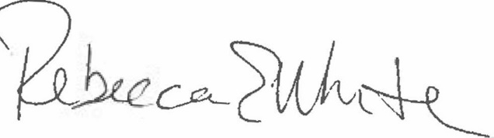  Rebecca E. White,  Director | THE PUBLIC UTILITIES COMMISSION  OF THE STATE OF COLORADO  ERIC BLANK  ________________________________  MEGAN M. GILMAN  ________________________________  TOM PLANT  ________________________________  Commissioners

