Decision No. C23-0521-I
BEFORE THE PUBLIC UTILITIES COMMISSION OF THE STATE OF COLORADO
PROCEEDING NO. 22I-0471R
IN THE MATTER OF THE REGIONAL TRANSPORTATION DISTRICT'S CORRECTIVE ACTION PLAN REGARDING THE SABLE BOULEVARD AND EXPOSITION AVENUE DERAILMENT, RULE 4 CCR 723-7-7347.
Interim COMMISSION DECISION GRANTING Unopposed Motion Requesting Protection of Confidential Information, Decision on Release of Records in Response to Law Enforcement Subpoena, Expedited Review, and Waiver of Response Time
Mailed Date: August 7, 2023
Adopted Date: August 2, 2023

BY THE COMMISSION

Statement
- By this Decision, the Commission grants Regional Transportation District’s (RTD) Unopposed Motion Requesting Protection of Confidential Information, Decision on Release of Records in Response to Law Enforcement Subpoena, Expedited Review, and Waiver of Response Time (Motion), and authorizes RTD to release the records in question.

Discussion, Findings, and Conclusions
- As set forth in the Motion, RTD was recently served a subpoena duces tecum by a law enforcement agency requesting records and all information and data related to RTD’s investigation of the derailment that is the subject of this proceeding. RTD notes that the Derailment Accident Report (which it developed and filed with the Commission) is responsive to the subpoena, and that the report and related information were filed under seal, designated as highly confidential, and once filed, became an investigative report of the Commission. Accordingly, RTD filed this motion seeking a decision from this Commission as to whether it may produce the report in response to the subpoena.
- RTD also requests that the Commission treat redacted sections of its Motion as a confidential filing pursuant to certain statutory sections governing law enforcement investigations, and waive the requirements to file a form nondisclosure agreement and affidavit containing the names of all persons with access to redacted sections of the Motion.
- The Commission finds and concludes that given the ongoing law enforcement investigation the relief requested in the Motion is reasonable and good cause exists to grant the waivers and confidential protection requested in the Motion. We further authorize RTD to disclose the Derailment Accident Report and related information, reports, and other evidence aiding in the formulation of the conclusion as to the cause of the accident in response to the subpoena from the law enforcement agency.

ORDER

It Is Ordered That:
- The Unopposed Motion Requesting Protection of Confidential Information, Decision on Release of Records in Response to Law Enforcement Subpoena, Expedited Review,
and Waiver of Response Time filed on July 28, 2023 by Regional Transportation District is granted.
- Regional Transportation District is authorized to release the Derailment Accident Report and related information, reports, and other evidence aiding in the formulation of the conclusion as to the cause of the accident in response to the subpoena to the law enforcement agency.
- This Decision is effective upon its Mailed Date.

ADOPTED IN COMMISSIONERS’ WEEKLY MEETING
August 2, 2023.
(S E A L)    ATTEST: A TRUE COPY  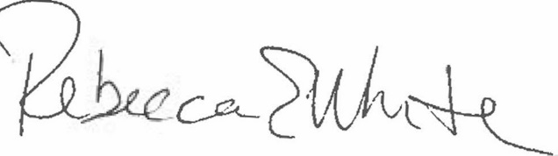  Rebecca E. White,  Director | THE PUBLIC UTILITIES COMMISSION  OF THE STATE OF COLORADO  ERIC BLANK  ________________________________  MEGAN M. GILMAN  ________________________________  TOM PLANT  ________________________________  Commissioners

See § 40-18-104, C.R.S., and Commission Rules 7349(d)(III) and (IV).
§§ 24-72-204(2)(a) -302(4) & -305(5), C.R.S.
Rule 1101(b)(V).
Rule 1101(b)(VI).

