Decision No. C23-0497-I-E
BEFORE THE PUBLIC UTILITIES COMMISSION OF THE STATE OF COLORADO
PROCEEDING NO. 23M-0234G
IN THE MATTER OF THE GAS INFRASTRUCTURE PLAN OF PUBLIC SERVICE COMPANY OF COLORADO FILED PURSUANT TO 4 CODE OF COLORADO REGULATIONS 723-4-4552 OF THE COMMISSION'S RULES REGULATING GAS UTILITIES.
ERRATA NOTICE FOR
Interim commission Decision Adopting Proposed Discovery Parameters
Errata Mailed August 4, 2023
Original Decision No. C23-0497-I mailed on July 28, 2023

- This Decision inadvertently failed to extend the deadline for submission of initial comments from August 9, 2023, to August 10, 2023, consistent with the Commissioners’ decision at the July 19, 2023 Commissioners’ Weekly Meeting.
- The title of the Decision shall be amended to read:
INTERIM COMMISSION DECISION ADOPTING
PROPOSED DISCOVERY PARAMETERS AND
EXTENDING INITIAL COMMENT DEADLINE

- The ordering paragraphs of this Decision shall be amended to renumber existing ordering paragraph 3 and include ordering paragraph 4. These ordering paragraphs shall read as follows:
3. The deadline to file initial comments on Public Service’s Initial 2023-2028 Gas Infrastructure Plan shall be extended from August 9, 2023, to August 10, 2023.
4. This Decision is effective upon its Mailed Date.

(S E A L)    ATTEST: A TRUE COPY  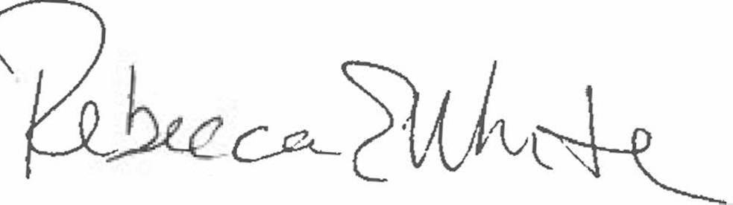  Rebecca E. White,  Director | THE PUBLIC UTILITIES COMMISSION  OF THE STATE OF COLORADO  REBECCA E. WHITE  ________________________________  Director

