Decision No. C23-0304
BEFORE THE PUBLIC UTILITIES COMMISSION OF THE STATE OF COLORADO
PROCEEDING NO. 23A-0122CP-SUSP
IN THE MATTER OF THE APPLICATION OF DNC PARKS & RESORTS AT ROCKY MOUNTAIN PARK INN, INC. DOING BUSINESS AS RIDGELINE TOURS FOR AN ORDER OF THE COMMISSION AUTHORIZING A SUSPENSION OF CERTIFICATE OF PUBLIC CONVENIENCE AND NECESSITY NO. 55947.
commission DECISION granting
suspension OF OPERATIONS
Mailed Date: May 9, 2023
Adopted Date: April 5, 2023

BY THE COMMISSION

Statement, Findings, and Conclusions
- On March 14, 2023, DNC Parks & Resorts at Rocky Mountain Park Inn, Inc., doing business as Ridgeline Tours (Ridgeline Tours) filed an application seeking approval to suspend operations under Certificate of Public Convenience and Necessity (CPCN) PUC No. 55947, from March 3, 2023, through March 2, 2024.
- The Commission noticed this application to all interested persons, firms, and corporations pursuant to § 40-6-108(2), C.R.S., on March 20, 2023, for a period of ten days. The notice period expired on March 30, 2023.
- No petition to intervene or otherwise participate in this proceeding has been filed. This proceeding is uncontested. Under § 40-6-109(5), C.R.S., this matter may be determined without a hearing.
- In support of this suspension application, a manager of Ridgeline Tours states:
Ridgeline Tours recently stopped performing the passenger transportation in Colorado, including the services authorized under the Certificate of Public Convenience and Necessity (CPCN). That said, there is a potential for Ridgeline Tours to recommence these operations in the near future.
- In consideration of the information submitted by Ridgeline Tours with this application, the Commission finds that the suspension of CPCN PUC No. 55947 is in the public interest and will be granted for the requested 12-month period.

ORDER

The Commission Orders That:
- This application was deemed complete on April 5, 2023, within the meaning of § 40-6-109.5, C.R.S.
- The application filed by DNC Parks & Resorts at Rocky Mountain Park Inn, Inc., doing business as Ridgeline Tours (Ridgeline Tours) on March 14, 2023, for approval to suspend operations under Certificate of Public Convenience and Necessity (CPCN) PUC No. 55947 is granted nunc pro tunc from March 3, 2023 through March 2, 2024.
- On March 3, 2024, CPCN PUC No. 55947 shall be administratively reactivated.
- Prior to commencing operations, Ridgeline Tours shall: (a) cause proof of insurance or surety bond coverage to be filed with the Commission pursuant to Rule 6008,
4 Code of Colorado Regulations 723-6; (b) pay to the Commission the applicable vehicle identification fee for each vehicle to be operated under authority granted by the Commission; and, (c) ensure that an effective tariff is on file with the Commission, in compliance with applicable Commission rules.
- The 20-day time period provided by § 40-6-114(1), C.R.S., to file an application for rehearing, reargument, or reconsideration shall begin on the first day after the Commission mails or serves this Decision.
- This Decision is effective on its Mailed Date.

ADOPTED IN COMMISSIONERS' WEEKLY MEETING
April 5, 2023.
(S E A L)    ATTEST: A TRUE COPY  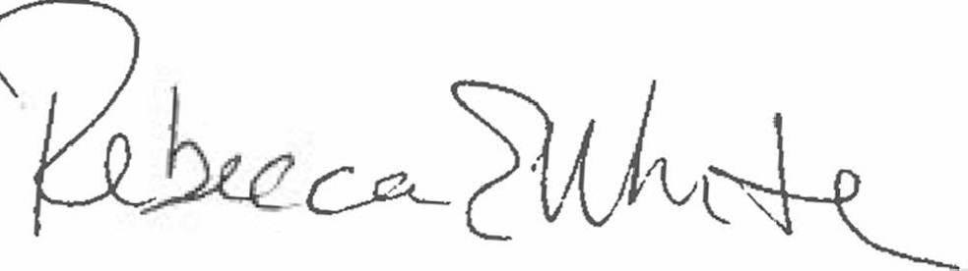  Rebecca E. White,  Director | THE PUBLIC UTILITIES COMMISSION  OF THE STATE OF COLORADO  ERIC BLANK  ________________________________  MEGAN M. GILMAN  ________________________________  TOM PLANT  ________________________________  Commissioners

Ridgeline Tours, under CPCN PUC No. 55947 may provide: (I) call-and-demand sightseeing service originating at the Ridgeline Hotel, 101 South St. Vrain Avenue, Estes Park, Colorado, to all points in Larimer County, State of Colorado, returning to the origination point; and, (II) call-and-demand charter service between all points in Larimer County, Colorado, and between said points, on the one hand, and all points in the State of Colorado, on the other hand. Restrictions: This certificate is restricted: A. against providing any transportation service to or from the Denver International Airport; and B. to service involving vehicles with a seating capacity of less than 15 passengers (excluding the driver).

