Decision No. C22-0773-E
BEFORE THE PUBLIC UTILITIES COMMISSION OF THE STATE OF COLORADO
PROCEEDING NO. 20M-0109R
REPOSITORY DOCKET FOR THREE-YEAR STATE SAFETY OVERSIGHT AUDIT AND INVESTIGATIONS OF THE REGIONAL TRANSPORTATION DISTRICT.
ERRATA NOTICE FOR
Commission DECISION adopting
accident investigation reports
Errata mailed December 2, 2022
Original Decision No. C22-0773 mailed December 1, 2022

The Decision Title below is incorrect:
COMMISSION DECISION APROVING
CORRECTIVE ACTION PLANS

The Decision Title should be replaced to read as follows:
COMMISSION DECISION ADOPTING
ACCIDENT INVESTIGATION REPORTS
The Entire Decision should be replaced to read as follows:

BY THE COMMISSION

Statement
- This matter comes before the Commission for consideration of formal adoption of ten accident investigation reports submitted by the metro Denver area Regional Transportation District light rail operation. The investigation reports are for ten accidents between the dates of April 1, 2022 and June 30, 2022. A report summarizing these accidents was filed by Staff of the Public Utilities Commission (Staff) on November 30, 2022.
- The accident numbers for the ten accidents reviewed by the Commission are:
A1-04052022, A1-04302022, A2-04302022, A1-05062022, A1-05132022, A1-05182022, A1-05292022, A106192022, A1-06252022, A1-06262022.

- The Commission has reviewed the summary report filed by Staff and concurs with Staff’s review of the investigation reports and recommendations.
- The Commission has jurisdiction in this matter under § 40-18-103, C.R.S., and Rule 7349 of the Rules Regulating Railroads, Rail Fixed Guideways, Transportation by Rail, and Rail Crossings, 4 Code of Colorado Regulations 723-7.

ORDER

The Commission Orders That:
- The Commission formally adopts investigation reports A1-04052022, A1-04302022, A2-04302022, A1-05062022, A1-05132022, A1-05182022, A1-05292022, A1-06192022, A1-06252022 and A1-06262022, submitted by the metro Denver area Regional Transportation District light rail operations.

- This Decision is effective on its Mailed Date.
(S E A L)    ATTEST: A TRUE COPY  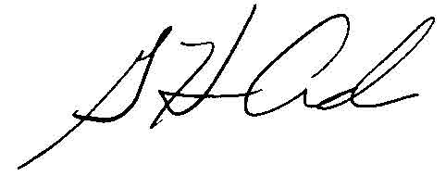  G. Harris Adams,  Interim Director | THE PUBLIC UTILITIES COMMISSION  OF THE STATE OF COLORADO  G. HARRIS ADAMS  ________________________________  Interim Director

