Attachment A

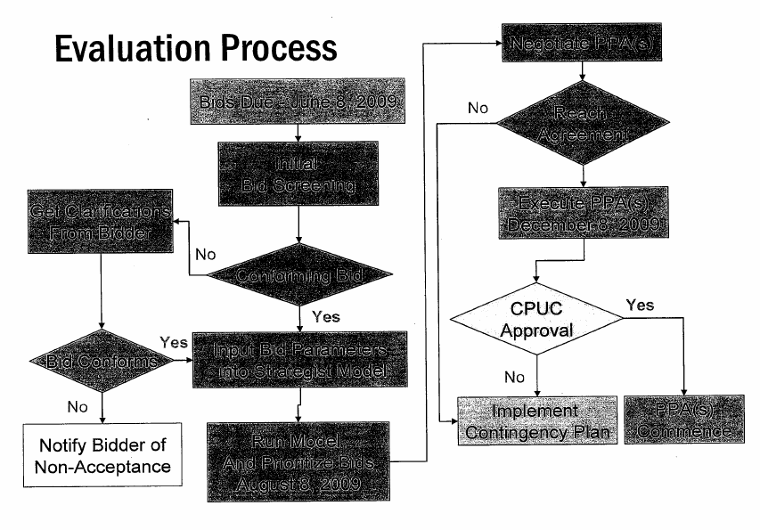
Yes
No
Implement Revised Contingency Plan
Cross hatch denotes lines to be deleted
Yes

