Decision No. C04-0131
BEFORE THE PUBLIC UTILITIES COMMISSION OF THE STATE OF COLORADO
DOCKET NO. 03A-550T
IN THE MATTER OF THE APPLICATION for a transfer of assets to lightyear network solutions, llc from lightyear communications, inc. and lightyear telecommunications, llc.
Order granting application
Mailed Date: February 5, 2004
Adopted Date: February 4, 2004

BY THE COMMISSION

Statement
- On December 23, 2003, Lightyear Communications, Inc. (Lightyear), and Lightyear Network Solutions, LLC (New Lightyear) filed an application to execute a transfer whereby Lightyear will transfer its assets and the telecommunications authorities issued by this Commission to New Lightyear pursuant to 4 Code of Colorado Regulations (CCR) 723-25-8 and 4 CCR 723-25-4.
- Lightyear was granted a Certificate to provide local exchange telecommunications services and a Letter of Registration to provide emerging competitive telecommunications services in Commission Decision No. C03-0645.
- Lightyear is currently a wholly-owned subsidiary of Lightyear Holdings, Inc. As a result of the transaction, Lightyear will be merged into New Lightyear, which will obtain the existing operating authorities held by Lightyear.
- The application contains information for the Commission to consider a grant of authority to New Lightyear, as required in 4 CCR 723-25-8 of a transferee that does not have a certificate of public convenience and necessity of its own, as is the case with New Lightyear.
- Notice of the application was posted on the Commission's web site on December 29, 2003. Interventions were due on or before January 28, 2004. None were filed.

Discussion
- The application is unopposed and may be considered without a hearing. § 40-6-109(5), C.R.S.
- The Commission finds that the proposed transfer of authorities is not contrary to the public interest.

ORDER

The Commission Orders That:
- The application by Lightyear Communications, Inc., and Lightyear Network Solutions, LLC is deemed complete.
- Lightyear Network Solutions, LLC is issued a grant of authority to effectuate the transfer of authorities issued by this Commission and held by Lightyear Communications, Inc.
- The application to approve the transfer assets and authorities held by Lightyear Communications, Inc., to Lightyear Network Solutions, LLC is granted.
- The obligation of Lightyear Communications, Inc., to file an annual report with the Commission and contribute to all applicable Colorado funds for the period prior to the effective date of this Order remains. These funds include the Public Utilities Commission's Fixed Utilities Fund, the Colorado High Cost Administration Fund, the Telecommunications Relay Services for the Disabled Telephone Users Program, and the Emergency Telephone Access Act Program.
- Lightyear Network Solutions, LLC is authorized to file for adoption of Lightyear Communications, Inc.’s tariffs currently on file with the Commission on one day’s notice.
- This Order is effective on its Mailed Date.

ADOPTED IN COMMISSIONERS’ WEEKLY MEETING
February 4, 2004.

THE PUBLIC UTILITIES COMMISSION
OF THE STATE OF COLORADO
GREGORY E. SOPKIN
________________________________
POLLY PAGE
________________________________
JIM DYER
________________________________
Commissioners
(S E A L)


ATTEST: A TRUE COPY
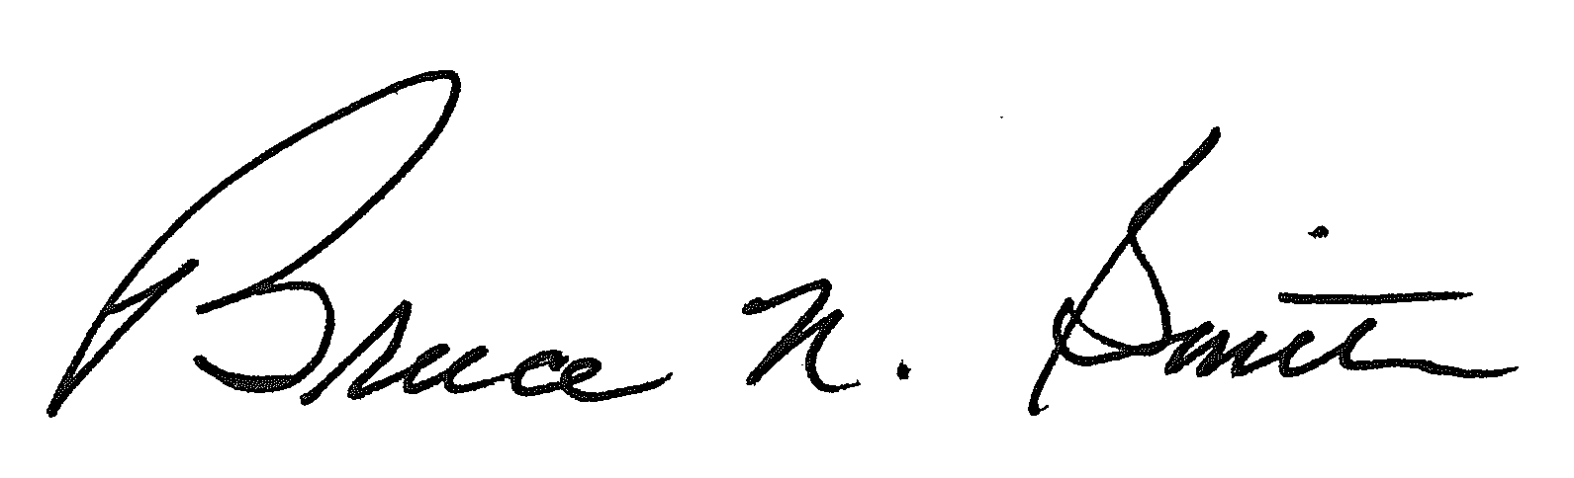
Bruce N. Smith
Director
/tmp/in/input.doc

