Decision No. R03-1346
BEFORE THE PUBLIC UTILITIES COMMISSION OF THE STATE OF COLORADO
DOCKET NO. 03A-442CP
IN THE MATTER OF THE APPLICATION OF EAST WEST TRANSPORTATION, LLC, DOING BUSINESS AS COLORADO MOUNTAIN EXPRESS &/OR CME PREMIER &/OR PREMIER VIP TRANSPORTATION &/OR RESORT EXPRESS, FOR AN ORDER OF THE COMMISSION AUTHORIZING A SUSPENSION OF OPERATIONS UNDER A PORTION OF CERTIFICATE OF PUBLIC CONVENIENCE AND NECESSITY PUC NO. 13123.
Recommended decision of
administrative law judge
ken f. kirkpatrick
dismissing application
Mailed Date: December 2, 2003

statement
- This application was filed on October 14, 2003 by Applicant East West Resort Transportation, LLC. The Commission gave notice of the application on October 27, 2003. An intervention was filed on November 10, 2003 by Rainbows, Inc.
- On November 20, 2003, Applicant filed its Motion to Withdraw Docket No. 03A-442CP-Suspension. Applicant states that it seeks to file an application to abandon a portion of the affected certificate. The motion should be granted and the application dismissed. The hearing scheduled for December 3, 2003 is vacated.
- In accordance with § 40-6-109, C.R.S., it is recommended that the Commission enter the following order.

ORDER

The Commission Orders That:
- Docket No. 03A-442CP, being an application of East West Resort Transportation, LLC, is dismissed. The hearing in this matter scheduled for December 3, 2003 is vacated.
- This Recommended Decision shall be effective on the day it becomes the Decision of the Commission, if that is the case, and is entered as of the date above.
- As provided by § 40-6-109, C.R.S., copies of this Recommended Decision shall be served upon the parties, who may file exceptions to it.
- If no exceptions are filed within 20 days after service or within any extended period of time authorized, or unless the decision is stayed by the Commission upon its own motion, the recommended decision shall become the decision of the Commission and subject to the provisions of § 40-6-114, C.R.S.
- If a party seeks to amend, modify, annul, or reverse basic findings of fact in its exceptions, that party must request and pay for a transcript to be filed, or the parties may stipulate to portions of the transcript according to the procedure stated in § 40-6-113, C.R.S. If no transcript or stipulation is filed, the Commission is bound by the facts set out by the administrative law judge and the parties cannot challenge these facts. This will limit what the Commission can review if exceptions are filed.
- If exceptions to this Decision are filed, they shall not exceed 30 pages in length, unless the Commission for good cause shown permits this limit to be exceeded.

THE PUBLIC UTILITIES COMMISSION
OF THE STATE OF COLORADO
KEN F. KIRKPATRICK
________________________________
Administrative Law Judge
(S E A L)

ATTEST: A TRUE COPY
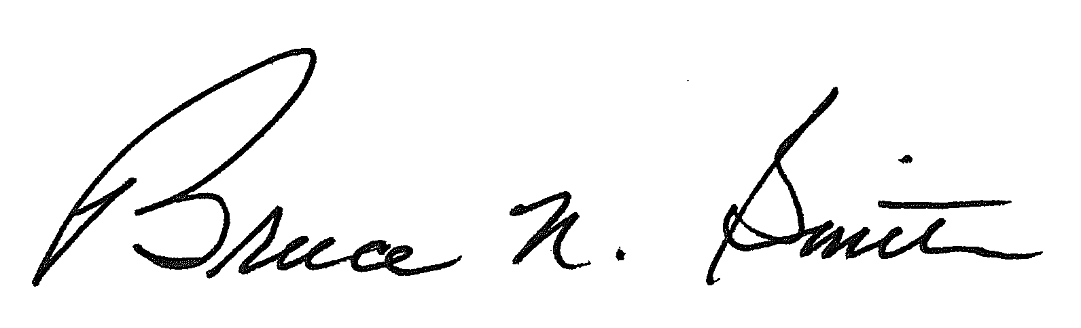
Bruce N. Smith
Director
/tmp/in/input.doc:srs

