Decision No. R03-1343-I
BEFORE THE PUBLIC UTILITIES COMMISSION OF THE STATE OF COLORADO
DOCKET NO. 03A-432CP
in the matter of the application of rocky mountain powder, inc., 4950 south yosemite, f-2, #118, greenwood village, colorado 80111 for a certificate of public convenience and necessity to operate as a common carrier by motor vehicle for hire.
interim order of
administrative law judge
dale e. isley
vacating and re-scheduling hearing
Mailed Date: December 1, 2003

statement
- The captioned application of Rocky Mountain Powder, Inc. (RMPI), was filed with the Colorado Public Utilities Commission on September 29, 2003, and was originally “noticed” on October 6, 2003. The matter is currently scheduled for hearing on December 9, 2003.
- On November 25, 2003, RMPI file a Motion to Amend Application With Expedited Re-Notice (Motion). The Motion was granted on November 28, 2003. See, Decision No. R03-1339-I. The amended RMPI application will be re-noticed on December 1, 2003, for a period of ten days.
- Since the re-notice period will not expire until after the currently scheduled hearing date, it is necessary to vacate that date and re-schedule the hearing to a later date.

order

It Is Ordered That:
- The hearing of this matter, currently scheduled for December 9, 2003, is vacated.
- This matter is re-scheduled for hearing as follows:
DATE: January 12, 2004
TIME: 9:00 a.m.
PLACE: Commission Hearing Room
1580 Logan Street, Office Level 2
Denver, Colorado
- This Order shall be effective immediately.

THE PUBLIC UTILITIES COMMISSION
OF THE STATE OF COLORADO
DALE E. ISLEY
________________________________
Administrative Law Judge
(S E A L)

ATTEST: A TRUE COPY
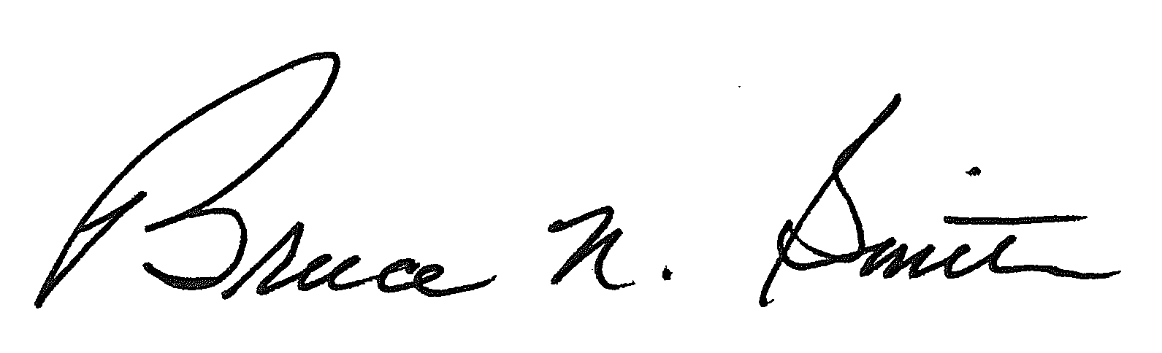
Bruce N. Smith
Director
/tmp/in/input.doc:srs

On November 21, 2003, RMPI and those who had intervened in this matter within the initial notice period filed motions to withdraw their respective interventions upon approval of the restrictive amendments described therein. It is anticipated that RMPI’s amended application will incorporate these restrictive amendments thereby making the subject motions moot. Nonetheless, they will be held in abeyance pending expiration of the re-notice period. If interventions are not filed in connection with the amended application, it can be handled under modified procedure and the re-scheduled hearing date can also be vacated.

