Decision No. R03-1315-I
BEFORE THE PUBLIC UTILITIES COMMISSION OF THE STATE OF COLORADO
DOCKET NO. 03G-472CP
Colorado public utilities commission,
complainant,
v.
east west resort transportation, llc, doing business as
colorado mountain express and/or CME Premier and/or
premier vip transportation and/or resort express
a/k/a colorado mountain express, llc,
respondent.
INTERIM ORDER OF
ADMINISTRATIVE LAW JUDGE
MANA L. JENNINGS-FADER
granting unopposed motion,
vacating hearing, and
requiring filing
Mailed Date: November 24, 2003

statement
- On October 29, 2003, the Commission set the hearing in this matter for November 28, 2003, at 9:00 a.m. See Order Setting Hearing and Notice of Hearing.
- On November 14, 2003, Respondent East West Resort Transportation, LLC, doing business as Colorado Mountain Express and/or CME Premier and/or Premier VIP Transportation and/or Resort Express, also known as Colorado Mountain Express, LLC (Respondent) filed a Motion for Continuance (Motion). In its Motion Respondent states that it has recently retained counsel, that counsel requires additional time to investigate the factual and legal issues in this proceeding, and that already-scheduled staff absences due to the Thanksgiving holiday will hamper Respondent’s preparation and presentation of its defense in this matter.
- The only parties in this proceeding are Respondent and Staff of the Commission (Staff). Staff has no objection to the granting of the Motion.
- The Motion states good cause and is unopposed. No party will be prejudiced by the granting of the Motion. The Motion will be granted. The hearing in this matter scheduled for November 28, 2003, will be vacated.
- It is necessary to schedule a new hearing date. On or before December 3, 2003, Respondent shall file a list of three proposed hearing dates. This filing must be based on discussions held with counsel for Staff and must reflect dates acceptable to all parties. If possible, the Administrative Law Judge (ALJ) will select a date based on this filing. If the parties are unable to agree on proposed dates, Respondent shall make a filing, on or before December 3, 2003, which informs the ALJ of this fact. In that event, the ALJ will select the hearing date.

ORDER

It Is Ordered That:
- The Motion for Continuance is granted.
- The hearing in this matter scheduled for November 28, 2003, is vacated.
- On or before December 3, 2003, East West Resort Transportation, LLC, doing business as Colorado Mountain Express and/or CME Premier and/or Premier VIP Transportation and/or Resort Express, also known as Colorado Mountain Express, LLC, shall make the filing specified above.
- This Order is effective immediately.

THE PUBLIC UTILITIES COMMISSION
OF THE STATE OF COLORADO
MANA L. JENNINGS-FADER
________________________________
Administrative Law Judge
(S E A L)

ATTEST: A TRUE COPY
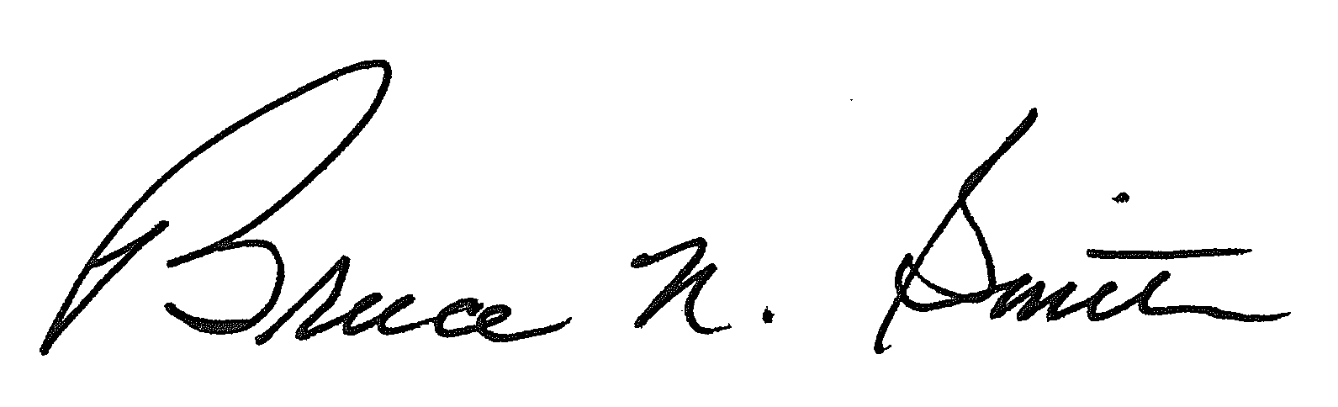
Bruce N. Smith
Director
/tmp/in/input.doc:srs

