Decision No. R03-1302
BEFORE THE PUBLIC UTILITIES COMMISSION OF THE STATE OF COLORADO
DOCKET NO. 03A-434CP
IN THE MATTER OF THE APPLICATION OF silverpick tours l.l.c. for a certificate of public convenience and necessity to operate as a common carrier by motor vehicle for hire.
RECOMMENDED DECISION OF
ADMINISTRATIVE LAW JUDGE
mana l. jennings-fader
GRANTING stipulated motions to
amend application, dismissing
interventions, granting application
under modified procedure,
and closing docket
Mailed Date: November 20, 2003

STATEMENT
- By its Application for a Certificate of Public Convenience and Necessity to Operate as a Common Carrier by Motor Vehicle for Hire (Application), Silverpick Tours L.L.C. (Applicant) seeks a Commission-issued Certificate of Public Convenience and Necessity (CPCN) to provide transportation service as a common carrier as more specifically described in the Notice of Application Filed. The Application, filed on September 29, 2003, commenced this docket.
- On October 6, 2003, the Commission gave public notice of the Application in the Notice of Applications Filed (Notice). See Notice, dated October 6, 2003, at 2. The Notice, inter alia, established a procedural schedule and scheduled the hearing in this matter for December 10, 2003.
- On October 15, 2003, San Miguel Mountain Ventures, LLC, doing business as Telluride Express (Telluride Express), timely filed an intervention of right. On October 23, 2003, Durango Transportation, Inc. (DTI), timely filed an intervention of right. These are the only interventions in this proceeding.
- On November 10, 2003, by Decision No. R03-1263-I, the undersigned Administrative Law Judge (ALJ) vacated the December 10, 2003, hearing.
- On November 12, 2003, Applicant and Telluride Express filed a Stipulated Motion to Restrictively Amend Application and for Dismissal of Intervenor’s Intervention (Telluride Stipulated Motion).
- On November 14, 2003, Applicant and DTI filed a Stipulated Motion to Restrictively Amend Application and for Dismissal of Intervenor’s Intervention (DTI Stipulated Motion).
- On November 18, 2003, by Decision No. R03-1290-I, the ALJ vacated the procedural schedule in this proceeding.
- Each of the Stipulated Motions states that, in exchange for Applicant’s agreement to limit the authority sought as set out in the Stipulated Motion, the signatory intervenor will withdraw its intervention. Each of the Stipulated Motions contains Applicant’s agreement to limit the authority sought in the manner set out in the Stipulated Motion.
- The proposed amendments are restrictive in nature, are clear and understandable, and are administratively enforceable. The Stipulated Motions state good grounds, granting the Stipulated Motions will not prejudice any party, and the Stipulated Motions will be granted.
- Granting the Stipulated Motions has two impacts. First, the Application will be amended to conform with the restrictions. Second, the intervention of Telluride Express and the intervention of DTI will be dismissed.
- Dismissal of the two interventions leaves the Application uncontested. The Application now may be processed under the modified procedure, pursuant to § 40-6-109(5), C.R.S., and Rule 4 Code of Colorado Regulations (CCR) 723-1-24, without a formal hearing.
- In accordance with § 40-6-109, C.R.S., the undersigned ALJ now transmits to the Commission the record in this proceeding along with a written recommended decision.

FINDINGS AND CONCLUSIONS
- By the Application, as amended, Applicant seeks Commission issuance of a CPCN to operate as a common carrier by motor vehicle for hire. Applicant seeks a Letter of Authority (i.e., a CPCN) to provide:
transportation of
passengers and their baggage in sightseeing service
between all points in the Counties of San Miguel and Ouray, State of Colorado, and between said points, on the one hand, and all points in the Counties of Dolores, Montezuma, and Montrose, State of Colorado, on the other hand.
RESTRICTIONS: This authority is restricted as follows:
(1) against any transportation service to or from the Montrose Airport, which airport is located at or near Montrose, Colorado;
(2) against any transportation service to or from the Telluride Regional Airport, which airport is located at or near Telluride, Colorado; and
(3) against any transportation service which originates in or terminates in Montezuma County.
- The verified Application establishes that Applicant is familiar with the Rules, Regulations, and Civil Penalties Governing Common Carriers of Passengers by Motor Vehicle for Hire, 4 CCR 723-31, and agrees to be bound by, and to comply with, those Rules. The verified Application and its supporting documentation also establish that Applicant has sufficient equipment with which to render the proposed service and is financially fit to conduct operations under the authority requested. Therefore, Applicant is fit, financially and otherwise, to provide the proposed service.
- Review of the verified Application and its supporting documentation indicates a need for the proposed service.
- In accordance with § 40-6-109, C.R.S., the ALJ recommends that the Commission enter the following order.

ORDER

The Commission Orders That:
- The Stipulated Motion of Silverpick Tours L.L.C. and San Miguel Mountain Ventures, LLC, doing business as Telluride Express, to Restrictively Amend Application and for Dismissal of Intervenor’s Intervention is granted.
- The intervention filed by San Miguel Mountain Ventures, LLC, doing business as Telluride Express, is dismissed.
- The Stipulated Motion of Silverpick Tours L.L.C. and Durango Transportation, Inc., to Restrictively Amend Application and for Dismissal of Intervenor’s Intervention is granted.
- The intervention filed by Durango Transportation, Inc., is dismissed.
- The Application for a Certificate of Public Convenience and Necessity to Operate as a Common Carrier by Motor Vehicle for Hire filed by Silverpick Tours L.L.C., as that Application has been amended, is granted.
- Silverpick Tours L.L.C. is hereby granted a Letter of Authority to read as follows:
transportation of
passengers and their baggage in sightseeing
service between all points in the Counties of San Miguel and Ouray, State of Colorado, and between said points, on the one hand, and all points in the Counties of Dolores, Montezuma, and Montrose, State of Colorado, on the other hand.
RESTRICTIONS: This authority is restricted as follows:
(1) against any transportation service to or from the Montrose Airport, which airport is located at or near Montrose, Colorado;
(2) against any transportation service to or from the Telluride Regional Airport, which airport is located at or near Telluride, Colorado; and
(3) against any transportation service which originates or terminates in Montezuma County.
- Silverpick Tours L.L.C. shall file an appropriate tariff with the Commission.
- Silverpick Tours L.L.C. shall cause to be filed with the Commission certificates of insurance as required by Commission rules.
- Silverpick Tours L.L.C. shall pay the issuance fee and annual vehicle identification fees.
- Silverpick Tours L.L.C. may not begin operations until it has met the requirements set out in Ordering Paragraphs 7 through 9, above.
- If Silverpick Tours L.L.C. does not comply with the requirements of Ordering Paragraphs 7 through 9, above, within 60 days of the effective date of this Order, then Ordering Paragraphs 5 and 6, above, shall be void. On good cause shown, the Commission may grant additional time for compliance.
- Docket No. 03A-434CP is closed.
- This Recommended Decision shall be effective on the day it becomes the Decision of the Commission, if that is the case, and is entered as of the date above.
- As provided by § 40-6-106, C.R.S., copies of this Recommended Decision shall be served upon the parties, who may file exceptions to it.
- If no exceptions are filed within 20 days after service or within any extended period of time authorized, or unless the recommended decision is stayed by the Commission upon its own motion, the recommended decision shall become the decision of the Commission and subject to the provisions of § 40-6-114, C.R.S.
- If a party seeks to amend, modify, annul, or reverse a basic finding of fact in its exceptions, that party must request and pay for a transcript to be filed, or the parties may stipulate to portions of the transcript according to the procedure stated in § 40-6-113, C.R.S. If no transcript or stipulation is filed, the Commission is bound by the facts set out by the administrative law judge; and the parties cannot challenge these facts. This will limit what the Commission can review if exceptions are filed.
- If exceptions to this Recommended Decision are filed, they shall not exceed 30 pages in length, unless the Commission for good cause shown permits this limit to be exceeded.

THE PUBLIC UTILITIES COMMISSION
OF THE STATE OF COLORADO
MANA L. JENNINGS-FADER
________________________________
Administrative Law Judge
(S E A L)

ATTEST: A TRUE COPY
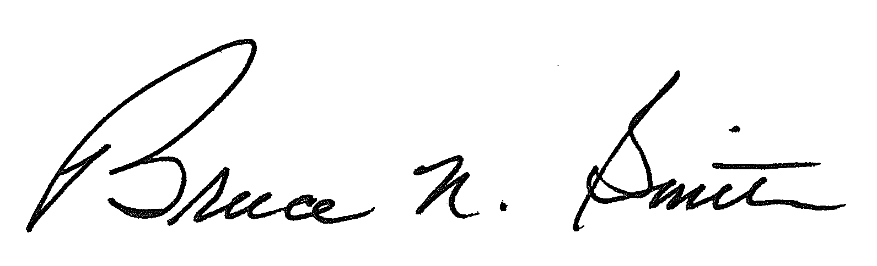
Bruce N. Smith
Director
/tmp/in/input.doc:srs

In this Order the Telluride Stipulated Motion and the DTI Stipulated Motion, collectively, are referred to as the Stipulated Motions.

