Decision No. R03-1290-I
BEFORE THE PUBLIC UTILITIES COMMISSION OF THE STATE OF COLORADO
DOCKET NO. 03A-434CP
IN THE MATTER OF THE APPLICATION OF silverpick tours l.l.c. for a certificate of public convenience and necessity to operate as a common carrier by motor vehicle for hire.
interim order of
administrative law judge
MANA L. JENNINGS-FADER
vacating filing requirement
and vacating procedural schedule
Mailed Date: November 18, 2003

statement
- On September 29, 2003, Silverpick Tours L.L.C. (Applicant) filed its Application for a Certificate of Public Convenience and Necessity to Operate as a Common Carrier by Motor Vehicle for Hire (Application). That Application commenced this docket.
- On October 6, 2003, the Commission gave public notice of the Application in the Notice of Applications Filed (Notice). See Notice of Applications Filed, dated October 6, 2003, at 2. The Notice, inter alia, established a procedural schedule and scheduled the hearing in this matter for December 10, 2003.
- San Miguel Mountain Ventures, LLC, doing business as Telluride Express (Telluride Express), timely filed an intervention of right. Durango Transportation, Inc. (DTI), timely filed an intervention of right. These are the only interventions.
- On November 10, 2003, by Decision No. R03-1263-I, the undersigned Administrative Law Judge (ALJ) vacated the December 10, 2003, hearing and ordered Applicant to file, on or before November 21, 2003, a list of three proposed hearing dates in January or February 2004 and the city in which the hearing should be held. The ALJ would select a date and a hearing location based on this filing.
- On November 12, 2003, Applicant and Telluride Express filed a Stipulated Motion to Restrictively Amend Application and for Dismissal of Intervenor’s Intervention. On November 14, 2003, Applicant and DTI filed a Stipulated Motion to Restrictively Amend Application and for Dismissal of Intervenor’s Intervention. If the two stipulations are approved, the only interventions will be dismissed and the Application will be unopposed.
- In view of the two stipulations, the ALJ will vacate the requirement that Applicant file proposed hearing dates on or before November 21, 2003. In addition, the procedural schedule established in the Notice and set out in Decision No. R03-1263-I at ¶ 8 will be vacated. If the two stipulations are not accepted, a procedural schedule and a hearing date will be established by subsequent Order.

order

It Is Ordered That:
- The requirement in Decision No. R03-1263-I that Applicant Silverpick Tours L.L.C. make a filing, on or before November 21, 2003, is vacated.
- The procedural schedule established in the Notice of Applications Filed, dated October 6, 2003, and contained in ¶ 8 of Decision No. R03-1263-I is vacated.
- If necessary, a procedural schedule and a hearing date will be established in a future order.
- This Order shall be effective immediately.

THE PUBLIC UTILITIES COMMISSION
OF THE STATE OF COLORADO
MANA L. JENNINGS-FADER
________________________________
Administrative Law Judge
(S E A L)

ATTEST: A TRUE COPY
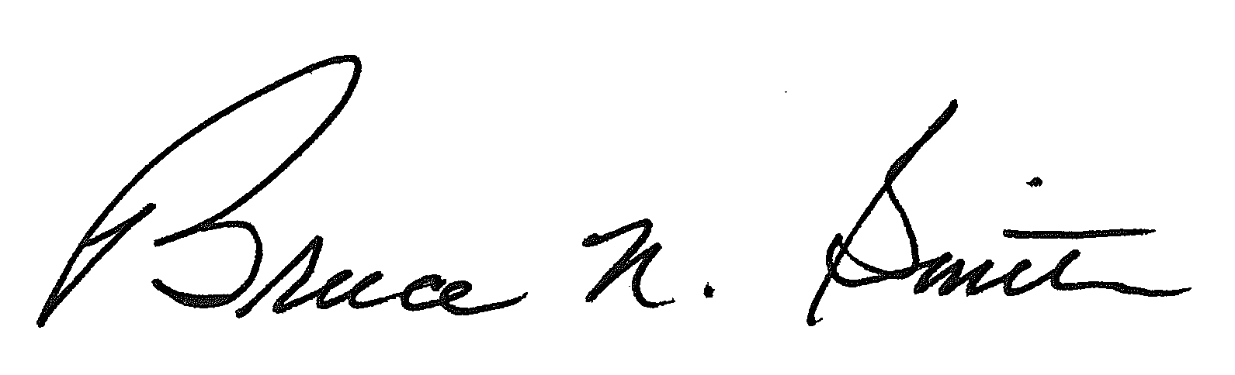
Bruce N. Smith
Director
/tmp/in/input.doc:srs

