Decision No. R03-1268-I
BEFORE THE PUBLIC UTILITIES COMMISSION OF THE STATE OF COLORADO
DOCKET NO. 98M-147T
REGARDING THE ADMINISTRATION OF THE COLORADO HIGH COST FUND AND THE ADOPTION OF A PROXY COST MODEL.
interim order of
administrative law judge
ken f. kirkpatrick
accepting status report
and vacating status hearing
Mailed Date: November 12, 2003

statement
- A status hearing in this proceeding was established by Decision No. R03-0923-I, August 15, 2003. That Decision noted that the hearing may be vacated should an adequate status report be filed in advance of the hearing.
- On November 7, 2003, Staff of the Commission filed its Motion to Accept Staff’s 2003 Status Report in Lieu of Status Hearing and Request for Waiver of Response Time. Attached to the motion was a Proxy Model Status Report for November 2003. The status report contains a discussion of the events that have occurred over the last three months, as well as discussing future tasks that need to be addressed.
- The Administrative Law Judge has read the status report and determines that it is sufficient and that there is no need for a hearing. Therefore the hearing scheduled for November 13, 2003 is vacated. The next status hearing is scheduled for February 12, 2004 pursuant to Decision No. R03-0923-I.

ORDER

It Is Ordered That:
- The status hearing in this matter scheduled for November 13, 2003 is vacated. The next status hearing remains scheduled for:
DATE: February 12, 2004
TIME: 9:00 a.m.
PLACE: Commission Hearing Room
1580 Logan Street, OL2
Denver, Colorado
- This Order shall be effective immediately.

THE PUBLIC UTILITIES COMMISSION
OF THE STATE OF COLORADO
KEN F. KIRKPATRICK
________________________________
Administrative Law Judge
(S E A L)

ATTEST: A TRUE COPY
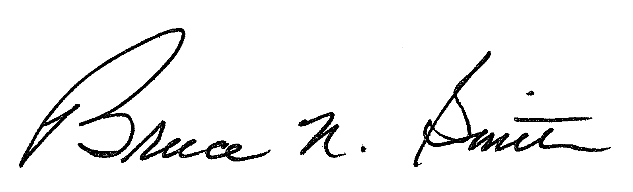
Bruce N. Smith
Director
/tmp/in/input.doc:srs

