Decision No. C03-1365
BEFORE THE PUBLIC UTILITIES COMMISSION OF THE STATE OF COLORADO
DOCKET NO. 03M-509T
IN THE MATTER OF THE request of the AT&T communications of the mountain states, inc. for commission approval of an operational test.
decision granting application for variance
Mailed Date: December 4, 2003
Adopted Date: December 3, 2003

BY THE COMMISSION

Statement
- This matter comes before the Commission for consideration of AT&T Communications of the Mountain States, Inc.'s (AT&T) request filed on November 24, 2003 for approval of an operational test to offer residential local telephone service. AT&T acknowledges that it may not be able to strictly comply with Commission rules during the trial and requests that the Commission allow it to conduct a market trial with this understanding.
- AT&T in its filing included additional information that was provided to the Commission under protective seal. The information provided additional disclosure related to the market trial to be conducted.
- The Commission will treat AT&T’s request as a motion for variance of our telecommunications rules related to the offering of telecommunications services.. No specific ending date to the variance of Commission rules was identified in AT&T’s request.
- Notice of the filing was posted on the Commission's web site on December 1, 2003.
- We encourage alternative market entry strategies for competitors in the telecommunications market. The Colorado Legislature has directed this Commission to encourage competition and AT&T’s request to conduct a market trial may increase the level of competition to the benefit of consumers. Therefore, we grant AT&T's request to conduct a market trial for residential local exchange services and in turn allow a temporary variance to Commission rules related to the offering of these services until May 11, 2004.

ORDER

The Commission Orders That:
- AT&T Communications of the Mountain States, Inc.’s request for a variance of the Commission’s telecommunication rules for the purpose of conducting a market trial is granted. The variance shall continue until May 11, 2004.
- This Order is effective on its Mailed Date.

ADOPTED IN COMMISSIONERS’ WEEKLY MEETING
December 3, 2003.

THE PUBLIC UTILITIES COMMISSION
OF THE STATE OF COLORADO
GREGORY E. SOPKIN
________________________________
POLLY PAGE
________________________________
JIM DYER
________________________________
Commissioners
(S E A L)


ATTEST: A TRUE COPY
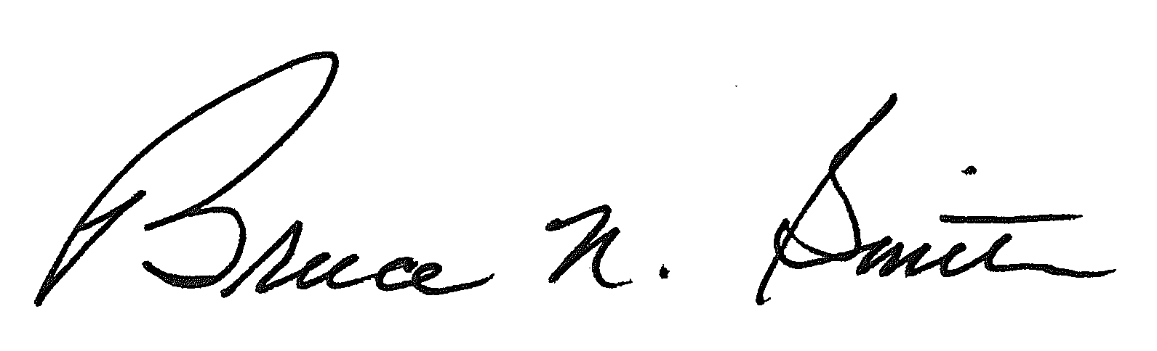
Bruce N. Smith
Director
/tmp/in/input.doc

