Decision No. C03-1324
BEFORE THE PUBLIC UTILITIES COMMISSION OF THE STATE OF COLORADO
DOCKET NO. 03A-012T
IN THE MATTER OF THE APPLICATION OF ALTICOMM, INC. FOR A CERTIFICATE OF PUBLIC CONVENIENCE AND NECESSITY TO PROVIDE LOCAL EXCHANGE TELECOMMUNICATIONS SERVICES.
ORDER GRANTING EXTENSION OF
TIME TO FILE
Mailed Date: December 1, 2003
Adopted Date: November 26, 2003

BY THE COMMISSION

Statement
- On November 19, 2003, AltiComm, Inc. (AltiComm), filed a motion requesting an extension of time within which Staff of the Colorado Public Utilities Commission and AltiComm may file their settlement agreement regarding the ordered bond and other security ordered in Commission Decision No. C03-1116.
- Now being duly advised in the matter, the Commission finds good cause has been stated and will grant the motion.

ORDER

The Commission Orders That:
- The motion for extension of time filed by AltiComm, Inc., is granted. Staff of the Colorado Public Utilities Commission and AltiComm, Inc., shall be permitted to file, on or before December 15, 2003, their settlement agreement regarding the ordered bond and other security ordered in Commission Decision No. C03-1116.
- The Commission waives response time to the motion.
- This Order is effective on its Mailed Date.

ADOPTED IN COMMISSIONERS’ WEEKLY MEETING
November 26, 2003.

THE PUBLIC UTILITIES COMMISSION
OF THE STATE OF COLORADO
GREGORY E. SOPKIN
________________________________
POLLY PAGE
________________________________
JIM DYER
________________________________
Commissioners
(S E A L)

ATTEST: A TRUE COPY
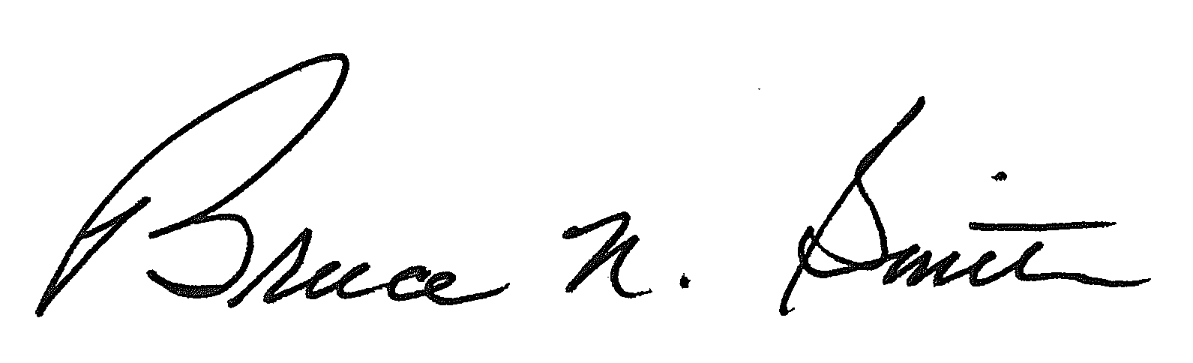
Bruce N. Smith
Director
/tmp/in/input.doc:srs

